# Glyndwr Timetable SatNav

**Connor Laurence**

A project submitted in partial fulfilment of the requirements

for the Wrexham Glyndŵr University award of

**M.Sc. in Computer Science**,

undertaken in the Subject of Computing within the School

of Applied Science, Computing and Engineering,

Wrexham Glyndŵr University

August 2021

# Acknowledgements

I would like to thank my supervisor Julie Mayers for the support,

advice, and encouragement she provided throughout my project.

I would also like to thank my family and friends for

the support they have given me during this degree.

# Abstract

Indoor Navigation applications have been in use for over a decade in many different environments but are typically closed and specially developed rather than open source and widely available. These systems are not without their problems however, indoor localization techniques using Wi-Fi are somewhat inaccurate due to scatter, signal attenuation and poorly implemented Wi-Fi network infrastructures. This project seeks to determine whether the most current infrastructure-less localisation techniques coupled with a unique method for wayfinding provides a viable and feasible application for real world scenarios. The method for wayfinding – timetables – may prove an intriguing method for users such that environments you may typically use indoor navigation in (i.e., Universities, Bus stations, Train stations, Airports, Shopping Centres and Museums to name a few) could benefit tremendously. The feasibility will be determined by software testing to demonstrate a proof-of-concept application that demonstrates this method, its usefulness and perceived quality will be determined by both software testing and user testing surveys.

Table of Contents

Glyndwr Timetable SatNav i

Acknowledgements ii

Abstract iii

List of Figures vii

List of Tables x

1. Introduction 1

1.1. Background 1

1.2. Scope for Research 1

1.3. Limitations 1

1.4. Ethical Issues 2

2. Literature Review 3

2.1. Indoor Mapping and Navigation 3

2.1.1. Indoor Positioning Systems 3

2.1.2. Indoor Navigation and Route Planning 6

2.1.3. ARCore and SLAM Indoor Navigation 6

2.1.4. IndoorAtlas 7

2.2. Web Scraping and PDF Parsing 8

2.3. Indoor Positioning Systems in Competitions and Experts Preference 8

2.4. Analysis and Conclusions 9

3. Research Hypothesis and Questions 10

3.1. Research Hypothesis 10

3.2. Research Questions 10

4. Methodology 11

4.1. Requested Supervisor 11

4.2. Preparation 11

4.3. Top-Level Design 12

4.4. Development 13

4.5. Testing 13

4.6. Evaluation 13

4.7. Reporting Results and Conclusions 14

4.8. Project Planning and Timescales 14

4.9. Risk Analysis 15

5. Ethical Approval 16

5.1. Components Requiring Ethical Approval 16

5.2. Action to Obtain Ethical Approval 16

6. Top-Level Design 17

6.1. Architectural Design 17

6.2. User Interface Design 17

6.1.1. Human-Computer Interaction and Accessibility 17

6.1.2. Android Activities 18

6.1.3. Storyboards/UI Wireframes 19

6.1.4. Database Design and Data Flow Diagram 22

6.2. SCRUM 23

6.2.1. Product Backlog 23

6.2.2. Sprint Planning 24

6.3. Program Logic - Jackson Structured Programming 25

6.4. Test Design 30

6.4.1. Software Test Plans 30

6.5. Survey Design 31

7. Development 33

7.1. Sprint One – App Prototype 33

7.1.1. Adjusted Sprint Backlog 33

7.1.2. Sprint One Development Documentation 34

7.1.3. Sprint One Retrospection 59

7.2. Sprint Two – Indoor Map Functionality 60

7.2.1. Adjusted Sprint Backlog 60

7.2.2. Sprint Two Documentation 60

7.2.3. Sprint Two Retrospection 75

7.3. Sprint Reviews and MVP 76

7.4. Future Development: Improvements and Points to Consider 76

8. Testing 78

8.1. Software Testing 78

8.1.1. Unit Testing 78

8.1.2. Systems and Integration Testing 79

8.1.3. Data Flow Testing 80

8.1.4. User Acceptance 81

8.1.5. Beta Testing – Initial Feedback 82

8.1.6. Software Testing and the Research Hypothesis 82

8.2. User Testing and Survey 82

8.3. Initial Results 83

9. Evaluation 86

9.1. Description 86

9.2. Feelings and Thoughts 87

9.3. Evaluation 88

9.4. Analysis 89

9.5. Conclusion 89

9.6. Action Plan 89

10. Conclusion 91

10.1. Current State of the Artefact and Areas for Improvement 91

References 1

Appendices 12

Appendix A – Ethical Approval Form 12

Appendix B – Initial Survey Design 15

Appendix C – Test Plan Document 17

Appendix D – Testing Incident Report 20

Appendix E – Final Survey Design 21

Appendix F – Survey Results 24

Appendix G – Demonstration Video 28

Appendix H – Project Files – GitHub Repository 28

# List of Figures

Figure 1 - Gannt Project Chart 15

Figure 2 - Top Level Design of Architecture 17

Figure 3 - Main Menu Wireframe 19

Figure 4 - Timetables Activity Wireframe Diagram 19

Figure 5 - Timetable Contents Activity Wireframe 20

Figure 6 - Timetable POI Dialog Box 20

Figure 7 - Timetable Info Dialog 20

Figure 8 - Maps Activity Wireframe Diagram 21

Figure 9 - App Sitemap 21

Figure 10 - Database Tables Design 22

Figure 11 - Data Flow Diagram 23

Figure 12 - Sprint 1 Plan 24

Figure 13 - Sprint 2 Plan 24

Figure 14 - Sprint 3 Plan 25

Figure 15 - OpenDatabase JSP Diagram 26

Figure 16 - Timetable Web Scrape JSP Diagram 26

Figure 17 - Timetable Contents Web Scrape JSP Diagram 27

Figure 18 - Main Menu JSP Diagram 27

Figure 19 - Timetable Activity JSP Diagram 28

Figure 20 - Timetable Contents Selector JSP Diagram 28

Figure 21 - Timetable Info Dialog JSP Diagram 29

Figure 22 - Timetable Contents Dialog JSP Diagram 29

Figure 23 - Map JSP Diagram 29

Figure 24 - Ground Floor Floorplan adjusted 34

Figure 25 - First Floor Floorplan 34

Figure 26 - Uploading floorplan using IA Webtool 35

Figure 27 - IA Webtool Waypoints 35

Figure 28 - Ground Floor Mapping Info 36

Figure 29 - Magnetic Field Coverage for C corridor ground floor 36

Figure 30 - Magnetic Field Coverage for B Corridor and Main Lobby ground floor 37

Figure 31 - Magnetic Field Quality C corridor ground floor 37

Figure 32 - Magnetic Field Quality B corridor and Main lobby ground floor 38

Figure 33 - Wi-Fi Coverage C corridor ground floor 38

Figure 34 - Wi-Fi Coverage B corridor and Main lobby ground floor 39

Figure 35 - Wi-Fi Quality C corridor ground floor 39

Figure 36 - Wi-Fi Quality B corridor and Main lobby ground floor 40

Figure 37 - First Floor Mapping Info 40

Figure 38 - Magnetic Field Coverage C corridor upper floor 41

Figure 39 - Magnetic Field Coverage B corridor and Gallery upper floor 41

Figure 40 - Magnetic Field Quality C corridor upper floor 42

Figure 41 - Magnetic Field Quality B corridor and Gallery upper floor 42

Figure 42 - Wi-Fi Coverage C corridor upper floor 43

Figure 43 - Wi-Fi Coverage B corridor and Gallery upper floor 43

Figure 44 - Wi-Fi Quality C corridor upper floor 44

Figure 45 - Wi-Fi Quality B corridor and Gallery upper floor 44

Figure 46 - Ground Floor Top Wayfinding 45

Figure 47 - Ground Floor Bottom Wayfinding 45

Figure 48 - Top Floor Top Wayfinding 46

Figure 49 - Top Floor Bottom Wayfinding 46

Figure 50 - Timetable Records Database Table 47

Figure 51 - Timetable Contents Database Table 47

Figure 52 - OpenDatabase Imports, Constructor, onCreate and onUpgrade 48

Figure 53 - OpenDatabase removeAllTimetables and addTimetableRecord 48

Figure 54 - OpenDatabase ListAllTimetables 49

Figure 55 - OpenDatabase SearchTimetableRecords 49

Figure 56 - OpenDatabase removeTimetableContents and addTimetableContents 50

Figure 57 - OpenDatabase retrieveWeeks 50

Figure 58 - OpenDatabase weekContentsFormat 51

Figure 59 - OpenDatabase eventDetails 51

Figure 60 - Main Menu Activity UI 52

Figure 61 - Timetable Contents Activity UI 52

Figure 62 - Timetables UI Activity 52

Figure 63 - Timetable Contents Dialog UI 53

Figure 64 - Timetable Dialog UI 53

Figure 65 - Web Scraping Timetables Code 53

Figure 66 - Pre-Web Scrape Table Clear Log 54

Figure 67 - Web Scrape Timetables Log 54

Figure 68 - Web Scrape Timetable Contents Code 54

Figure 69 - Timetables Functionality 1/2 55

Figure 70 - Timetable Functionality 2/2 56

Figure 71 - Timetable Contents Functionality 1/6 56

Figure 72 - Timetable Contents Functionality 2/6 57

Figure 73 - Timetable Contents Functionality 3/6 57

Figure 74 - Timetable Contents Functionality 4/6 58

Figure 75 - Timetable Contents Functionality 5/6 58

Figure 76 - Timetable Contents Functionality 6/6 59

Figure 77 - Indoor Atlas Web Tool API Key Setup 61

Figure 78 - IA Webtool API Setup Process 61

Figure 79 - Google Maps API Credentials 61

Figure 80 - IA API and Secret Keys 62

Figure 81 - Google Maps API Key in Values 62

Figure 82 - Build.gradle config 1/3 62

Figure 83 Build.gradle 2/3 63

Figure 84 - Build.gradle 3/3 – Dependencies 63

Figure 85 - Android Manifest Permissions 64

Figure 86 - Main Activity Check Permission Functionality 1/2 64

Figure 87 - Main Activity Check Permission Functionality 2/2 64

Figure 88 - Main Activity SDK Configuration Check 65

Figure 89 - Wayfinding Activity - onCreate Method 65

Figure 90 - IALocationListener method 66

Figure 91 - showLocationCircle Method 66

Figure 92 - IARegionListener Region Enter and Exit Methods 67

Figure 93 - Fetch Floorplan Bitmap 1/2 68

Figure 94 - Fetch Floorplan Bitmap 2/2 68

Figure 95 - Set Up Ground Overlay Method 69

Figure 96 - Map Activity Lifecycle methods 69

Figure 97 - OnMapReady Method 70

Figure 98 - OnMapClick Method 71

Figure 99 - Set Up POIs Method 71

Figure 100 - Set Wayfinding Target Method 72

Figure 101 - IA Wayfinding Listener Method 72

Figure 102 - IA Orientation Listener Method 72

Figure 103 - Update Heading Method 72

Figure 104 – Update Route Visualisation Update 73

Figure 105 - Clear Route Visualisation Method 73

Figure 106 - Arrived at Destination Method 74

Figure 107 - Style Resource 74

Figure 108 - Timetable Dialog updated UI 75

Figure 109 - Event Dialog updated UI 75

Figure 110 - Timetable Contents UI 75

Figure 111 - Timetables updated UI 75

Figure 112 - Main Menu updated UI 75

Figure 113 - Web Scraping Unit Tests 78

Figure 114 - Instrumented Unit Test - Maps 79

Figure 115 - Remove Timetables expected Log Message 80

Figure 116 - Remove Timetables Log Results 80

Figure 117 - Add Timetable expected Log Message 80

Figure 118 - Add Timetable partial Log Results 80

Figure 119 - List All Timetables expected Log Message 80

Figure 120 - List All Timetables Log Results 80

Figure 121 - Search Timetables expected Log Message 80

Figure 122 - Search Timetables Log Results 80

Figure 123 - Remove Timetable Contents expected Log Message 80

Figure 124 - Remove Timetables Log Results 80

Figure 125 - Add Timetable Event expected Log Message(s) 80

Figure 126 - Add Timetable Event Partial Log Results 81

Figure 127 - Retrieve Weeks expected Log Message 81

Figure 128 - Retrieve Weeks Log Results 81

Figure 129 - Week Contents expected Log Message 81

Figure 130 - Week Contents Log Results 81

Figure 131 - Retrieve Event Details expected Log Message 81

Figure 132 - Retrieve Event Details Log Results 81

Figure 133 - Accuracy Questions 83

Figure 134 - Functionality Questions 83

Figure 135 - Timetable Functionality and User Preference 84

Figure 136 - Usability question 84

Figure 137 - Destination assistance 85

# List of Tables

Table 1 - Risk Analysis 15

Table 2 - Ethical Issues 16

Table 3 - Product Backlog User Stories 23

Table 4 - Sprint One Backlog Adjusted 33

Table 5 - Sprint Two Backlog Adjusted 60

Table 6 - Integration Test Decision Table 79

Table 7 - Test Incident Report 20

# Introduction

Universities and other higher education establishments offer students various resources like timetables and campus maps digitally. This project will explore the viability of indoor maps and navigation in an intuitive way by creating an android application that uses Web scraping to dynamically collect timetable content. This content could then be used to select a location within the university to navigate to. Furthermore, navigation could provide multi-floor options, accessibility routes and clear routes to the nearest fire exits as well as more modern and intuitive interfaces useful to those with visual disabilities and difficulties.

## Background

The artefact will be developed on Google’s Android platform for two main reasons; firstly, during the course projects have been undertaken by myself, and this has demonstrated relevant skills in Androids main programming language Java and secondly, Android as a platform has the lion share of the mobile OS market with nearly 72% share of smartphone users [1]. The other technologies that will be explored and used include Indoor Mapping, Navigation, and Web Scraping.

Indoor Mapping is a technology that builds on the ever-familiar outdoor navigation using GPS that most people use. It takes an indoor venue and displays it on a 2D, or 3D map so that users can see areas of interest, rooms, exits, entrances, lifts, and ramps to name a few. Solutions can be built to implement indoor positioning and thus navigation becomes possible [2]. Large areas such as universities, shopping centres or stadiums to name but a few can be explored with a digital tool. This is not an innovative or new technology and has by and large seen some implementations in public buildings [3] however, the technology is not without its limitations. Limitations introduced by the method in which the indoor positioning is gathered (typically through Wi-Fi and GPS based systems) which can be heavily affected by thick walls, poorly placed access points and poor mobile signal [4].

This app aims to explore the viability of Indoor Mapping and Navigation at its current level of development commercially in a largely unique method of wayfinding – locating and navigating to a room from a timetable – and whether that would also be effective in aiding a student get around a campus. The web scraping works to collect timetable content dynamically from the university timetable website and format it into a usable format for wayfinding.

## Scope for Research

The main scope of research involves determining the viability of indoor navigation via timetable and whether it is possible to create an effective indoor navigation tool for students navigating via timetable. The primary research element of this work will be centred around software testing to determine application viability for real world usage, and end-user testing of the application which will survey users to determine whether; indoor positioning was accurate, navigation routes were useful, timetable features worked and provided a unique positive method of wayfinding.

This would be useful to determine whether commercial indoor navigation solutions are accurate and viable enough in an indoor environment to use as a main user feature within applications or whether issues plaguing indoor positioning still affects these technologies. Also, it will determine whether navigating via timetable is an effective wayfinding method for students. This research may prove interesting to developers seeking to implement similar solutions, other students and faculty who may find an application like these useful and indoor navigation experts who may be seeking to validate current performance or seek feedback on improving indoor navigation solutions.

As a result of previously undertaking work within the android development environment, it is possible to conclude that this project will be feasible, challenging and rewarding within the current timeframe.

## Limitations

There are many commercial solutions available to implement indoor mapping and navigation that could be used, and this is not a project testing all such solutions but rather exploring each of the solutions and selecting one to implement within the application (likely the most common or popular solution available). Navigation or wayfinding will purely be accessed via the timetable system to eliminate extra factors and better evaluate the effectiveness of this method. Indoor Navigation will be limited purely to the main building on Plas Coch Campus as the floorplans provided only cover this area.

## Ethical Issues

As the university floorplans are not immediately available to the public it is important to ensure the artefacts implementation does not change this. Solutions must allow ‘offline’ or access to the floorplans purely within the app and not make this available to all users of this service around the world. Location data will not be permanently stored and will ask user permission upon first use of application.

All web-scraping will be of publicly available timetable information from the Universities timetabling system. Only timetables being searched for will be displayed to the user within app and navigation to rooms will be limited to lecturing rooms and labs available to all students and not to staff-only areas or staff offices. Timetable data will only be loaded dynamically and not stored offline.

When surveying end-users, data collection will be; collected anonymously, ask only relevant questions, make clear intention of the survey, and only accept UK participants over the age of 16 as they can personally consent.

# Literature Review

The nature of this application is not counted among the first to demonstrate usage of indoor mapping and navigation within a university or other large public building. The first implementation of an indoor maps app using a smartphone for a university was over a decade ago when the Norwegian University of Science and Technology (NTNU) developed a Campus Guide free for iPhone, Android, and web users [5]. This system had an accuracy of 5-10 metres using a well-developed Wi-Fi network of over 1800 wireless routers. This first implementation worked off user-driven innovation whereby all phases of the project were led by systematic user testing at each stage.

There are some universities today offering their students mobile apps for this purpose, for example the University of West Scotland [6] and Lancaster University [7]. These solutions are the typical navigate by search and rely on commercial solutions provided to the universities like the Netherlands-based Eyedog Indoor Navigation and MazeMap, respectively. These solutions use advanced methods of acquiring indoor positioning such as Wi-Fi triangulation, BLE beaconing, sensor fusion platforms and geomagnetic field fingerprinting [8].

This application seeks to determine whether Infrastructure-less methods such as GPS, Wi-Fi, Inertial sensors, or AR – the least resistance route to setting up indoor navigation – is enough to enable indoor navigation on a campus scale and whether wayfinding is a niche but effective method of navigating a building like a university. For that purpose, there are three main technical aspects associated with its function which are Indoor Mapping, Indoor Navigation, and Web scraping.

## Indoor Mapping and Navigation

Indoor mapping is a concept that visualises indoor spaces such as venues and spatial data on a 2D or 3D map [2]. This is similar to how google maps or apple maps show the user outside information for example buildings, roads, and points of interest (POI) as indoor maps show you places, rooms and indoor POIs. This is especially useful in large indoor venues like shopping malls and universities where it can become easy to get lost or difficult to find a specific location quickly [9].

Research into Indoor Mapping has been active for over three decades [10]. Initially, this technology was privy to engineers, contractors, and designers but increasingly commercial solutions have become the mainstay for this technology’s offerings [10]. Some solutions such as Google’s Indoor Maps [3] and Apple’s Indoor Maps [11] offer simple indoor maps to display information on websites and smartphones whereas other more in-depth commercial solutions like WRLD3D’s Indoor 3D Maps [12], Mapwize [13], Mapspeople [14], MazeMap [8] and IndoorAtlas [15] offer Indoor Positioning and even wayfinding to enhance the users experience. Past commercial endeavours, these indoor maps solutions tend to be self-developed and closed source like in the previously mentioned case at NTNU which was initially started as a student project [5] or crowdsourced open-source projects like ‘Anyplace’ [16].

A map alone would not be entirely helpful to the user. If the user knew their location on that map, they could begin to see how useful a tool Indoor Mapping could become. The most complex issue lies in acquiring the location of the user. Outdoor maps rely on global navigation satellite systems (GNSS) such as the Global Positioning System (GPS) [17]. GPS was first fully operational in 1993 and consists of a few dozen satellites orbiting the earth which compute positions in three dimensions and time offset [17]. This system is at best case scenario, accurate to within three metres given a variety of factors such as signal blockage, atmospheric conditions, and satellite geometry [18]. GPS accuracy drops even further when exploring its use within indoor environments. This is because buildings have thicker walls which in turn affect GPS signals [19]. Indoor accuracy is at best within 10 metres in an indoor environment [20]. This can be jarring to users experience as in a scenario like an indoor shopping mall or university, 10 metres could make it impossible to navigate by. User localisation is determined by what is known as an Indoor Positioning System (IPS) and navigation is typically determined by pathfinding on a graph with modelling.

### Indoor Positioning Systems

Indoor positioning systems (IPS) supplant the use of GPS/GNSS within indoor environments. This is because these signals degrade quickly when they hit obstacles resulting in signal attenuation and scatter, further affecting the typical 1-3m accuracy achievable outside [21]. IPS uses different techniques and algorithms to achieve a position estimation calculated from signal strength or range. There are a range of measuring principles used in detecting locations. These approaches either fall into the infrastructure-based or infrastructure-less categories depending on whether they need specialised equipment installed.

1. **Triangulation**

Triangulation uses the geometry of triangles to determine distance and orientation. This is done in two ways; Lateration and Angulation. Time of Arrival (TOA), Time Difference of Arrival (TDOA) and Angle of Arrival (AOA) are the most common techniques of triangulation, however, Received Signal Strength (RSS), and Return Time of Flight (RTOF) can sometimes also be used [21]. Lateration uses TOA to see the time it takes for signal to travel between multiple devices to calculate position of a target. Angulation uses AOA to determine target location by estimating the intersection of at which signals arrive at receiving sensors [21]. Typically, Wi-Fi triangulation is accurate to 5-15 meters [22]. Latency issues with irregular updates and changing mac addresses can affect this further and some devices like those that use IOS are restricted and have no client-based positioning altogether [22].

Newer methods of triangulation like Google’s Round Trip Time (RTT) [23] which is a new addition to the Wi-Fi standard (IEEE 802.11mc) defines a protocol for round trip messages between device and a single access point with light speed signals. By using four access points and measuring this distance regularly, the device’s location can be triangulated in 3D space and can bring the accuracy down to just one meter [24]. RTT is dependent on a good infrastructure setup throughout a given indoor space due to the requirement for multiple access points that support 802.11ac and have firmware upgrades to support Wi-Fi RTT [25].

1. **Fingerprinting**

A successful technique used in IPS is radio fingerprinting [21]. This method is based on scene analysis where an area is mapped and analysed, signal properties in different locations are then collected and stored. When a device requests its location, device signal properties are compared to the database and the closest match provides an approximation of location [21]. Radio fingerprinting uses RSS which has a disadvantage of errors caused by radio signal scatter, multipath and attenuation [21].

RSSI Fingerprinting usually maps Wi-Fi signals in a given area and can be accurate 0.6m (median) with a tail accuracy of 1.3m [26]. This approach also uses multiple access points simultaneously along with a propagation model to determine target location. The area mapping must first be carried out, RSSI values from all AP’s are determined and stored so that at a later point when the user’s device is at that same location it will exhibit the same fingerprint [26]. These systems are difficult to deploy as they require an expensive, recurring fingerprinting routine to constantly update the heatmaps for changing environments [26].

1. **Signal Propagation Modelling**

Also known as radio propagation modelling, signal propagation modelling provides an alternative to the empirical form of fingerprinting previously mentioned. Instead, mathematical signal propagation models are made and based on theoretical computed signal strength data. User location is then estimated by matching signal strength measured in real-time [21].

1. **Dead Reckoning**

The oldest technique amongst these is dead reckoning. This relies upon estimation of current position based on a previously known position and estimated movement and direction since then. This is done by using the internal inertial sensors of a device like gyroscope, compass, or accelerometer. Dead reckoning is rarely used in IPS systems due to small errors accruing and resulting in major errors in position estimation [21]. It can, however, be used in hybrid systems to great effect to reaffirm the primary method of localisation and act as backup in areas with spotty signal coverage whether that be Wi-Fi signals, BLE beacons, GPS, or a combination of IPS types [27].

1. **Proximity**

Proximity location provides location based on distance to a known position in an area. Although not exactly accurate, the more known location devices and better sensitivity therein provide an increasingly accurate relative approximation of the location [21]. This form of IPS is very dependent on infrastructure being in place using devices such as; BLE beacons, RFID tag and/or wireless access points. Depending on the number of these devices, this method can be very accurate with some popular beacons such as Estimote providing an accuracy of 1.5 meters [28].

1. **Cooperative Positioning**

This approach uses other devices in a peer-to-peer system to share users position information. Using information gathered from the device’s vicinity, the device can estimate, improve accuracy and reliability of their position [21]. Peer-to-peer navigation is fast to deploy, overcomes requirements of pre-deployment like area mapping or proximity devices setup and takes advantage of the typical number of users that may be participating within large indoor environments [29]. This can be accurate to within 5 meters, however, as users’ devices only gather sensor data such as Wi-Fi and Inertial sensors, at best only a relative location with respect to the peer can be given rather than an exact location. The more peers involved in the system, the more accurate this estimation becomes [29].

1. **Augmented Reality**

AR based solutions uses the devices internal sensors to detect magnetic field, Wi-Fi signals, other inertial sensors as well as plane detection and light estimation as a hybrid approach to indoor positioning and also supplements the traditional 2D and 3D map approaches with an augmented reality approach to navigation [30]. This approach proves a valuable interface to individuals with accessibility requirements.

The IPS systems of today typically use Wireless Local Area Networks (WLANs), Radio-Frequency Identification (RFID), Ultrasonic, Bluetooth, Inertial sensors, Ultra-wideband (UWB) or a Hybrid approach of these technologies [21]. WLANs using Wi-Fi networks to determine target positions typically via fingerprinting and signal propagation, though it is possible through triangulation too. The more access points and the better the placement of them, the more accurate this system is [21]. This method works well in large venue settings as these places typically offer free Wi-Fi. The latest advancements in this area of IPS is the use of Wi-Fi ranging with RTT [31]. Wi-Fi with RTT uses multilateration algorithms to determine user position in 2D/3D space.

Radio Frequency Identification Devices (RFID) IPS systems uses passive, semi-passive or active RFID tags and proximity location to determine user position and at best provides a relative location. Like with WLAN, the more tags involved in the system the more accurate the location accuracy. Passive tags provide the least range but are attractive due to low level of maintenance and cost [32]. The most famous models for IPS using RFID are LANDMARC [33] and SPOTON [34]. RFID systems fall foul of tag collision, cost, and power consumption issues [35].

Ultrasonic systems can be highly accurate to the sub-centimetre scale [36]. An example of this is the TELIAMADE system which uses Time of Flight (TOF) of ultrasonic signals to estimate distance of receiver-transmitter nodes. By using triangulation through time synchronized TOF and multilateration techniques similar to Wi-Fi with RTT an accuracy of 9.6mm is achievable [36]. Ultrasonic is limited in larger scale environments due to the easily degradable signal’s which are dependent on signal-to-noise ratio, air, and objects. Unless there are many beacons installed and good line of sight is achieved, accuracy can degrade up to tens of metres [37]. Ultrasonic systems can be attractive due to the lower cost of ultrasonic based beacons and can also be a very good choice of complimentary support to other IPS systems [37].

One of the most common and popular methods of IPS are Bluetooth Low Energy (BLE) beacons [38]. These low power sensors are cheap, can run on cell batteries and can be setup quickly and easily with minimal effort. These beacons use universal identifiers and multiple different beacons can be used in the same environment. These beacons can be accurate to 1-2 metres and use either proximity if minimal beacons are used or triangulation if there are many beacons in use [38]. Many out of the box solutions like the previously mentioned MazeMap, Mapspeople, Mapwize and IndoorAtlas all support BLE beacons from various vendors and these devices are considered amongst the top tier for infrastructure-based approaches in pop-up venues and events. However, due to the short-term nature of cell batteries, BLE beacons are not the main choice for long term infrastructure solutions unless they are powered by the existing buildings electricity outlets [39].

Inertial sensors alone are perhaps the most inaccurate approach due to changes in gait distance or other factors affecting the device users’ passage to a destination. At best, if an Inertial based IPS is implemented well with a Model Wave and Particle Filter then accuracy of a traditional IPS system is capable of being reached [40]. The intrinsic drift in these approaches can be corrected through use of QR codes or AR waypoints to ‘recentre’ the device in a given space. When used in hybrid systems, inertial sensors can be very complimentary to the whole systems localization.

Last but not least, geomagnetic field fingerprinting IPS systems are a form of signal propagation modelling type IPS’ [41]. This type of system very much depends on the stability of the magnetic field within the indoor environment. Studies show it is possible to discern between two overlapping floors [41]. Alone, this system can also fall foul of changes in the environment, objects users may be carrying, and objects being moved within the environment [41].

### Indoor Navigation and Route Planning

Indoor Navigation or Indoor wayfinding is the guidance of a user in unknown building interiors and complexes. The user’s navigation system acquires its location from the IPS and displays a 2D map, 3D maps or augmented navigation guide to the user. The users then search and/or select a POI and then a route is displayed on the map. The system updates the user’s position via IPS continuously [42]. The important function of a navigation system is to plot an optimal route given various inputs, in standard outdoor maps we may think of this as quickest, shortest or routes without tolls or other conditions. In an indoor map, this may include the typical quickest but also may include accessibility options like lifts and ramps or multi-floor routes [43].

Pathfinding techniques are an essential part of any navigation-based application. Complex indoor environments have increasingly complex demands on route planning methods such that IFC-based path planning, semantically enriched indoor navigation, context-aware indoor navigation, and indoor route planning methods with environment awareness have all arisen to the challenge of improving the users experience [44]. Typically, an indoor route plan will be based off of geometric models to provide an optimal route. This can be done by feeding environment semantics into algorithms like Dijkstra [44], A* or ACO [45]. Route planning can be considered like networks are in that doors and rooms are nodes, and corridors are edges [44] [46]. This allows for optimal pathing based on shortest distance and time like you would do for network design, and also environment variables like accessibility aspects of a building’s floorplan.

Graph based models like Symbolic modelling can establish a structure based off reference points like rooms to carry out distance computation more accurately. This allows for direct usage of graph algorithms like shortest path, traversals, and connectivity [47]. A hybrid pathfinding approach can take advantage of both grid-based and node-based pathfinding such that pre-processed routes on a node path could provide quick navigation and should there be changes to the environment such as obstacles, a fall back to grid-based pathfinding would allow for overcoming this [48]. This backup approach would need a LIDAR or similar system to provide obstacle detection and update pathing in real time.

### ARCore and SLAM Indoor Navigation

Aside from these techniques mentioned above, some modern solutions are making the most of the user’s smartphone functionality for indoor navigation. For Android environments from Android 7.0 onwards (Android 7.0 covers more than 50% of android users), ARCore can be used to build augmented reality experiences, IOS supports their version of this technology ARKit from IOS 11 onwards (covering 89% of all IOS users). ARCore enables the phone to sense its environment in three key aspects; motion tracking, environmental understanding, and light estimation [49]. Using these aspects, it becomes rather easy to see that the tracking of the device as it moves, the building and understanding of the real world can be useful to creating infrastructure-less indoor navigation tools [49].

The ARCore motion tracking system tracks both the position and orientation of the devices camera relative to the world around it by observing and tracking visually distinctive features and using the inertial sensors. This approach is called Visual-Inertial Odometry (VIO) [50]. ARCore and other augmented reality toolkits are best placed as a high-quality infrastructure-less approach to indoor navigation tools as a large number of the population possesses Android and IOS smartphones [1] with the technology built in capable of providing this functionality [50].

As indoor positioning systems involving GPS or Wi-Fi alone are not without their drawbacks when it comes to precision, ARCore can use its motion tracking system in combination with an accurately scaled blueprints of the environments floorplan to improve precision greatly [50]. Instantaneous localisation in this environment can be carried out through the use of visible marker references such as an image-based code like QR Codes known as AR waypoints [30] or a marker-less approach of determining location from natural features such as textures and corners could be used, however, this approach is a very computationally intense workload and is prone to being affected by light source interference and changes in the device’s environment [30] [51].

ARCore and other augmented reality navigation tools can be demonstrated largely in two ways – a 2D map with a pin highlighting user location and route largely like many map providers have or a augmented view that takes the feed the camera receives and overlays it with instructions to navigate by such as arrows or as a little animation to follow around [30]. The former method follows the intuitive user interface that have led to the success of many map applications however the latter has great potential for accessibility as it reduces time and recognition workload of wayfinding behaviours in humans [52]. The latter shows a first-person view such that target direction in navigation should be immediately evident to the user.

ARCore can maintain its indoor positioning through space understanding such as plane detection and depth map as well as Simultaneous Localisation and Mapping for Android (SLAM) through the use of inertial sensors and images for the devices camera to estimate both position and orientation in a 3D based coordinate system [53]. These IPS technologies are not without issue though as plane detection can be flawed if walls and floors are predominantly featureless such as white walls and SLAM has the potential to allow intrinsic drift into its determination which unless corrected by other means can make the actual location differ from the registered location by a noticeable margin [54]. Furthermore, space understanding can also be negatively affected by busy environments. For example, a busy venue may make it difficult for the device to regularly detect marker points which keep the navigation accurate as marker points must always be fully visible. If the markers are temporary or implemented in a way that damage to them is considerable such as being torn this can also have the same affect [52] [51].

Various algorithms and approaches to computation involving Visual Markers, SLAM, and Inertial Measurement Unit (IMU) are either constrained by computational performance as found in some Android devices or are very much close sourced and kept secret by developers on the IOS platform [55]. This highlights an area of potential for hybrid based indoor navigation solutions as the various methods such as RSSI fingerprinting, and beacons offload the IPS computation complexity that could arise from AR toolkits and allow for the toolkits to provide an intuitive and user-friendly interface.

Augmented Reality approaches to indoor navigation tools are not just simply more intuitive to navigate by as research has shown that for visually impaired people and those who may struggle with the more traditional interfaces of navigation tools that an AR approach significantly eases the stress and improves the overall experience for these particular people [56] [57]. Of all the approaches to indoor navigation, AR can prove an asset as both a navigation tool and as an assistive tool. Good design should aim to provide a high level of human-machine interaction where possible and be open to all people [57].

ARCore has been used alone and as part of a hybrid system of technologies to great effect in creating indoor navigation tools. Some examples include the Augmented Reality Based Indoor Navigation System (ARBIN) [27] which uses Bluetooth beacons and the orientation and direction indicator to deliver an accurate and user-friendly solution. Solutions using ARCore alone can be seen in conjunction with an autonomous robot to great effect too [50].

### IndoorAtlas

Indoor Atlas is an all-in-one commercial solution that is open to developers to create, build, and maintain an indoor navigation tool that uses a fusion of geomagnetic fingerprinting, Wi-Fi fingerprinting and ARCore technologies that provides a decent accuracy between 1 and 2 meters [15]. The service provides a web tool to add floor plan images, a mobile app called ‘IndoorAtlas MapCreator’ is used to map data and generate the heatmap for the indoor environment [58] and an SDK to add these location-based features to your own app [59]. With these tools, floor plan management, fingerprint collection, map generation and testing can all be carried out [60] without the need for custom and potentially cumbersome solutions with regards to project timeframe.

The pathfinding can use either Dijkstra’s or A* algorithms within and works on the principles of graph theory where doors and rooms are nodes and corridors are edges [61]. Navigation is provided as the system creates a new node at the user location with longitude, latitude, and floor number as parameters. Once assigned, the current location node is added to the network of nodes and the shortest path is then calculated. In multi-story buildings, the floor number of the destination is compared to that of the floor number of the current location node to determine pathing as stairs, ramps or lifts will be necessary to change floors [61].

## Web Scraping and PDF Parsing

The web is considered a huge information source for many people coming from many backgrounds. Containing useful information amongst a huge swathe of structured and unstructured information in varying different formats. Web Scraping is a tool used to retrieve and format this data to best suit our usage and application [62]. Web scraping itself is just the process of acquiring this data, the method could be manual like using a search engine or to some degree automated like a software-based web scraping tool.

Different approaches to web scraping include mimicry, weight measurement, differential, and machine learning. Mimicry is the scraper that works with predefined rules whereas the others work largely on an algorithmic based approach [62]. Web scraping is a relatively easy to access field with ready-made tools from many different providers for out the box scraping with little configuration [62]. One such tool – JSoup - is an easy-to-use open-source scraping tool that works well in an android environment [63].

In terms of formats, Web scraping can scrape all the content of a site unless specifically blocked. This could involve basic html like text information, pictures, and other embedded content such as PDFs and download links. This information may be really useful but without a method of parsing the content like text extraction of a PDF document or an embedded player to show videos and pictures, integrating web scraping into a dynamic product can be somewhat difficult. PDFs are perfect for cross-compatibility across devices being “portable, platform independent and human-readable” [64]. The format is largely unstructured which makes analysis of these documents somewhat difficult. Ready-made tools and libraries are also available in this area, one such tool is Apache PDFBox which is a Java based library that works in android development environments [65].

## Indoor Positioning Systems in Competitions and Experts Preference

Competitions by different organisations such as the IPIN conference [66], Geo IOT conference [67] and Microsoft Indoor Localization Competition (IPSN) conference [68] are held annually to test many different research teams worldwide that come together in competition to develop prototype indoor positioning apps using current and advancing IPS technologies to create an accurate application that furthers the field of indoor positioning. Due to Covid19, most of these conferences have not been able to host competitions like this since 2018 when IPIN had their competition based in a shopping mall in Nantes, France [69] and Microsoft’s 2018 indoor localization competition was held in Porto, Portugal [68].

These competitions include many different teams amounting to hundreds of experts in their field. IPINs 2018 competition had over 400 experts and 34 teams all competing to make the most accurate IPS systems [69]. IPINs competition seeks to create an empirically evaluated view of both real-time and post-processing (offsite) IPS systems. Both of which differ only in the former has their teams gather and survey the location data whilst the latter has all teams provided all the location data that may be captured real-time. This evaluates both solutions inclusive of the mapping procedure beforehand and a fair view of solutions when all the data is available to all teams [69].

Four tracks, two of which were on site – one camera based, and one non-camera based – and two offsite – again differing as one being smartphone-based positioning and the other foot-mounted IMU and GPS based – are provided spanning several 1km tracks within an indoor environment. Overall, over 9000 square meters were covered within the mall. Included amongst this were 180 ground-truth landmarks accurate to within 10cm were included for the teams to use [69].

For the tracks where all the sensors of a smartphone were used whether offsite or on tended to include a hybrid system of Wi-Fi, BLE and IMU sensors with either of those maybe being supplanted by magnetic field sensors. Surprisingly, Dead reckoning despite its intrinsic issue of drift was used to great effect with different algorithms either adjusting intrinsic drift or filtering like Bayesian filtering were used to dampen noise added into this information gathering [69]. Vision based systems based around VIO, Slam and AR were also used to great effect in the camera-based tracks.

The results from this conference showed for the Onsite camera-based track, Team ARIEL2 came first and ARIEL1 came second, with each team using Visual indoor positioning systems such as AR and Mixed Reality (MR). For the second Onsite track without the use of the camera, SONY came in first and KYUSHU came in second with the second team using upper body IMU with personal dead reckoning and map matching to achieve their position. The onsite tracks were less accurate than offsite tracks to within 11.7m (Track 1 – Ariel 2 - Camera Based) and 5.5m (Track 2 – Sony - Non-Camera based) [69].

For offsite tracks, the best accuracy scores were within 0.9m (Track 3 – FiveWhu – Smartphone based) and 1.3m (Track 4 – WHU – Foot-mounted IMU and GPS) [69]. FiveWhu used PDF, Wi-Fi fingerprinting and magnetic matching within their IPS system to achieve their accuracy. WHU have been working on a pedestrian navigation system prior to this competition which works with IMU data and GNSS raw data.

Microsoft’s Indoor Localisation Competition (IPSN) has a similar goal to IPIN in evaluating and comparing IPS technologies currently being explored in both academia and industry [70]. It sought to bring teams together to work in a more effective way and test their solutions in unfamiliar spaces. Of 34 teams that signed up, 26 officially registered to take part, 25 systems were shown in the conference in Porto and only 22 systems were evaluated [70].

Two categories were formed; 2D (where X and Y only need be reported, and no infrastructure is required so solutions just used Wi-Fi and IMU) and 3D (X,Y and Z need to be reported, custom hardware needs to be deployed and teams can deploy up to 10 anchor devices). In the 2D category, Ariel university came in first with an error factor of 2.4m [71] whilst Tongji university came in second with more accuracy (only 2.3m error) however, the team required initialisation first [72]. The 3D category was even more accurate with first place CMU with an error factor of 0.27m [73], ATE electronics and Yodel Labs tied for 2nd with 0.4m [74] and 0.47m [75] error factors respectively.

## Analysis and Conclusions

In the context of this application, the research has led to some conditions that we can pre-define. Due to the limitation of budget and the requirement for some decent level of accuracy, an infrastructure-less (or suitable to existing infrastructure) and free or open-source solution to indoor navigation is necessary. This could be solutions like *Anyplace* – with an accuracy level of 1.96m [76], IndoorAtlas with an accuracy between 1 and 2 meters [15], *ARCore* based approaches [53] or a hybrid approach of multiple technologies have all been used to great effect in various Android applications. Secondly, in terms of web scraping tools, JSoup is a great open-source tool that can achieve the goal of dynamically scraping timetable content [63]. Finally, when extracting information from the scraped PDF files, PDFBox is an excellent open-source tool to carry out text extraction from PDF files [65]. Together, these tools should provide an excellent basis for developing this application and determining the effectiveness of timetables as a method of wayfinding and whether the application is viable enough for real world usage.

Though many IPS systems are used to great effect in many differing indoor positioning systems, it is evident from many of the experts developed prototypes in competitions that no singular type of indoor positioning system is used alone. Circumstances depend on the quality of infrastructure available in the indoor environment, the quality and availability of the onboard sensors found in many smartphones, the maintenance factor in upkeep and scalability of infrastructure – not to mention the remapping that is needed in changing environments. All systems found regardless of these variables above make use of what is available to them.

Any developers and academics seeking to develop such solutions should plan for the intended audience and intended areas. For an all-purpose IPS application to be used in multiple areas – crowdsourced and easily accessible signals like Wi-Fi, GNSS, IMU and magnetic field can provide a decent enough solution for users to navigate by. For solutions requiring higher precision like usage within industry, sub-centimetre scale accuracy is important but heavily relies on quality hardware like visual sensors and infrastructure-based approaches would be considered the gold standard here.

# Research Hypothesis and Questions

This project aims to determine whether digital ‘Timetables’ are a viable method of wayfinding in an indoor environment. By ‘Timetables’, the research seeks to determine whether a user searching for their timetable and selecting rooms would be an intuitive approach to navigating to rooms in an indoor environment. By using a widely available and open-source solution to indoor navigation, the project also seeks to determine if the infrastructure-less approach of using Wi-Fi, Magnetic Field, AR, and inertial sensors provide an accurate enough indoor positioning system to the app to provide a viable ‘Timetable Satnav’ Android application.

The research hypothesis will be determined from primary research in the form of software testing of the application and the associated research questions will be determined from further user testing of the resulting android application. A viable solution should be considered as one that allows the user to navigate without issue within an indoor environment without getting lost.

## Research Hypothesis

It is possible to create a ‘Timetable Satnav’ Android application

## Research Questions

1. Is Wi-Fi viable enough for indoor navigation?
2. Is wayfinding via timetables an effective method of navigation?

# Methodology

Good projects tend to plan well in advance. This typically involves the use of methodologies. These methodologies generally fall into one of two categories: hard or soft approaches. Hard approaches

involve strictly defining the problem to be solved and rigid techniques and procedures to developing solutions. Soft approaches form a looser framework of tools which are more appropriate to problems with fuzzy requirements [77].

This project would better suit a hard approach given its defined problem of implementing a wayfinding method in an indoor navigation system. Given the time and resource constraints for the project and the essential need for an artefact as a deliverable, a methodology which prioritises presenting working software over documentation such as an Agile methodology would be well suited to the project [78].

Agile methodologies like Scrum expand on the older Agile methodology [79]. The Scrum process involves scrum artifacts, roles, events, and the daily scrum. The artifacts involve the Product backlog (a prioritized list of system requirements) and Sprint backlog (functional and non-functional customer and technical requirements). The roles encompass three types; Product Owner, Team Member and Scrum Master. The product owner represents the stake holders, team member is self-evident and Scrum master coaches the team through following the scrum process [79].

Scrums work in units defined as sprints. These are set periods of the development, each with a sprint backlog, sprint goal and sprint meetings. These tie in with Minimum Viable Product (MVP) which is an objective to deliver a product at each level of development [80]. Should sprints overrun or time constraints affect the project, minimum viable product (MVP) ensures that a deliverable of some level is at least delivered as proof of concept.

This project will be developed in the Android development environment. Further research and experimentation with specific solutions for indoor navigation will need to be carried out to ascertain the most appropriate solution to use. Other tools used included *Apache PDFBox* (an open source java tool for working with PDF documents) [65], *JSoup* (an API for fetching URLS, extracting and manipulating data) [63], *SQLite* (a free public domain SQL database engine) [81] and the *JAVA* programming language [82].

A development methodology ensures a strong defined process which will aid in producing deliverables, however, this does not guarantee that the deliverable meets the requirements either set by the customer or by the larger research goals. Research methods are designed to try to determine those research goals. These can encompass largely Qualitative or Quantitative approaches [83]. The Qualitative approach is centred around gathering quality data, this can be done through interviews and expert feedback. The Quantitative approach is centred around quantity of data and can be gathered by surveys and experiments generally [84]. Both have their positives and drawbacks such that another research method: Mixed-Methods was developed to try and achieve the best of both scenarios. This could be done in the form of a survey gathering quantitative data and including open ended questions to gather qualitative data together [85] [86].

## Requested Supervisor

Julie Mayers

## Preparation

Further research and experimentation into indoor navigation solutions like *Anyplace* [87]*, Navigine* [88]*, ARCore* [53]*, IndoorAtlas* [15]and the surrounding literature around these open-source projects will be necessary to gain a fundamental understanding into the setup, technical aspects and which is best to integrate into the new application. Further expansion into the literature review above may be necessary depending on what is discovered during this stage.

Having acquired the university’s floorplans, they will need to be adjusted to suit the constraints of the project. Since the application uses timetables as a method of wayfinding, timetabled rooms become the POIs and as such, only publicly accessible portions of the building need to be displayed. For Wrexham Glyndŵr University, these buildings include Blocks A, B, C, D, E, L, K, M, and the student union. Of these, timetabled rooms are only found in Blocks B, C, E, L, K and M. Since the student union and E block are external to the main building and blocks L, K and M are external to the main building floorplan, further analysis is necessary to determine whether it is prudent to include them within the scope of this application and how this may be done with overlap of an external navigation tool working in conjunction with this application. Initially, Blocks B and C may be included as POIs on the floorplan and depending upon time constraints, Block E may later be added as an extension. This may be considered as ‘Minimum Viable Product’ levels of development [80] or as a proof of concept.

Once the floorplan is adjusted, they will be uploaded and kept private on the device or a server. Once uploaded, all the relevant timetabled rooms associated with the adjusted floorplans will be added as POIs. For Anyplace this can be done using the Anyplace Architect web app that enables users to design and upload building structures to Anyplace [76]. Navigine has a similar method for creating POIs too through their developer portal. ARCore uses Unity or other tools to implement the map where you place markers on to relate to POIs [89]. IndoorAtlas has a web tool similar to Anyplace and Navigine above in adding POIs to a floorplan [58].

Once the map is setup, most solutions require setup with regards to localization. This might be similar to developing an RSSI map made up of a number of sensors results such as Wi-Fi, BLE, Fingerprinting, AR mapping and inertial sensors or even a hybrid approach of these. This map could then be later accessed by the application to estimate current user position based on previous sample data. RSSI maps rely on collecting and processing this data in sample runs covering the whole navigational area to be effective in any regard. Magnetic field variations of RSSI mapping are even more collection intensive [61].

ARCore based indoor navigation can work in a number of ways. Some solutions use the Tango platform with Area Learning [89], QR codes for instant start positions and NavMesh in Unity for pathfinding [90] or even using the localisation techniques found in other solutions like *Anyplace,* *Navigine* and *IndoorAtlas* like RSSI fingerprinting*.*

Anyplace uses a ’Logger’ app to crowdsource location-tagged data [76]. Prior to setting up the application, sensing campaigns will need to be undertaken within the university. This will require walking around each of the areas designated as being included in the floorplan while connected to the university’s Wi-Fi infrastructure. This process will create Wi-Fi Radiomap’s which can in turn be reviewed by the user to determine if a sufficient sample of data is acquired for the floorplan. Upon collection and verification of the data, the user can then upload this data to the cloud service through a Web 2.0 API [76]. IndoorAtlas uses a MapCreator app which similarly collects fingerprinting data for a floorplan as a user will travel around the indoor environment [58].

## Top-Level Design

After initial setup of floorplans and Wi-Fi Radiomap’s, it will be essential to discover how to integrate *Anyplace* Navigator [76] or *IndoorAtlas SDK* [59] into the new application. This will involve understanding how to determine user location within the indoor environment using the solution’s IPS. This will be done in an ethical manner with regards to location privacy and not storing that data for later use [91]. IPS will be a core component of the application, firstly by acquiring initial location and secondly by periodically updating the position of the user while on route to a destination.

Once location is acquired, Modelling becomes necessary to deal with the associated complexity of an indoor environment. This could include anything from walls, stairs and doors to escalators, elevators, and ramps [92]. This modelling ties in with the *Anyplace* Architect or the IndoorAtlas web tool involved in the setup. These tools provide an interface to “upload blueprints, annotate and geo-tag POIs and connect them to indicate feasible paths” within the university [76]. To maintain the University’s floorplan privacy, these can be shared privately using a URL such that users who may be mapping the university can do so privately. The directions can rely on modelling in two ways; automated indoor model checkers (this is like the previously mentioned graph connectivity where graph based models work similar to network modelling with nodes and edges) [47] and modelling led by user input – in this case, using the *Anyplace Architect* or *IndoorAtlas web tool* to upload routes alongside POIs and other data [16] [58].

The integration of timetables with the Indoor navigationwill replace searching for a POI with a user selecting a room from a timetable they have searched for and automate the search process and select a suitable route for the user to navigate by.

Meanwhile, in the leadup to this integration, on load the application will scrape the university timetabling website using JSoup, collate all of the associated PDF files with their data attributes into a SQLite 3 database linked to a list similar to Androids listview. From here, either PDFBox will be used to extract text from those files when selected and format the information to a usable interface or JSoup can be used to extract the data using xml scraping – this can be done by concatenating the link to the timetable (ensuring to replace .html or .pdf extensions with .xml) with the main website link to give an XML URL to scrape the timetable content data directly. Each of the rooms within that timetable will be linked to the integration mentioned above. Should a room not be available among the POIs for any reason, an error message should be displayed showing that room could not be found.

The last component of the app will later aid in the user testing stage of the artefact. Integrating an activity in the menu which leads to a WebView showing a Google Forms survey will streamline the process of user testing and will aid in the acquisition of data associated with the app’s user testing necessary to determine the hypothesis of this project.

## Development

This application will be developed using the principles of Minimum Viable Product [80] in an Agile development environment. This will suit to the timeframe for dissertation and should guarantee an artefact that demonstrates ability to prove the hypothesis at the very least as a proof of concept. Primary research data will be acquired through software testing and a survey. Within the app, functionality for completing this survey will allow the user to anonymously carry out a mixed methods-based survey, the user will be notified they have to be over the age of 18 to consent to participate, that their responses will form part of a small research study to determine the above-mentioned research questions and that the data will only be made accessible to the researcher and research supervisor if necessary.

The stages of minimum viable product will likely involve stages such as:

**Stage 1** – Artefact has timetable scraping, selection and can search and show location of room on map as well as current user location and navigation route. Map limited to Block B upper corridor for POIs. Artefact is considered Proof of Concept.

**Stage 2** – Artefact as above but encompasses upper and lower B and C corridors.

**Stage 3** – As above, but navigation includes AR for enhanced navigation.

**Stage 4** – As above, but includes accessibility routes such as lifts, stairs, ramps, and fire exit routes.

## Testing

Mixed Methods research is a research design that aims to gather both qualitative and quantitative research [85]. Both qualitative and quantitative research have positives and drawbacks, as such, a mixed methods approach can gather research with the benefits of both approaches. Given this project is being undertaken during a pandemic and the hypothesis is largely centred around the feasibility of the app, the survey will be focused on the research questions associated with the project rather than the main research hypothesis.

The app’s feasibility and the projects main hypothesis will be by and large proved by the artefact’s performance in various software testing techniques. There are many different techniques and standards that can be used to great effect. The main premise around testing will be to create test plans during the project to test each of the components and functionality of the end artefact [93]. Some involve breaking it down into small chunks known as unit testing where other cover aspects such as UI and UX as well as function and security testing.

For this artefact, test plans should follow the minimum viable product principles and at the very least cover manual testing like the black box testing approach (also known as system testing), black box testing with unit tests and integration testing between the timetable web-scraping elements and the indoor navigation service [93].

The research questions will be determined by surveying the users. Should the number of users be insignificant which is a large possibility given the nature of its usage and the environment in which it is to be used, qualitative answers can demonstrate more detail in relation to the app with thematic analysis. Quantitative answers can simply demonstrate binary answers like yes and no or Likert scale responses for less complicated answers needed.

The data will be made available only to the main researcher and research supervisor upon request. It will be stored on a google forms survey linked to a private google sheets document.

## Evaluation

The Research Hypothesis will be determined largely by the software testing. Should the artefact pass all software test plans, it would demonstrate that it is possible to create a viable timetable satnav application as a proof of concept and that there is real world potential for this type of wayfinding in this type of application. If it fails, then it may highlight areas for improvement or where the project and artefact may have failed.

The additional user testing will determine whether or not the additional research questions which are more dependent upon human elements in these questions: “Are Wi-Fi and GPS viable enough for indoor navigation?” and “Is wayfinding via timetables an effective method of navigation?”.

For the main hypothesis, it is very unlikely that there is an inconclusive result as the functionality either works or it does not. Some issues like the set-up of infrastructure may affect accuracy somewhat but should not affect the overall capability to determine user location and navigation by timetable wayfinding.

The ancillary research questions on the other hand run a much larger risk of proving inconclusive. With the current limitations of the Covid19 pandemic, the lack of users is a very real issue. Even trying to offset this by seeking more qualitative results and expert feedback, social distancing and user retention are still an aspect to cope with and risk analysis will be necessary to try and mitigate an inconclusive response.

Any unproven outcome derived from the survey would not affect the research contribution as the main research hypothesis is largely not affected by this outcome. This is because the original aim and main objective is tied to the real-world feasibility of the app. Software testing will provide the primary research results to determine the viability of the app and whether it even works in this setting. Later stages of MVP will demonstrate the scalability and feasibility for large scale indoor environments for elements of accessibility.

## Reporting Results and Conclusions

Given that this dissertation project is being undertaken during a pandemic, it is likely that a face-to-face demonstration as you would typically see with other artefacts would not be possible. Given the circumstances, results will likely have to be conveyed via an online demonstration such as a meeting on Microsoft Teams.

This highlights another issue in that given the nature of the artefact and its essential requirement to be within the university grounds to demonstrate functionality, a pre-recorded artefact demonstration must be made. This demonstration would have to go through each of the artefact’s elements of functionality.

Aside from the pre-recorded artefact demonstration video, the results from both the user survey and the software testing should be tabulated and put into a presentation of sorts in order to report those results more effectively in a live online demonstration with the research supervisor and other audience who may be involved. Here, the dissertation project can be shown through the demonstration video and later defended if and when questions arise.

## Project Planning and Timescales

Current deadline for this project is earmarked for mid-august 2021. This means the project timeline is around 11 weeks long. Putting the project planning deadline a week or so in advance and building in slack to some units allows for some leeway in extending some time aspects as and when it may be needed but for the most part the project timeline is as follows. 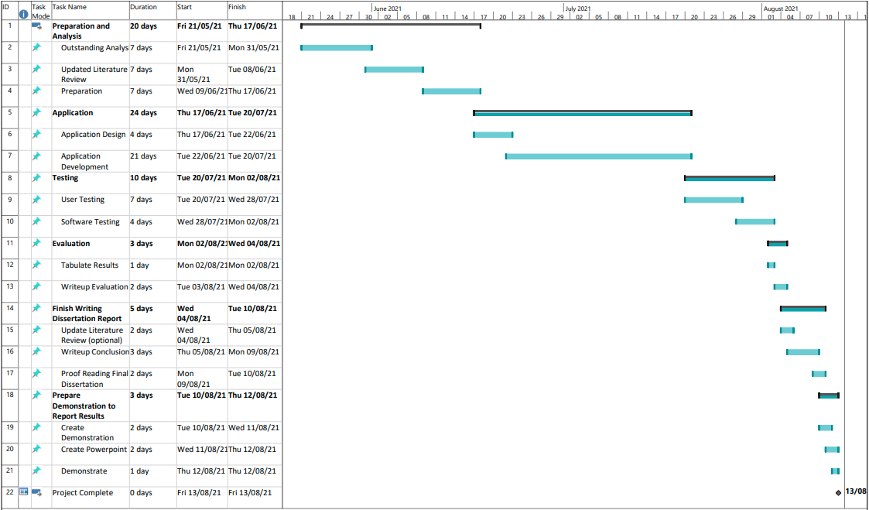

Figure - Gannt Project Chart

## Risk Analysis

Risk analysis is an important process to help identify and manage potential problems during a projects software development life cycle (SDLC). Risk analysis aims to avoid, minimize, and monitor risks and their associated impacts [94]. It is important to identify areas of risk, determine their likelihood and severity and discuss mitigation techniques for preventing or offsetting the impacts associated.

Table - Risk Analysis

|  |  |  |  |
| --- | --- | --- | --- |
| RISK | LIKELIHOOD | SEVERITY | MITIGATION |
| Unable to get enough user testers | High | Moderate | Qualitative approach for better quality data  Include self in user testing |
| Connectivity Issues – | Low | High | Set up own server if required. Adapt to infrastructure-based environment and limit area of use – i.e., implement BLE beacons |
| Unit of work takes longer than expected | Moderate | Moderate-High | Adjust project planning accordingly and start time-crunching  Follow a development methodology and allow for Minimum Viable product stages |
| User Survey inconclusive | High | Moderate | Demonstrate why inconclusive and extrapolate useful conclusion therein. |
| Repetitive Strain Injury (RSI) and Eye Strain | Low | High | Adjust workstation to promote good posture. Take regular breaks. |
| Insufficient QA and Testing time | Moderate | High | Adjust project planning |
| Injury/Illness during development affecting timeframe | Low-Moderate | High | Adjust project planning to suit personal workload that can be managed |

# Ethical Approval

## Components Requiring Ethical Approval

As this dissertation project contains an element of direct primary research gathering involving people in a user survey. It is important the project attains ethical approval in accordance with Wrexham Glyndŵr University’s Code of Practice on Ethical Standards [95]. The component requiring ethical approval directly involves people in a user testing survey. The ethical approval is important two-fold. Firstly, it guides the researcher to carefully consider the ethical implications of their research [96] and secondly, it ensures that participants of the research are given maximised benefit and minimised harm [97] – preferably none whatsoever.

Researchers carrying out user surveys will be obligated to main confidentiality and acquire informed consent [98]. Informed consent should invite the user to participate, inform the user of the research studies goal(s), name the researcher(s) (and funding if any), highlight any qualifiers required to undertake the study and let the user know it is voluntary [99]. Furthermore, qualifiers will likely include age restrictions due to the age of consent or will supply an enhanced level of informed consent with the underaged persons parent or guardian.

Confidentiality is associated the protection of user data acquired during the survey period. Data taken in should only be necessary to the research study, an anonymous survey would-be best-case scenario, however, if identifying information is taken in, it is the responsibility of the researchers to protect this information in accordance with “The Data Protection Act 2018” [100].

For this project, a user survey through ‘Google Forms’ will be sufficient to both inform consent, gather survey responses and safely store information gathered. Informed consent shall highlight the studies name, purpose, researcher’s information, and goals while highlighting the need for the respondent to be over 18 to participate. The user survey can be initiated from within the app after the user has progressed and is voluntary.

The user testing will likely cover only a few users, however, full consideration for current coronavirus regulations at the time of the testing period will be adhered to and other aspects of the app’s nature like user location will also adhere to the Data protection act and will only localise the user on the user’s device when in use and when not in use, that data will not be stored.

Table - Ethical Issues

|  |  |  |
| --- | --- | --- |
| Ethical Issues | Risks posed | Mitigation |
| Informed Consent | Consent may be given by minors or users without being properly informed | Inform user of study name, purpose, goal, researcher(s)  Inform user to be 18+ to participate |
| Confidentiality |  |  |
| * User Information and Data Handling | Information may include irrelevant, yet potentially harmful data | Ensure adherence to data protection, only take in data necessary to study |
| * User location | User information gathered during apps usage may prove useful to malicious actors | Ensure localisation only in use with user permission and when functionality requires |
| Coronavirus Regulations | No adherence to these regulations at this time may prove negative to user’s health | Adhere to current coronavirus regulations at time of user testing period |

## Action to Obtain Ethical Approval

To get Ethical Approval, an “Ethical approval of research projects in taught programmes” form will have to be completed and sent to the research supervisor. If the ethical issues are considered minor risks and the mitigation and risk analysis is well considered, either the research supervisor or module leader may be able to approve it. If not, then the project will be escalated to the universities research ethics committee, leeway is put into the planning and timelines for the project as there is a four-week gap between proposal submission and official start date for the dissertation. A pre-filled ethical approval form can be found in the appendix below for the dissertation project.

# Top-Level Design

Top-level design (or high-level) is an approach to software design that provides a system-wide view at an abstract level. This shows the major pieces of the finished artefact, how they fit together and interact with one another [101]. This process ensures the adequate planning process of the artefact so that the goals and aims of the product owner are reached.

## Architectural Design

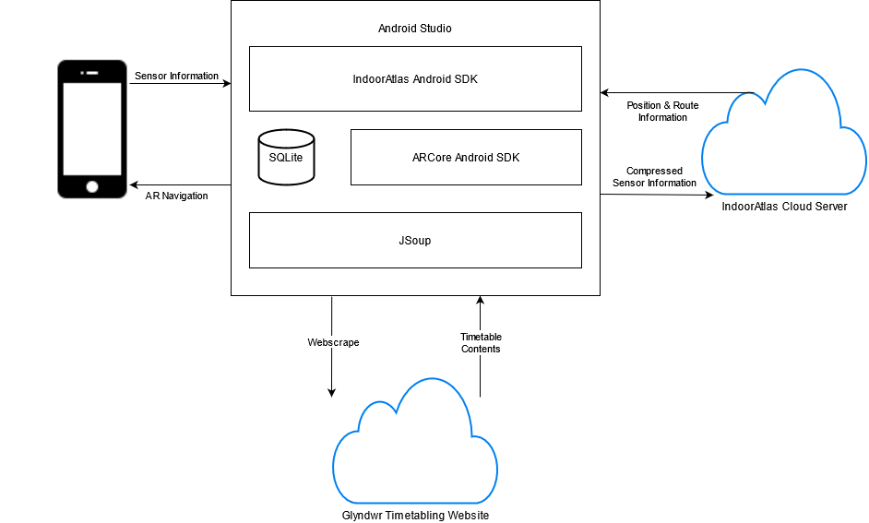The Timetable SatNav application is developed in Android Studio integrating the IndoorAtlas Android SDK [15], ARCore Android SDK [49], and JSoup [63]. SQLite local database is used to store both venue information and timetable content stored by the user.

Figure - Top Level Design of Architecture

IndoorAtlas SDK makes use of a fusion of Wi-Fi, magnetic field, and the device’s inertial sensors to provide indoor positioning information and to deliver pathfinding services. Once localization has happened, the device location will be added as a node to the pathfinding nodes and the route will be computed. For multi-floor navigation, the floor number of the current and destination nodes will be compared and a route using either stairs or lift will be computed. ARCore SDK is used to provide augmented reality guidance to the user to help them navigate to their destination. JSoup is used to scrape web content from Glyndwr’s timetabling website and format into a usable format for the user to select POI’s.

When the user initially loads the application, the timetable content will be dynamically scraped and prepared. When the user uses the application, they will search for their module, group or room which will bring up the timetables. Once a timetable is selected, the timetable contents and event details table will be populated, and the day and time fields used to configure and populate the tablelayout.

## User Interface Design

In an effort to maintain simplicity and intuitiveness for the interface. Only essential components will be displayed in an effort to display a minimalist approach which has proven to be a good form of design [102]. On load, the web-scraping will occur in the background, if this proves to be a timely process a small loading or initialising message will be given at the bottom of the screen being slightly greyed out. Once loaded, the user will be brought to a menu with three options; timetables, map, and survey. Only two of which lead to different activities as the survey will load an external link to google forms.

### Human-Computer Interaction and Accessibility

The priority for development is function over form to develop a proof-of-concept artefact, however, effort and thought should always be considered in design terms for Human-Computer Interaction (HCI) Issues such as dyslexia, visual impairment, or Irlen Syndrome to name but a few. To some extent, the latter AR functionality may prove helpful to some of these issues, however, this functionality falls into some of the last stages of Minimum Viable Product.

To overcome this risk, mitigation could cover design aspects of the rest of the apps interface to achieve some of these goals. Dyslexia affects between 15% of the general population and the general HCI issues arise from layout and fonts [103]. Some well-known fonts such as Arial, Calibri, and Verdana to name a few have proven to test well and are largely more understood by those affected with Dyslexia, other more specialised fonts like Open Dyslexic or Read Regular are not as well tested as they are not widespread and can look quite unusual [103]. To some developers, they may find it distracts from the overall design approach.

Google’s approach to typical android fonts since 2013 is the font Roboto [104], only later being supplemented by Google Sans [105]. The main characteristic of both – similar to Arial and Calibri mentioned above – are that they belong to the sans-serif font family and are clearer and more spread apart between letters. The second element affecting dyslexia – layout – affects users where large areas of the UI is devoted to text [103]. Simply breaking these elements up is aspects like cards, dialogs or showing only relevant information to the user can aid in this approach. Furthermore, when developers approach layout, they should aim to be consistent. Moving navigation buttons around and having multiple routes for navigating to an area of the app can confuse and exacerbate user difficulties [106].

Other HCI issues arising from Irlen’s syndrome, visual impairments and hearing issues are much more difficult to ease and the burden of good design has been eased for app developers through OS tools such as screen-readers like Google’s talkback [107], Colour overlay tools like Irlen’s app [108].

If development does reach the latter stages of MVP which includes augmented reality, then accessibility can be seen to be drastically improved. AR has been shown in research to aid people with visual impairments as typically complex or confusing UI elements can be more straightforward in an AR environment [52] [56] [57].

### Android Activities

For this application, there need only be four activities and a dialog box for user interface components. The first, a main menu will allow simple app-wide navigation and cover the potentially noticeable load time for scraping web content dynamically. From the main menu, the user can select either the timetables activity, map activity, or a link to the user survey which links externally to google forms. The dialog box can be found on the second activity – timetables – such that the user can see detailed information on a module/class and choose to navigate by it or close it and continue browsing.

### Storyboards/UI Wireframes

**Main Menu Activity**

As mentioned above, if scrape times are slow due to poor internet connection, a small loading description will appear greyed out while its running. This should be done using an AlertDialog.

The main menu will follow the minimalist principle with three options directing the user to two activities or an external survey and the image and title will help break up the monotony and boost the style to a satisfactory level associated with proof of concept.

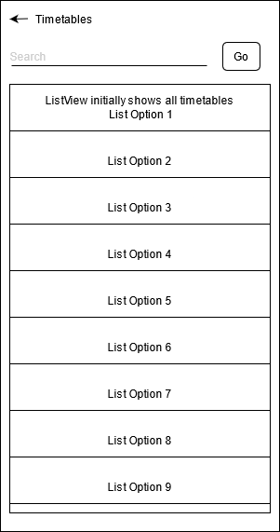

Figure - Main Menu Wireframe

**Timetable Search/List Activity**

Initially, this activity will show all timetabled content within its listview for the user to browse at will. Only those timetables that are within the navigation scope will be displayed.

Upon entering a search item and selecting go, the list view will update to show search results. Once the user is ready to select a search item, the list option can be clicked to open a dialog box with the timetable content as shown below.

Figure - Timetables Activity Wireframe Diagram

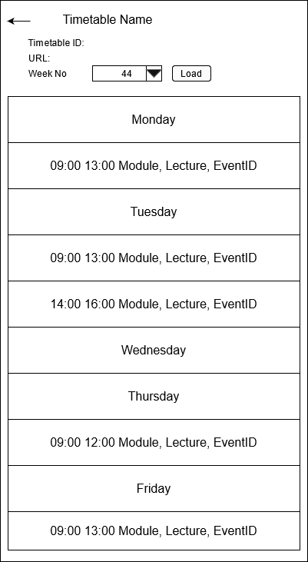**Timetable POI Selection Activity**

In this activity, realisation had occurred that due to the pandemic, the majority of Modules and Groups have been assigned as online lectures and as such have no room allocated to navigate too. This means that a check will have to be carried out when loading and formatting for a room allocation and if no room is linked a dialog box should pop up to alert the user this cannot be navigated to. There are timetabled rooms still, but navigable rooms are far lessened.

Also, because the landscape nature of the timetable it will have to be rearranged to suit the portrait aspects of smartphones. That or perhaps foregoing the table altogether and simply listing the modules, time, and date in order as most groups have only a few days within a week. Likewise, some weeks are induction weeks so the design could just show the current week at a given time.

If the table is a tablelayout and each cell that is populated by a timetable has an onclick listener, a dialog box can be opened to show further information and allow access to navigation.

Figure - Timetable Contents Activity Wireframe

**Timetable Contents Dialog Box**

Following the simple minimalist approach, the dialog box will open upon clicking a populated cell on the tablelayout of the previous activity and display further information and allow the user to navigate which in turn passes the POI variable through to the map activity or close the dialog and go back.

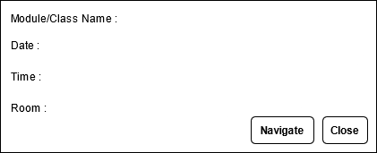

Figure - Timetable POI Dialog Box

**Timetable Info Dialog**

The timetable info dialog is shown on Figure 7. This dialog is accessed from the timetables activity through a list item click listener which then opens the dialog. The purpose of this dialog is to show further timetable information so that the user can better decide whether to choose to open it or go back and select another timetable.

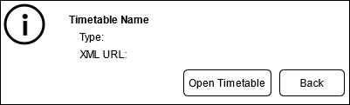

Figure - Timetable Info Dialog

**Map Activity**

In the first sprint, the map activity should be similar to this in showing a 2D top-down version of the floor plan with POIs, and the user location on that section of map. Routes will be in the form of a line following corridors and stairs to destinations ending in an arrow to indicate destination.

Should a later stage of development be reached then the devices viewpoint and AR will be used with navigation overlaid as AR objects. The user can see the destination below, change between 2D and AR and stop navigation. Navigation can also be initiated by choosing a POI from the map and could provide a useful comparison to survey from users on their preference.

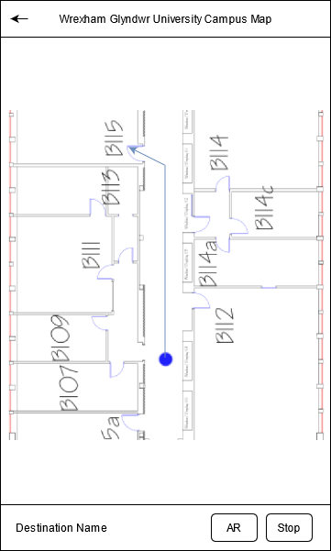

Figure - Maps Activity Wireframe Diagram

**Sitemap**

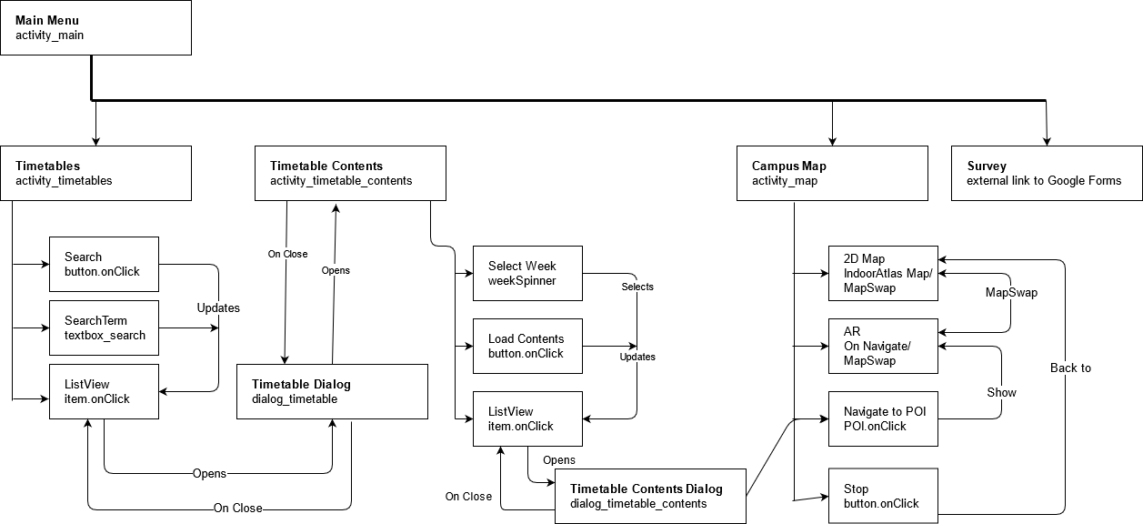

Figure - App Sitemap

In Figure 9, the layout for the overall app’s user interface can be seen. This shows the logical navigation between areas of the app. Initially, the user loads into the main menu as described in Figure 3, here they have the choice of navigating to two activities – Timetables and Campus Map – or to an external link to Google Forms for a user survey. In timetables (Figure 4), the user can view the list of all timetables, insert and select a search term to update that listview of tables and click a list item to open the timetables dialog (Figure 7) which displays timetable information and allows the user to open the Timetable Contents Activity as seen in Figure 5.

From here, table contents will be shown on a week-by-week basis with a week selection spinner and a load button to update the list, upon clicking an event list item a dialog will appear as shown in Figure 6. This dialog will show all the relevant information such as start time, end time, module, whether it is room-allocated and allow the user to navigate to it, this option takes the room name if any as a variable to the Map activity to initiate navigation. If it is not room allocated, no such navigation button will be displayed.

The Map activity can either be accessed from timetables or directly from the main menu from user input. This activity is described in Figure 8 and shows a 2D version of the map. If the user is coming from timetables, the destination name and route is displayed and simply needs the user to press start to initiate navigation. If the user accesses the map from the menu, they have the option of selecting rooms at will to navigate to. Once navigating, the user can swap between map modes from 2D to AR and vice versa, they can also stop navigation to return to the map. Stopping navigation when accessed from timetables will not return the user to that timetable.

### Database Design and Data Flow Diagram

For this application, data will be stored in two separate locations; locally on the phone and on IndoorAtlas Server. No design is necessary for the latter as it is already created and optimised through the use of the IA web tool and SDK. In addition, to maintain privacy, location data is only stored while the service is in use and clears after operation.

The former aspect of database has to be designed ahead of implementation to ensure all the necessary data required for the timetable functionality is catered for. This encompasses two database tables developed in SQLite 3 [81]. This publicly available lightweight database engine is self-contained, serverless, requires no configuration and is a transactional SQL database engine [81]. The two database tables include a Timetable records table for initially listing timetables on the Listview and providing search functionality, while the latter table deals with timetable contents such as includes week numbers, timetable ID and event information as weeks are not all identical as open days, induction weeks, multiple semesters and term breaks are included throughout [109]. 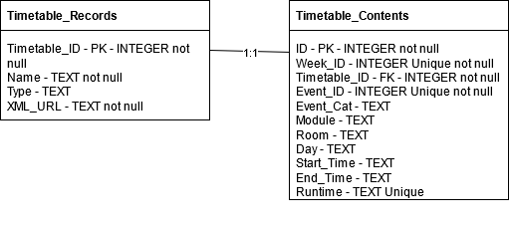

Figure - Database Tables Design

For the records table, each record will be assigned an ID from the table which is automatically auto-increment which is the primary key, the name and URL where the XML can be found are not null, so functionality will not break.

The timetable contents table will only be populated with one timetable record at a time. Similarly, to the records table, it has an automatically assigned auto-increment ID. A Unique constraint on the table will include 3 fields; ‘Week_ID’, ‘Event_ID’ and “Runtime” to ensure no duplicate event records are being populated. On conflict, this constraint will ignore the row i.e., a duplicate row being scraped will simply be ignored and not committed to the database. Furthermore, the contents table will have four not nulls, all on ID’s. 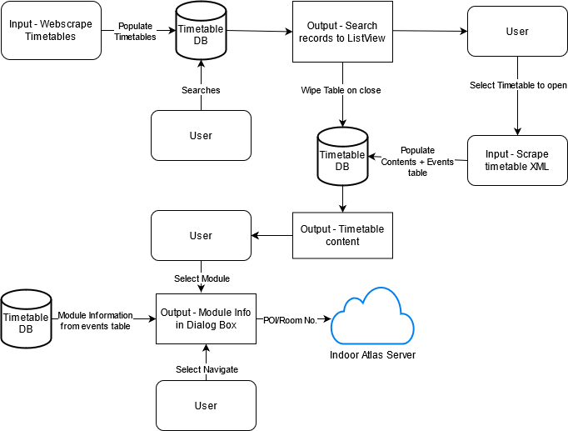

Figure - Data Flow Diagram

Figure 11 diagrammatically describes the flow of data within the application where development is concerned. There are two data stores; the local timetable database in SQLite 3 and the external cloud server managed by IndoorAtlas. There are also two major inputs for data; web-scraping all timetables brief information and web-scraping a single timetables content when chosen.

For inputs, there are three major outputs to display data and allow interaction; Displaying timetables in a listview on the timetables activity, displaying brief timetable content within the contents activity and displaying full and relevant module/event information in the timetable dialog box. Areas of data flow include specified table CRUD operations and passing Room number as data to the IndoorAtlas server for use in navigation.

## SCRUM

The SCRUM Methodology has three main phases that align with app development which include; Pre-Game Phase (Planning), Game Phase (Development) and Post-Game Phase (Closure). For this project, it aligns with design, planning, development, and testing. The Pre-Game Phase encompasses planning and design. For the planning, the development team, product owner and scrum master each have to list all the features of the end product and compile it into what is known as the Product Backlog.

In this project, the developer will assume the role of both scrum master and development team whilst the supervisor provides some aspect of product owner. The Product Backlog is necessary as a reference sheet for planning later Sprints and ensuring aims and objectives are reached by the end of the SCRUM lifespan [110]. The Product Backlog shows a list of the applications end objectives from the perspectives of the end user via “User Stories”, an estimation of development time and its priority for the end user.

### Product Backlog

Table - Product Backlog User Stories

|  |  |  |
| --- | --- | --- |
| User Story | Estimation | Priority |
| As a user I want to search for a specific timetable | 1 | 1 |
| As a user I want to see timetables listed | 1 | 1 |
| As a user I want to know my location on the map | 3 | 1 |
| As a user I want to see the map | 2 | 1 |
| As a user I want to select my destination through timetables | 2 | 1 |
| As a user I want to navigate to a POI | 3 | 2 |
| As a user I want an accessible form of navigation and direction to my POI (AR) | 5 | 3 |
| As a user I want to navigate to a POI I have selected from a timetable | 3 | 2 |
| As a user I want to see the timetable I have selected | 2 | 1 |
| As a user I want accessibility options while navigating | 3 | 3 |
| As an administrator I want a tool for users to submit feedback | 1 | 4 |
| Total | **26** |  |

### Sprint Planning

As planned in the project Gantt chart, allowance for development time is between three to four weeks and leeway is built into the schedule to allow for overtime in development. This provides time enough for two to three short development sprints, each with an aim to reach a level of minimum viable product and as such achieve a proof-of-concept artefact at the least. Based off of the product backlog, the sprints can be initially planned to meet those stages laid out in the methodology above. For Sprint planning, a software called JIRA [111] can be used to great effect.

This tool is designed for solo developers and teams to work through the SCRUM and Kanban methodologies very closely and track work and progress throughout a project lifecycle. This project will use JIRA to plan and execute three sprints, these sprints have user story aims tied to them with which a development team can plan features, steps and tasks that will be necessary to undergo the sprint [79].

Sprint 1 – Timetables, User Location, 2D Map and POIs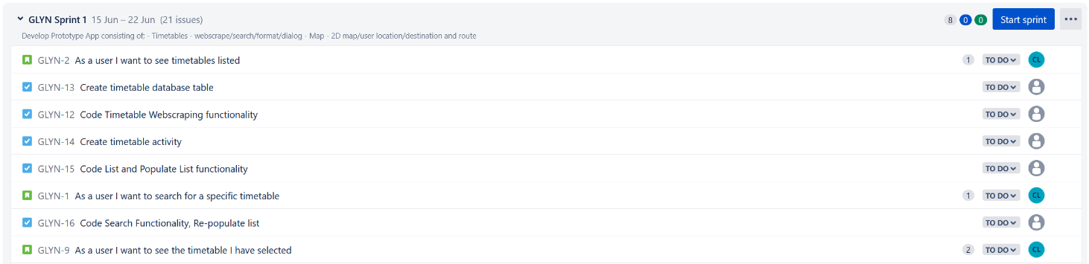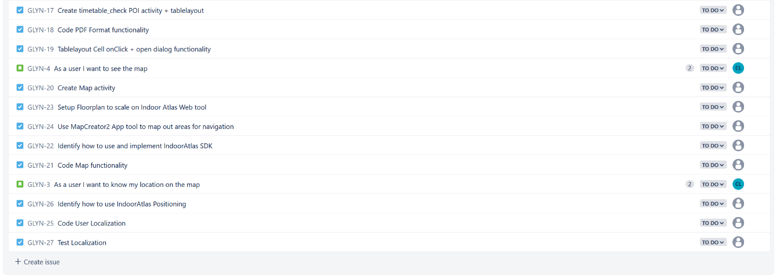

Figure - Sprint 1 Plan

Sprint 2 – Pathfinding to POI’s using timetable wayfinding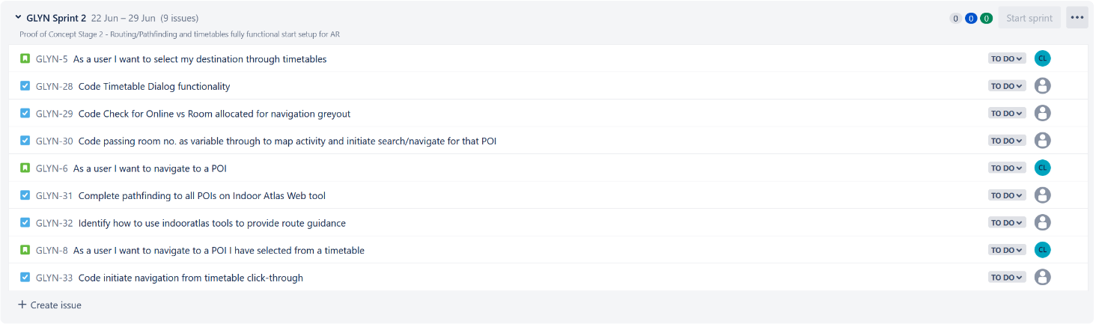

Figure - Sprint 2 Plan

Sprint 3 – AR Navigation and Accessibility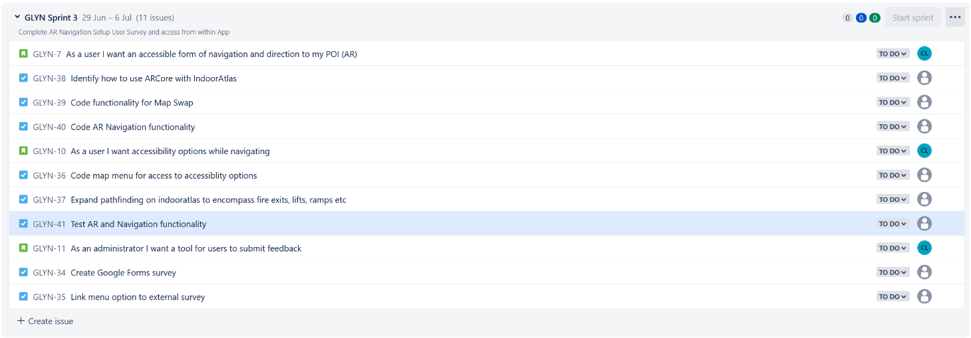

Figure - Sprint 3 Plan

## Program Logic - Jackson Structured Programming

Jackson Structured Programming (JSP) diagrams are used to create representations of solutions in a useful to communicate format. These diagrams communicate the program logic behind various operations and procedures in the software design of a given solution [112].

JSP is not concerned with the specifics of programming language nor implementation of a solution but rather, a language independent view of the system that expresses logic and flow of the developed solution. This ensures in the early instances of design that future problems in the logic can be discovered and rectified early rather than fixing them during the coding process [112].

Jackson Structured Programming (JSP) diagrams are made up of rectangles that represent a process in a given class [113]. This could be anything from initialisation to core processes to finishing and tidying up before finishing use with the class. These diagrammatic forms of programming representation provide a programming language-independent approach to describing logic which can improve design approaches to software development [113].

JSP uses lines between these boxes to show hierarchy like a class would with overall class, methods, and code [114]. The order from left to right demonstrates sequence of events, selection is shown by boxes with circles which can be derived from conditional statements and iteration can be shown by use of an asterisk with its condition (if any) shown to the asterisks top right [114]. Doing JSP diagrams for each of the classes allows a black box view of the system as a whole when viewing the main diagrams as complicated classes can simply be represented as their class name provided the class JSP diagram is separately given [113].

**OpenDatabase Logic**

This class deals primarily with the processes associated with the SQLite database tables. Here the database is initialised, cursors are used for direct raw queries to the database using SQL within the JAVA code of the class to carry out CRUD operations. The first process Search queries the database and returns the users search results to the ListView of the timetable activity. The next three processes are concerned with populating web-scraped timetables on load, populating xml-scraped timetable information and event details when selected from the ListView to the dialog box in Figure 7 and when selected from dialog box to the POI in Figure 5 respectively. The last process clears these tables when they are no longer in use.

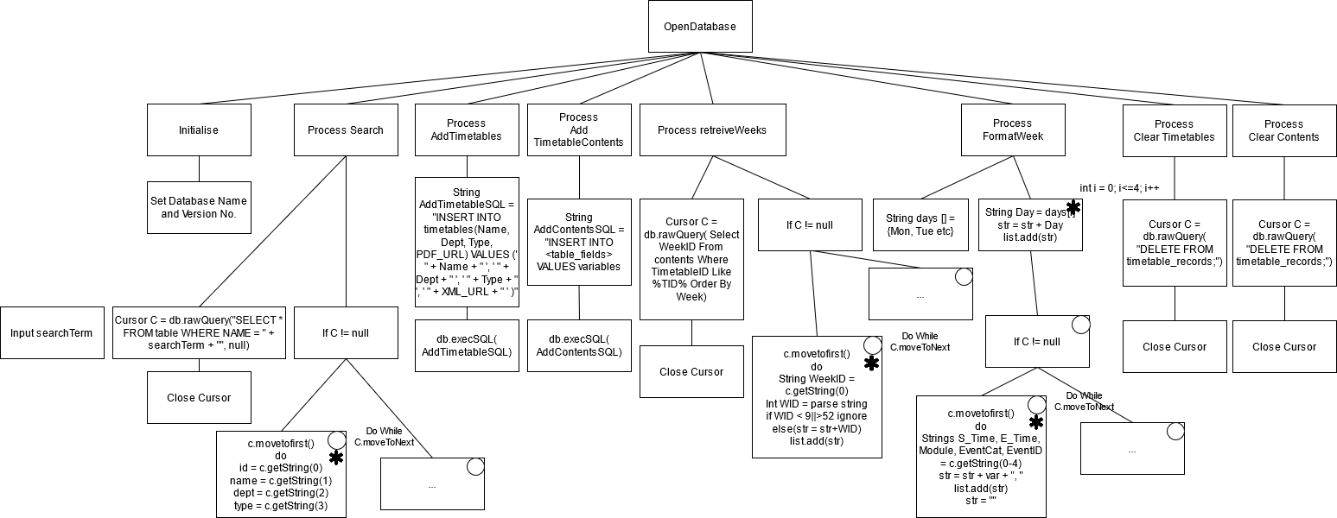

Figure - OpenDatabase JSP Diagram

**Timetables Web Scrape**

As redesigns have been made with regards to the database and tables. Web-scraping will now occur twice in the programs logic. The first initially to load timetables and various attributes tied to them which is described below diagrammatically using JSP and the second further below. The latter scraping process is needed to scrape timetable contents, this will be done by concatenating the original website being scraped with the XML URL for that timetable and using JSoup’s XML scraping to collect and collate the timetable data. 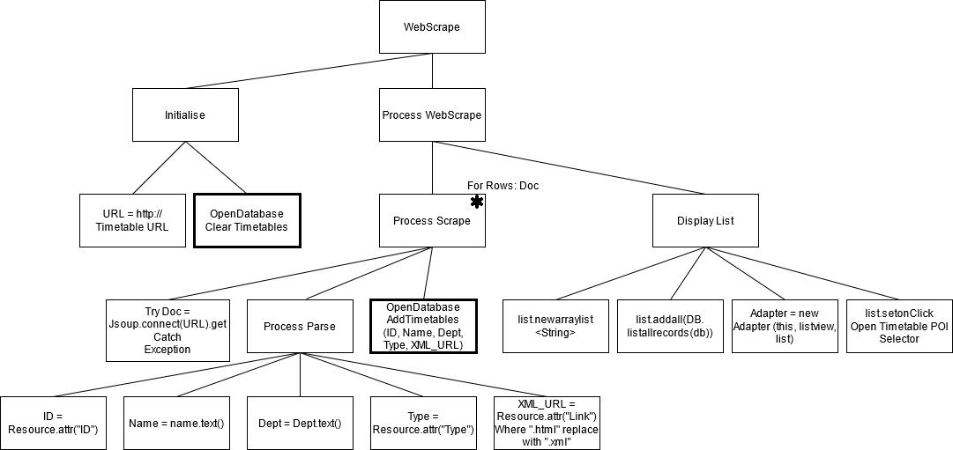

Figure - Timetable Web Scrape JSP Diagram

**Web Scrape Contents**

This web scraping is similar in functionality to the first in many ways, however, distinct differences such as taking timetable id from within the class after its been passed on from the timetables activity and dealing with more than three times as many fields make it look very complex. For that reason, Figure 17 shows a condensed version with due consideration for logic design still present. Notice that both room and module fields are different due to the tags being nested on the original site, in JSoup this is simply a matter of selecting the tag similar to the given select bracket and then selecting the tag within that by appending another ‘.select()’ on the end.

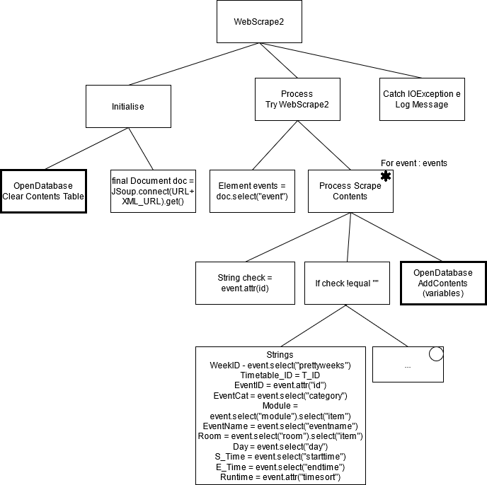

Figure - Timetable Contents Web Scrape JSP Diagram

**Main Menu Activity**

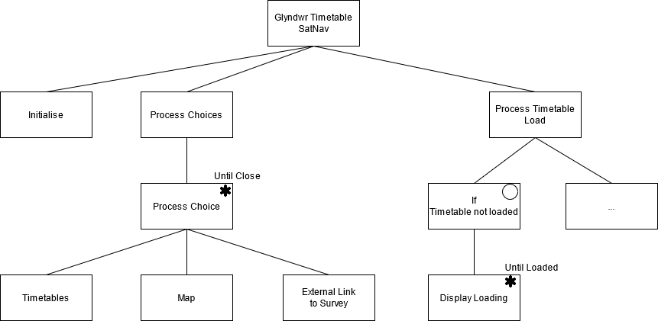

Figure - Main Menu JSP Diagram

**Timetable Activity**

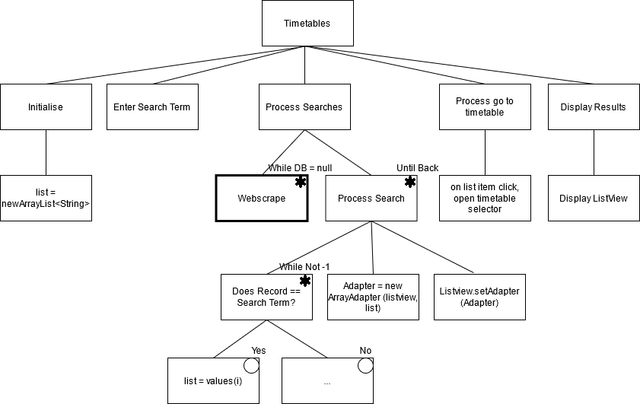

Figure - Timetable Activity JSP Diagram

The timetable activity builds in a check with a conditional statement to web scrape timetable data in the case of the timetable database being empty for any reason. There is also a conditional statement on the search procedure that checks if there is a result and display them in the refreshed list, if not the list comes back empty. The list is initially populated with all records and the user can select any item whether initially or after search results are displayed to navigate through to the Timetable Contents activity.

**Timetable Contents Selector**

In this activity, the intention is to use a tablelayout to display the timetable contents for a given week. To do this, data from the tables will be taken into an arraylist and programmatically added to rows using a loop. Further testing and experimentation are needed on how to do this effectively to create an intuitive UI that is not clunky. Each row shows a module/event in order from Monday to Friday. Each item can be clicked by the user to open a dialog that will either inform the user it is not navigable (i.e., Online Lecture) or allow further navigation.

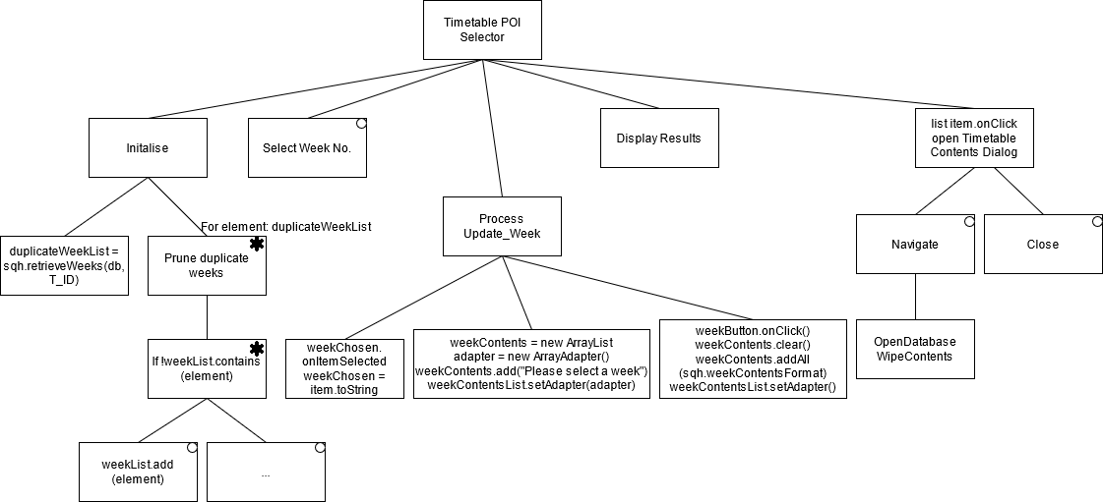

Figure - Timetable Contents Selector JSP Diagram

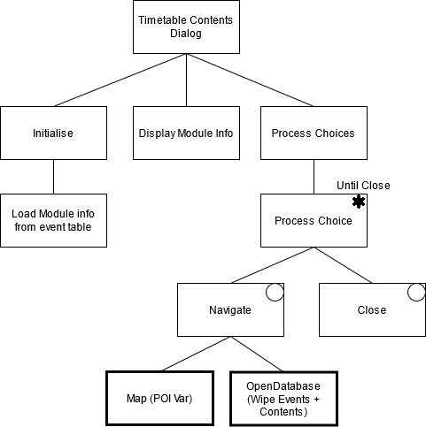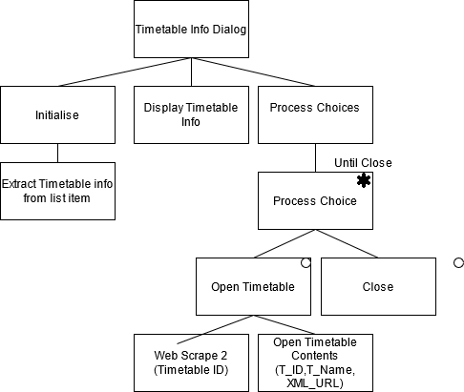**Timetable Contents Dialog and Timetable Info Dialog**

Figure - Timetable Info Dialog JSP Diagram

Figure - Timetable Contents Dialog JSP Diagram

**Map Activity** 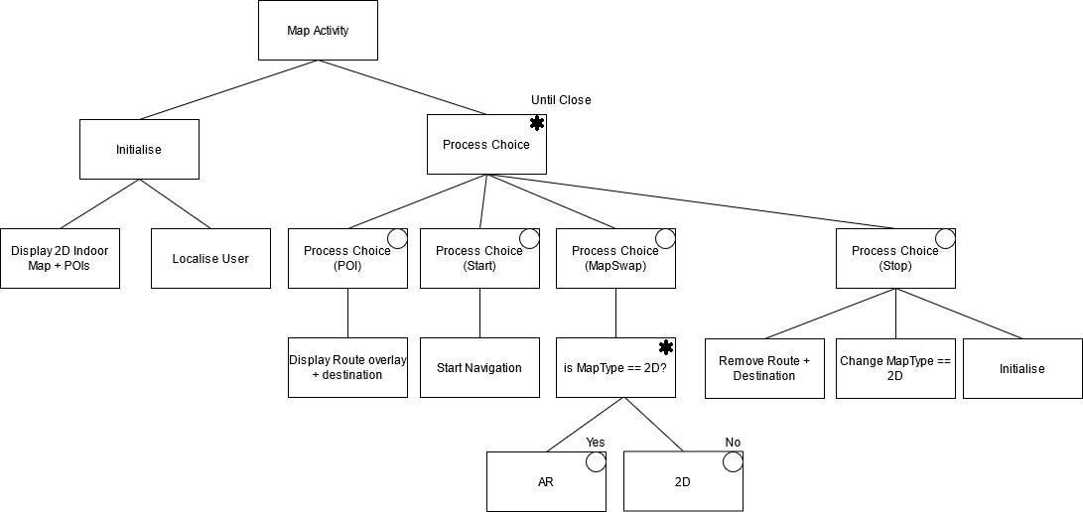

Figure - Map JSP Diagram

The Map activity is by far the most complex element of the project to implement and depending on how far in development and MVP the sprints help achieve. Design will be revisited to develop aspects such as AR and changing map type.

This activity has four main options to the user. Firstly, if the user has not used the timetables to navigate, they can instead navigate by selecting a POI from the map. This will display an overlayed route and show the destination below. As soon as the user presses start, the navigation will take place with periodical updates for location to keep localization updated.

The user can choose to stop navigation regardless of whether it started from timetables or the map, however, stopping after timetables will not return the user to the contents. If further MVP stages are reached later in development such as AR, ‘MapSwap’ could be implemented to allow the user to switch between different navigation modes to suit their preference.

## Test Design

Software Development and Engineering uses test design to derive and specify test cases to conditions to test software and compares ‘what it is’ with ‘what it ought to be’ [115]. A test condition is a statement about which the test object must pass to be verified, whether that condition be functions, feature, transaction, quality, or structural aspects. The IEEE standard 610.12-1990 defines testing as a “process of operating a system or component under specified conditions, observing and recording results” in order to make an evaluation of that test object [116].

There are infinitely many ways a test object could theoretically be tested and as such good test design requires planning to ensure a small subset of tests that are well chosen to verify these elements or highlight bugs can be ran within a given timeframe [117]. This ensures testing does not overrun schedule and that appropriate tests are ran [115].

Well-designed test cases cover three main aspects; Inputs, Outputs and Order of Execution [115]. Inputs cover anything ranging from system inputs and interfacing systems to data read from a file or database. In this project, that may cover web-scraping components and user input. Outputs can be thought of as data displayed to the user and outputted data sent to external components [115]. Outputs to consider in this design include the listview, timetable contents and dialog.

Lastly the order of execution covers two types of test case; Cascading – similar to integrated tests where components depend on one another – and Independent which is similar to unit tests in that they are fully self-contained [115]. The former has the advantage of typically being small and simple but very much depends on any of the components not failing otherwise that fail would cascade. The latter’s advantage allows for any quantity of tests in no particular order to be executed at the expense of being larger, more complex, and difficult to design, create and maintain [115].

Testing usually falls into one of two categories: black-box and white-box testing [115]. Black box is solely concerned with the requirements and specification requiring no knowledge of internal structure, path, or implementation of the software during the test. The latter is polar opposite in its consideration of testing those specific elements during testing [115].

Four of the most common types of tests include Unit, Integration, System and Acceptance Testing [115]. Unit testing involves breaking down the software to the smallest pieces – each known as units. In Java, this could be construed as a unit being a class or in android a unit being a feature [115]. Integration testing assembles all such units in system and sub-systems, this may highlight areas where units pass in isolation but fail when multiple are integrated [115]. A system may represent the whole app and sub-system represent an activity.

System Testing encompasses testing the whole system inclusive of; software, hardware, user documentation, training materials and other aspects that may encompass the entire product being delivered. Acceptance Testing is defined against product owner and user expectation with the pass condition being that of the user accepting the software and the product being marketable [115].

### Software Test Plans

For this project, it is important for the hypothesis to determine if the application is feasible for real world usage. To ensure testing is adequate, two to three tests from the black-box type of the testing strategies and one for the white-box should be chosen at the minimum to ensure a rounded view of the system and its issues.

**Test Plan 1-3** - Black Box Testing – Equivalence, Decision Tables and Use Case

Black box testing is based off requirements for the product without knowledge of internal structure. Here the first test plan should aim to approach the product from a user perspective, using both valid and invalid inputs for timetables and map activities. A successful test will show incorrect inputs are detected and handled properly and expected outputs for tested inputs shall be determined beforehand and compared upon test completion.

Black box can be implemented at all levels of development – unit, integration, system, and acceptance [115]. A type of black box test – equivalence – can be used on the search feature within the timetable activity to verify functionality.

Equivalence takes any value from within a range – if there are issues with that one then there will be issues with all values in that given range as they have equivalence. Take the search feature for example, there are timetabled rooms, groups, and modules. If the user searches for “group” and the search fails, then all group timetables also fail to list as results.

Another black box test – decision tables – can be used to ensure the check on allocated and non-allocated rooms is correctly functioning and that only timetabled rooms can be navigated to. Decision tables layout specific input conditions and actions are the processes that should be executed depending on the various combinations that result in the execution [115]. This can be demonstrated on a timetable with blended learning – having the same inputs to reach the Module Info dialog as seen in Figure 6 but non allocated results will show a alert message that it is not navigable whilst a allocated room will not.

Both equivalence and decision tables deal with system components and not as a system wide test. Use Case Testing is a black box test exercise’s the systems functionalities from start to finish by testing each individual aspect in succession thus integrating all the units involved [115]. It is called Use Case as it is similar to how an end user may take the product and use its functionality.

Two Use cases are immediately evident for this project: navigating using a module/event from a selected timetable and navigating to a POI from the map activity. Unified Modelling Language (UML) can be used to design use case diagrams. The use case allows the tester to select input data but follows a created test case for the main success scenario and one for each extension [115].

**Test Plan 4** – White-box testing – Data Flow Testing

Data flow testing is a useful tool to detecting errors. By making use of console prints and try/catch exceptions through a program’s logic, a developer can at stages verify that values, variables, and conditional statements are correctly being executed through use [115].

Luckily, Android Studio allows developers access to the console while the application is running on the emulator. This allows live code to print statements indicating success or failure whilst undertaking decision and use case test cases.

Data flow can be implemented throughout the database loading functionality from web-scraping and populating timetables, web-scraping and populating content tables, deleting table data, correct navigation through the app and proper functionality with navigation. Navigation itself will solely be reliant on black box testing and user surveys as emulators cannot mimic the real-world usage of navigating within the university.

A test plan for this project can be found in the appendix and is later documented in the Testing chapter and has been developed following a decent sample test plan document [118].

## Survey Design

The purpose of the survey is on helping to resolve the research questions associated with the project. In Chapter 3.2, those questions were concerned with the method of indoor positioning system from the users perspective and the usefulness of timetables as an effective method of navigation. The survey can also initially support the main research hypothesis by asking whether the user found it functional or whether there were any issues they found to submit in long answer form.

Since then, Indoor Atlas has been chosen as the solution to the former implementation and as such the research question should more appropriately be: 1. Is a fusion of Wi-Fi, Magnetic Field, and Inertial sensors viable enough for indoor navigation? This is akin to the user being intimate with the artefacts inner workings though so questions aimed to this should be quantitative and be related to the users perspective of it.

This can be done by directly asking on a five-point Likert scale.

* how accurate was the user location?
* how accurate was the navigation?
* Did you find the timetable functionality easy to use?

A more direct yes or no question could be asked of preference over navigating via map or timetables and a small series of statements asking how strongly the user agrees or disagrees on these areas below in four-point Likert will further the results. These statements are similar to a survey undertaken when developing an AR based indoor navigation system [30]. The inclusion of a control can helps show improvement if any in successfully navigating the university.

* I have difficulty navigating Glyndwr University without navigational assistance (control)
* I could easily find my way to a destination using the app
* The app is helpful in guiding me to my destination

Finally, the user survey will end on two questions – one quantitative five-point Likert scale and the other qualitative – on usability of the app. The first question will ask whether the user finds the app useful and the second will take in a long answer and asks the user what improvements they think can be made to the app.

In the appendix, the final survey design and later the anonymised results from the survey can be found.

# Development

Stage 2 – Game Phase

This is where the actual development work is accomplished. Each task assigned is started and the aim is to complete it to its “done” definition by sprint end. The first stage is to develop the first sprint backlog and then start development, testing, and documenting changes [119].

## Sprint One – App Prototype

Sprint 1 is being altered to include sprint 2 and run for a longer period to ensure a full prototype MVP is delivered after first sprint. This sprint will include full 2D map functionality and navigation as well as full timetable web-scraping functionality and timetable/module selection.

### Adjusted Sprint Backlog

Table - Sprint One Backlog Adjusted

|  |  |  |
| --- | --- | --- |
| Sprint 1 Backlog - 22nd June 2021 – 6th Jul | Estimation | Priority |
| As a user I want to see the map  (*Delayed due to COVID-19 – see* Sprint One Retrospection) | 8 | 1 |
| * Create Map activity |  |  |
| * Setup Floorplan using IA web tool |  |  |
| * Use MapCreator2 tool to map signal for areas |  |  |
| * Identify how to use IA SDK |  |  |
| * Implement Map functionality |  |  |
| * User Location functionality |  |  |
| * Routing and Pathing Functionality |  |  |
| * Test Localization and Pathing |  |  |
| As a user I want to see timetables listed and search | 3 | 1 |
| * Create Timetable database tables |  |  |
| * Create Timetable List activity |  |  |
| * Code Timetable Web-Scraping Functionality |  |  |
| * Code OpenDatabase Functionality |  |  |
| * Code List Search and Populate |  |  |
| As a user I want to see the timetable I have selected | 5 | 1 |
| * Create Timetable Contents Activity |  |  |
| * Code Timetable Contents Web-Scraping Activity |  |  |
| * Code Weeks Spinner |  |  |
| * Code Tablelayout populate with weeks contents |  |  |
| As a user, I want to select a module/event and navigate | 5 | 2 |
| * Create Module Dialog |  |  |
| * Code populates info from module table |  |  |
| * Close Button |  |  |
| * Navigate Button |  |  |
| * Code Room allocated Check |  |  |
| * Send Room No. as POI to Map activity |  |  |

Table 4 shows an adjusted sprint backlog for the first sprint in two aspects; firstly, the sprint takes two weeks to complete a first prototype and secondly, the sprint borrows both user stories of navigation either through the Map or through timetables. This alteration is necessary due to the design period taking longer than expected and for the timeframe left for project delivery, two sprints make far more sense than three as more can be done whilst still allowing for retrospective meetings and allowance for solving issues.

### Sprint One Development Documentation

Preparation

To use IndoorAtlas correctly, the floorplans for the university need to be adjusted and correctly configured for later mapping. This involves taking the existing floorplans provided in PDF Format, extracting the images to Paint3D in its raw form (highest quality). From here, room names were removed as they would later be added as POIs through Indoor Atlas web tool. Areas out of the scope of navigation or rooms that are allocated only to staff have been greyed out but kept in.

Figure 24 - Ground Floor Floorplan adjusted shows the ground level floorplan of the Plas Coch Campus. This floorplan is larger than the other due to the William Aston Hall and C Block being larger on ground level. Timetabled rooms will be along B Corridor and C corridor with stairs and lifts dotted throughout.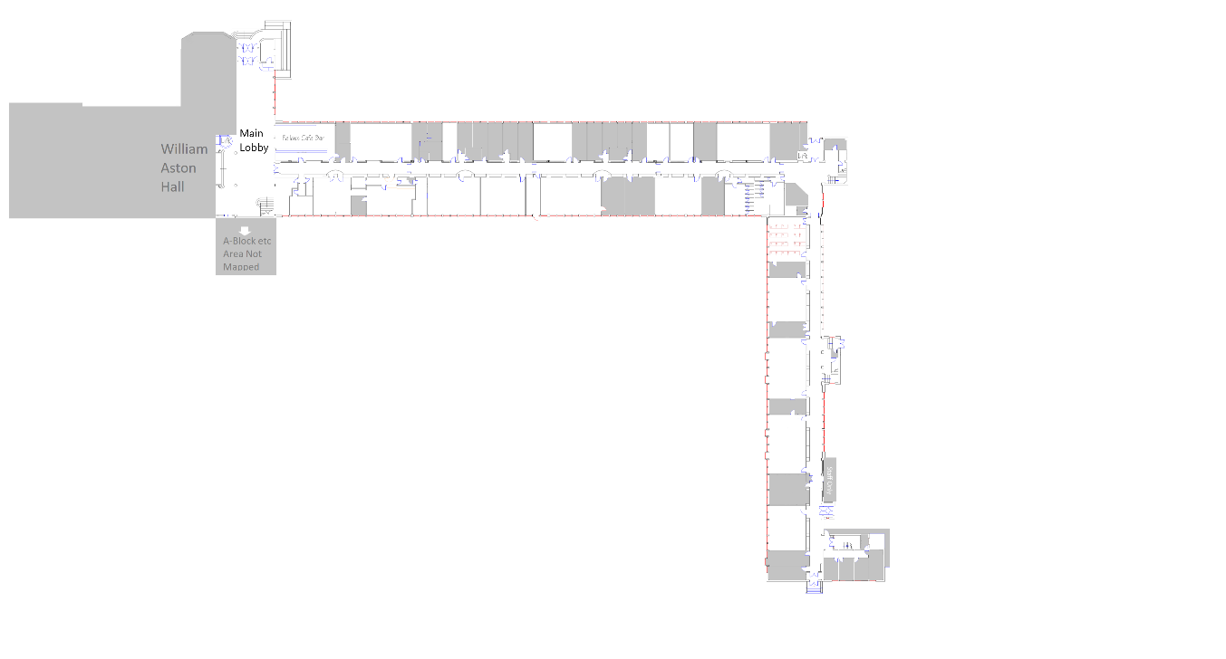

Figure - Ground Floor Floorplan adjusted

Figure 25 shows the first floor of the campus and likewise has timetabled rooms on B corridor and C corridor. As the University’s ‘Campus 2025’ scheme has begun to start [120], some rooms no longer exist or have been converted into study areas. Luckily, these changes thus far are not structural, and the existing floorplans provided are sufficient to provide a good navigation experience to the intended audience.

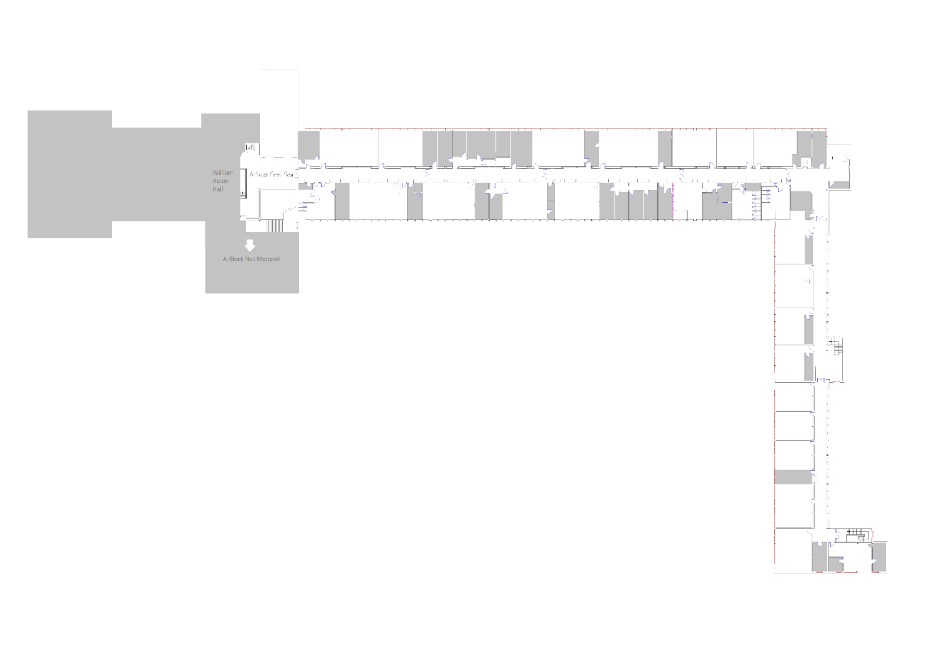

Figure - First Floor Floorplan

#### Mapping

Using IA Webtool as seen in Figure 26, the floorplans can be uploaded and aligned in two ways – manual alignment and coordinate alignment [58]. Here the floor number and accompanying info can be inputted as well as altitude (if known, otherwise a default of 5.4m is used).

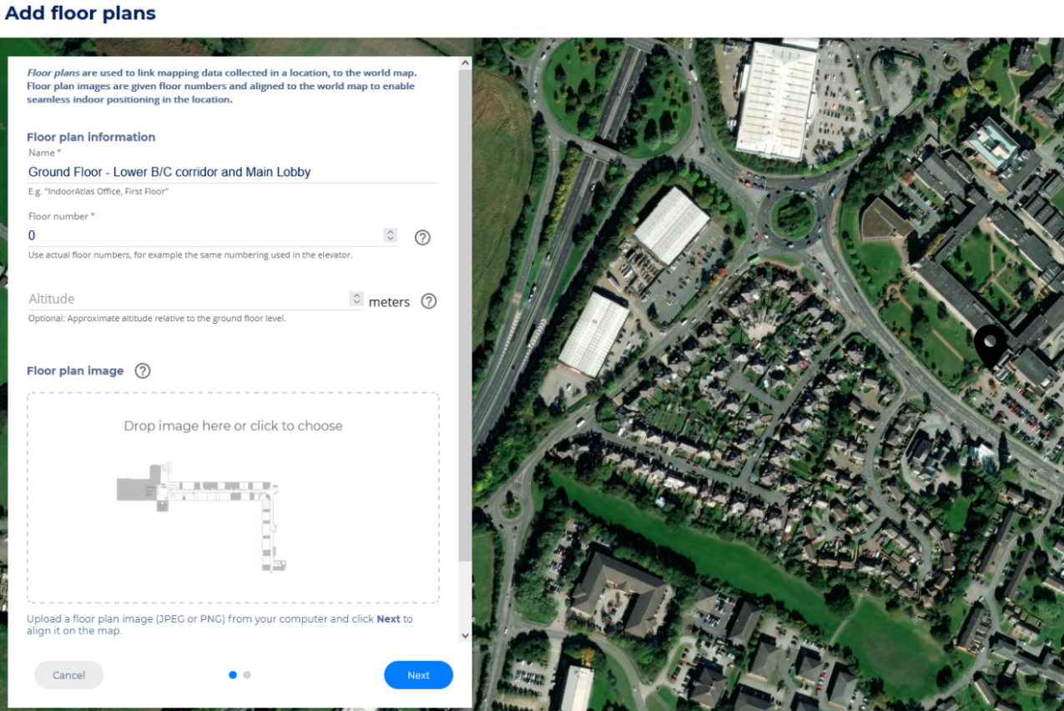

Figure - Uploading floorplan using IA Webtool

Once aligned and uploaded, the floorplan needs waypoints added for the mapping sequence to be carried out. Waypoints should be in distinct locations within ten to twenty metres of one another around the whole area to be mapped [58]. The floorplan for the university can help aid this as display boxes and window pillars are at exact intervals along the majority of corridors to be mapped. Greater quantities of accurate waypoints improve mapping measurement potential and thus the overall positioning system can be quite accurate.

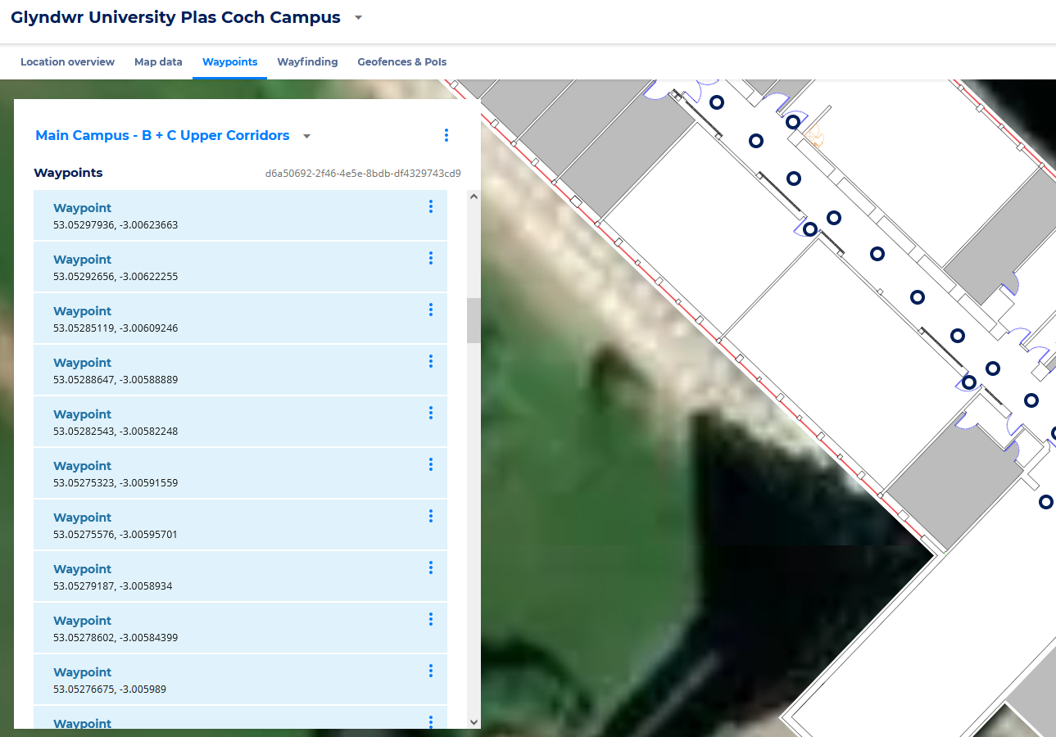

Figure - IA Webtool Waypoints

Once waypoints are selected, IA’s MapCreator2 app can be used to make recordings of navigating between these points. The more recordings saved to IAs cloud server, the more accurate a heatmap for magnetic and Wi-Fi AP signals there are which in turn improves the IPS system [58].

For the best capable IPS setup using Indoor Atlas, the developer should not only set up waypoints at regular intervals in distinct areas, a distance of between five and twenty metres between general waypoints should be used [58] otherwise incorrect waypoint tracking or errors could be expected if waypoints are too close or if too far away intrinsic drift in IMU sensors starts to affect accuracy. Indoor Atlas MapCreator2 tool and web tool both have a handy feature which shows the developer(s) the quality of map generated from the recorded paths for each associated sensor type [58]; in this case, the figures below show the quality of both magnetic field coverage and quality recordings and Wi-Fi coverage and quality recordings for both floors of the corridors B and C.

**Ground Floor Mapping**

Figure 28 shows the successful map generation on the 13th of July, this map covers approximately 1311 square meters and is made up of 73 individually recorded mapping runs.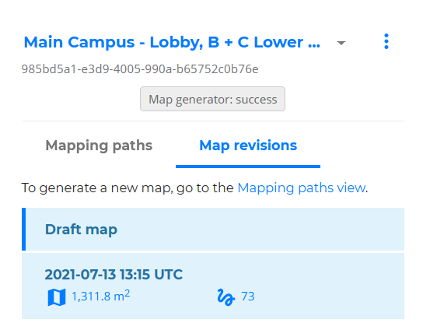

Figure - Ground Floor Mapping Info

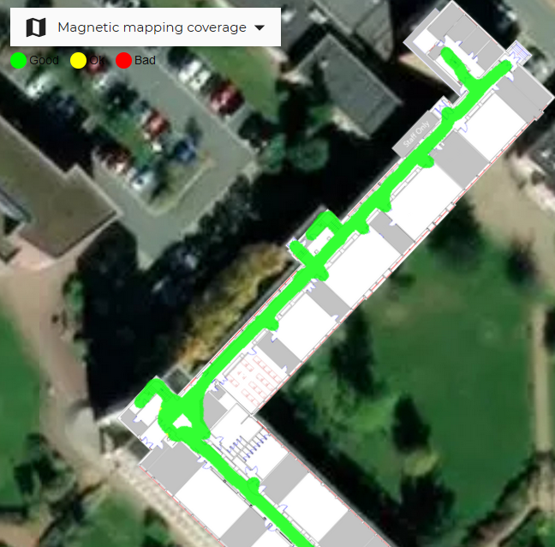

Figure - Magnetic Field Coverage for C corridor ground floor

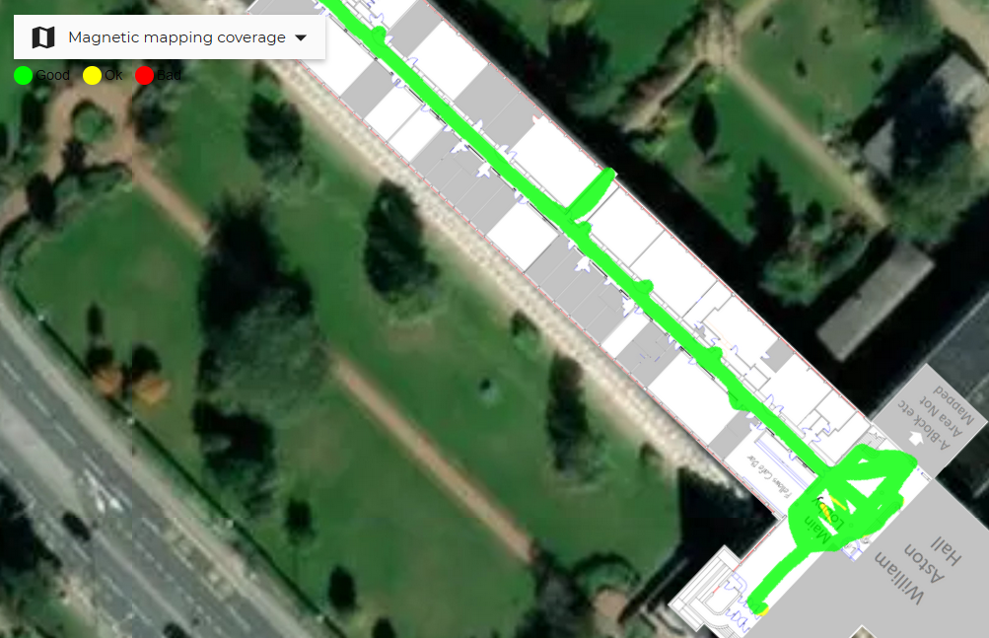

Figure - Magnetic Field Coverage for B Corridor and Main Lobby ground floor

Figure 29 and Figure 30 shows excellent coverage from these 73 runs throughout the navigable space on this section of map, however, Figure 31 and Figure 32 shows that despite this great coverage, the magnetic field data is still slightly spotty.

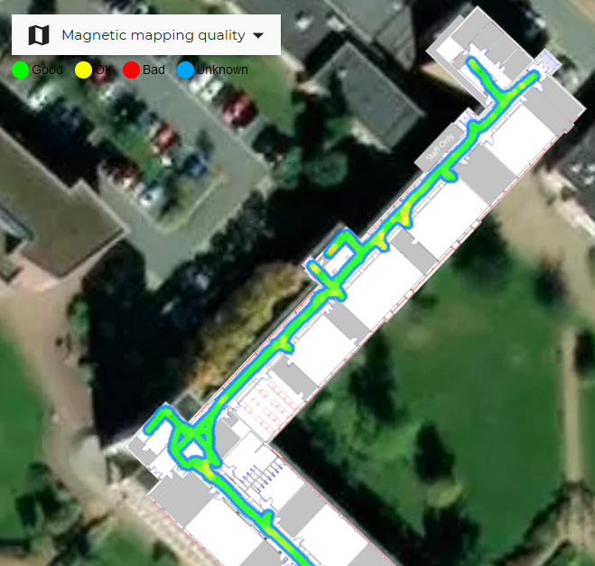

Figure - Magnetic Field Quality C corridor ground floor

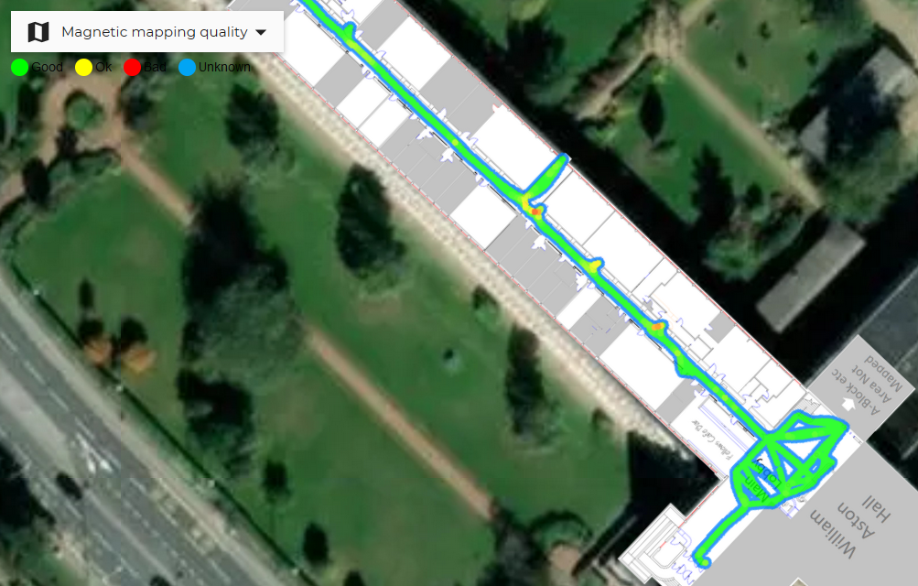

Figure - Magnetic Field Quality B corridor and Main lobby ground floor

The same theme of poor quality despite excellent coverage is even more noticeable in the Wi-Fi signal heatmap. This was because the Wi-Fi infrastructure largely being designed and implemented some time ago with the goal of delivering a good internet connection in classrooms as economically as possible with regards to Wi-Fi AP’s. During these runs, the Wi-Fi tended to drop out in some areas, likely where the device would be on a boundary furthest from its AP it was connected to at that time and that overlap was not great.

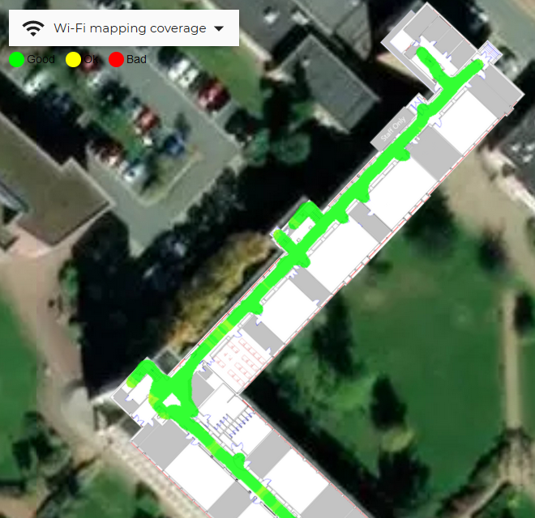

Figure - Wi-Fi Coverage C corridor ground floor

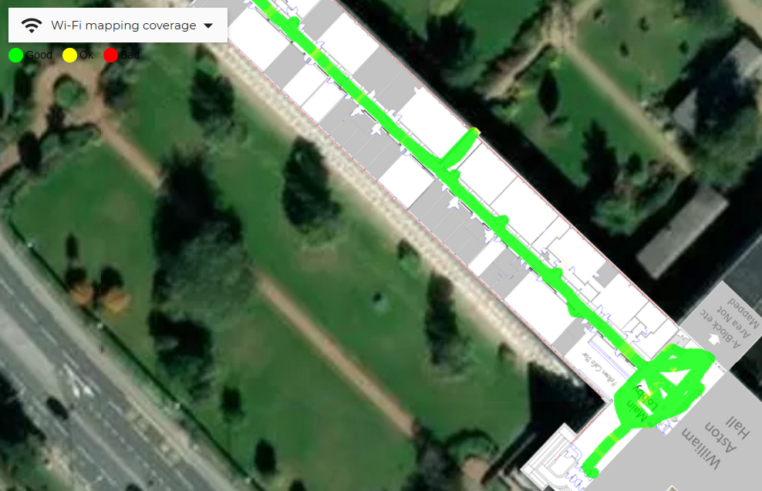

Figure - Wi-Fi Coverage B corridor and Main lobby ground floor

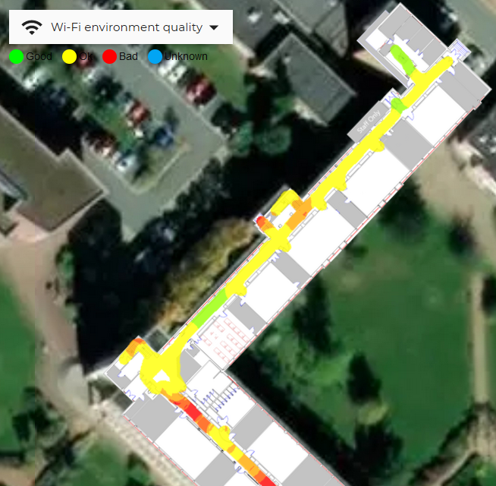

Figure - Wi-Fi Quality C corridor ground floor

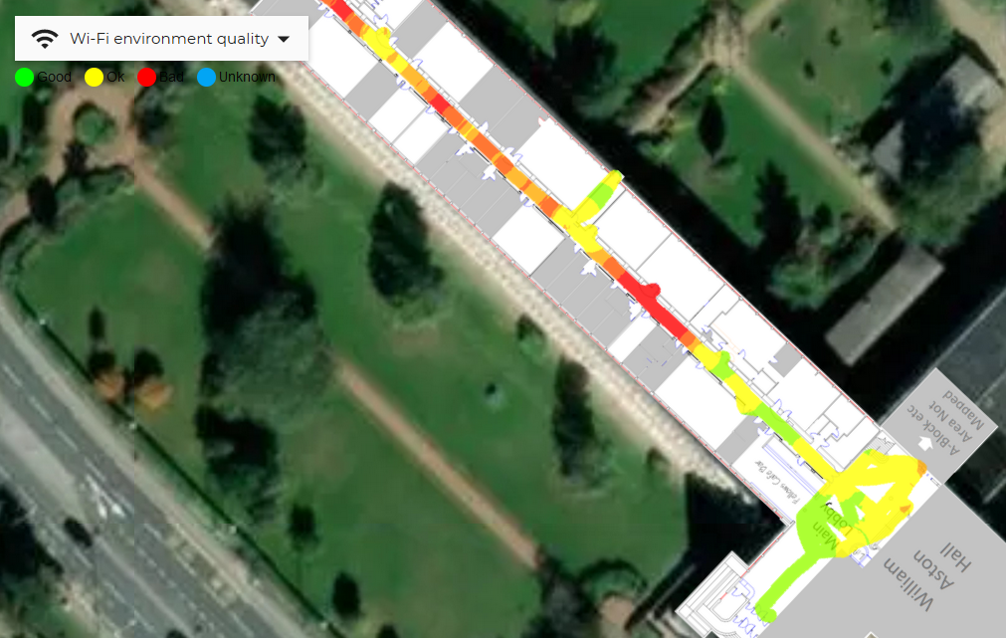

Figure - Wi-Fi Quality B corridor and Main lobby ground floor

**First Floor Mapping**

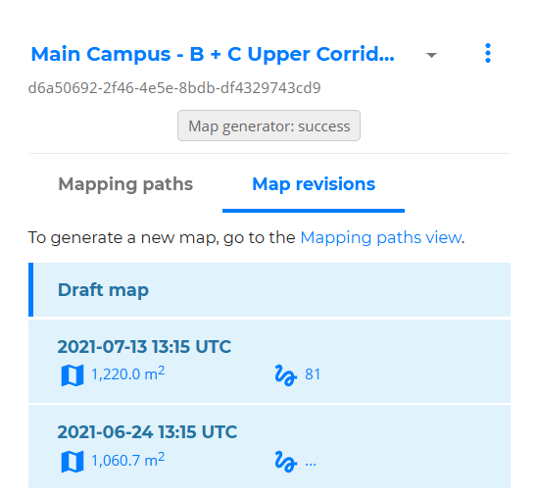

Figure - First Floor Mapping Info

Figure 37 shows a more extensive mapping process was undertaken for the first floor, overall, 81 individual recordings were made on two different occasions due to a floorplan alteration and the final version completed on 13th of July covers approximately 1220 square meters.

The quality for the magnetic field recordings is largely similar to the ground floor as its infrastructure-less and the environment is similar. The Wi-Fi quality, however, is distinctly worse than it was at ground floor along B corridor. This could be due to the renovations on the ground floor section of B corridor could have newer AP equipment, better positioning or just more APs in general.

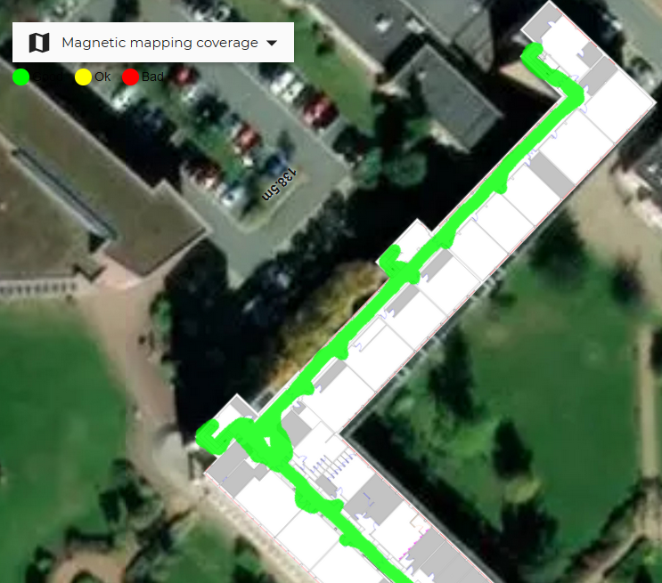

Figure - Magnetic Field Coverage C corridor upper floor

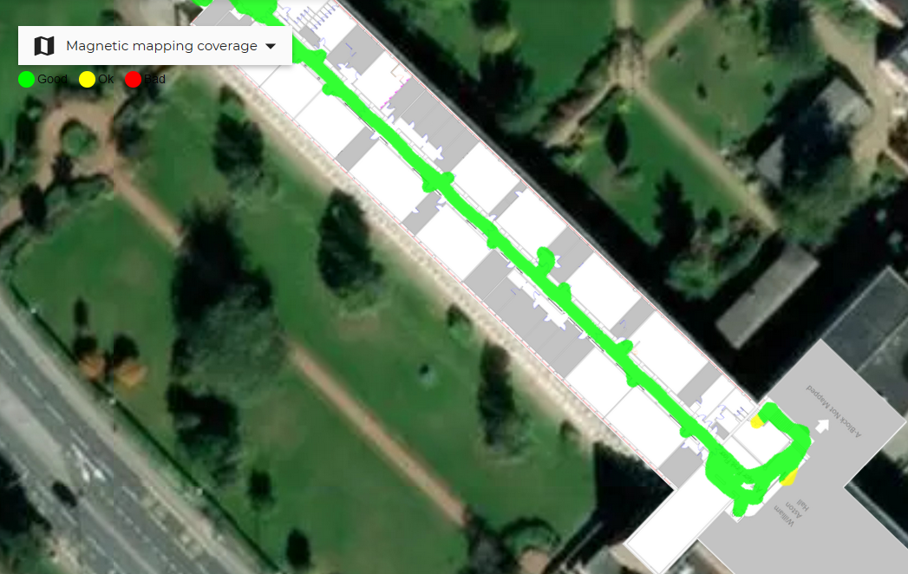

Figure - Magnetic Field Coverage B corridor and Gallery upper floor

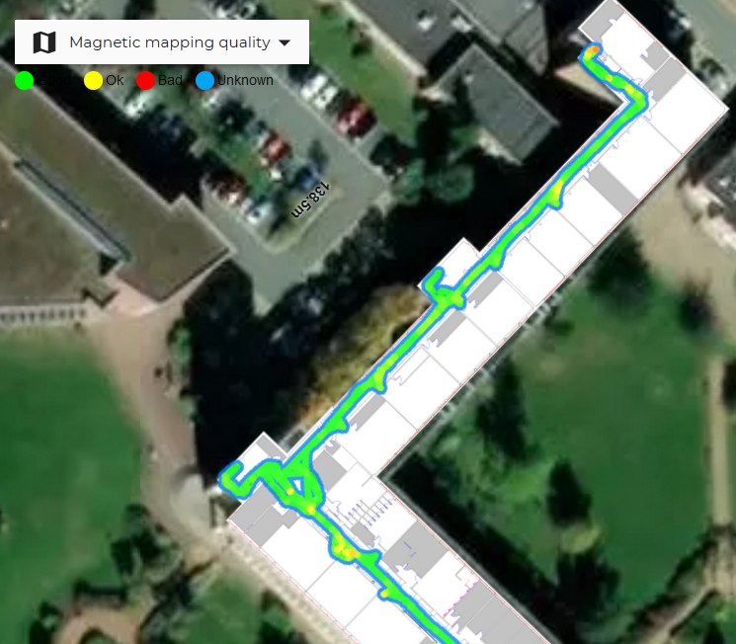

Figure - Magnetic Field Quality C corridor upper floor

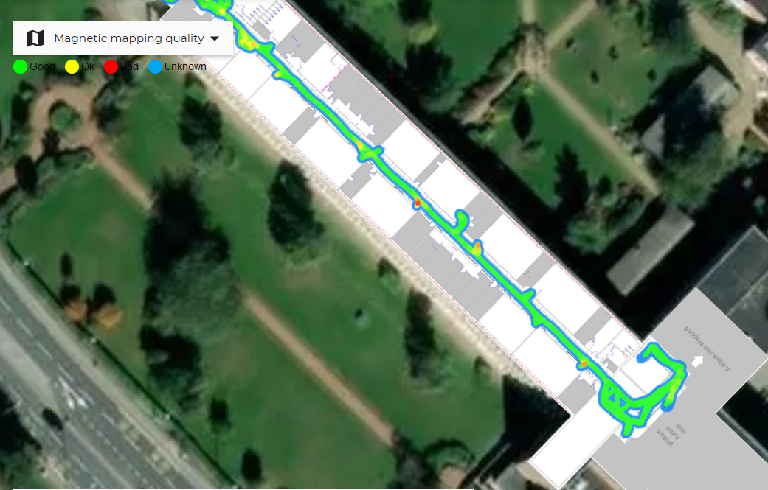

Figure - Magnetic Field Quality B corridor and Gallery upper floor

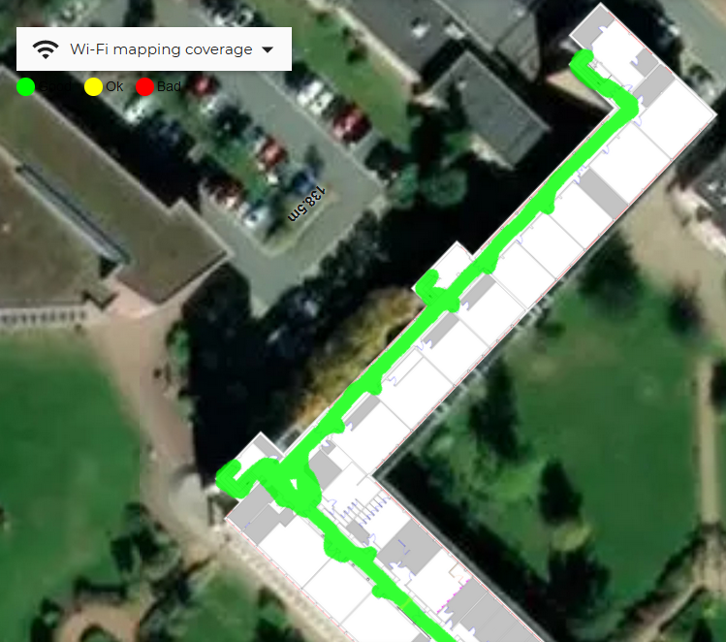

Figure - Wi-Fi Coverage C corridor upper floor

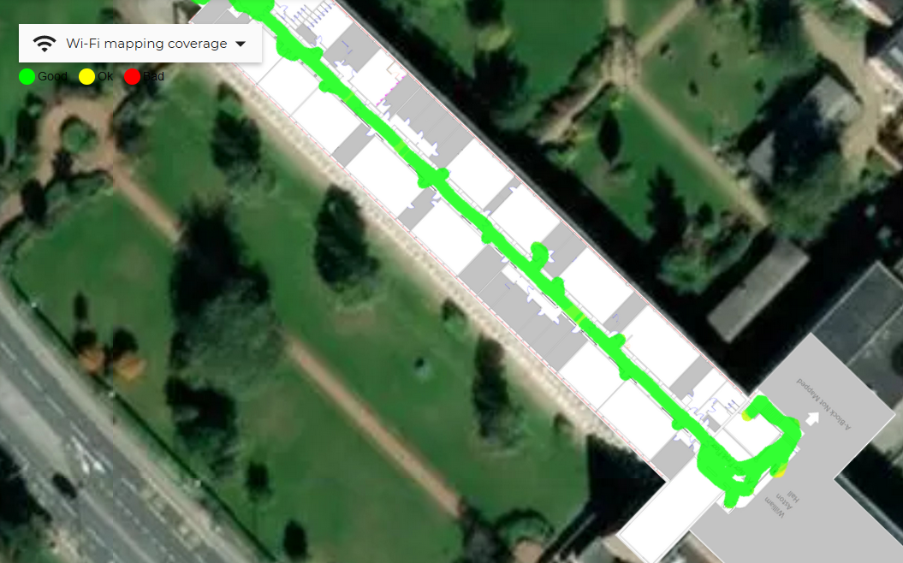

Figure - Wi-Fi Coverage B corridor and Gallery upper floor

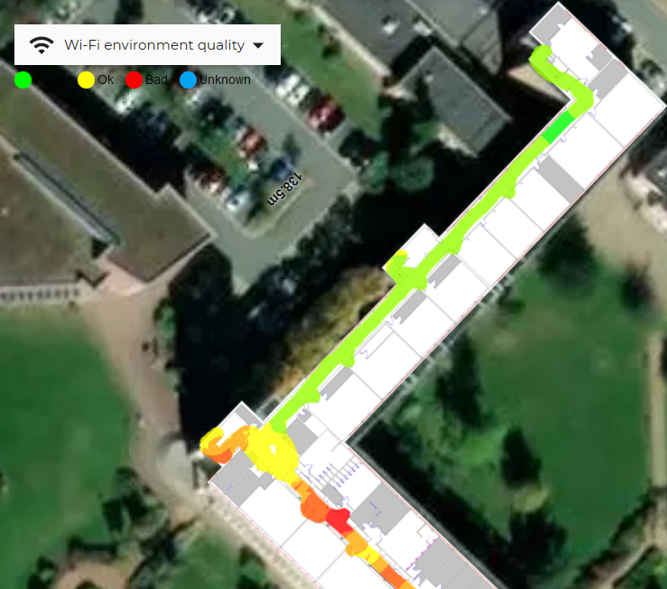

Figure - Wi-Fi Quality C corridor upper floor

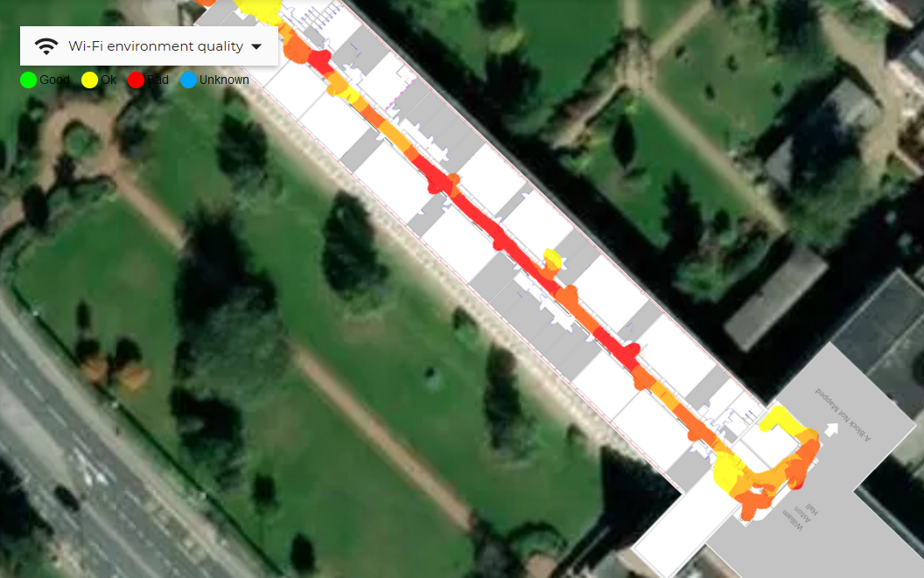

Figure - Wi-Fi Quality B corridor and Gallery upper floor

#### Wayfinding and Pathfinding

Indoor Atlas web tool also has a convenient method to implement POI’s and wayfinding paths. This is a manual implementation and does not necessarily ensure an optimal path, however, using 116 nodes to represent navigation points and 114 edges to represent paths between nodes. An implementation by a person with more in-depth knowledge of the building can implement shortcuts and ensure paths are correctly flowing through parts of the floorplan. Wayfinding can be tested by selecting a start and end points and the wayfinding graph can be saved and accessed from the IA cloud or downloaded as a JSON file and used offline on the app itself.

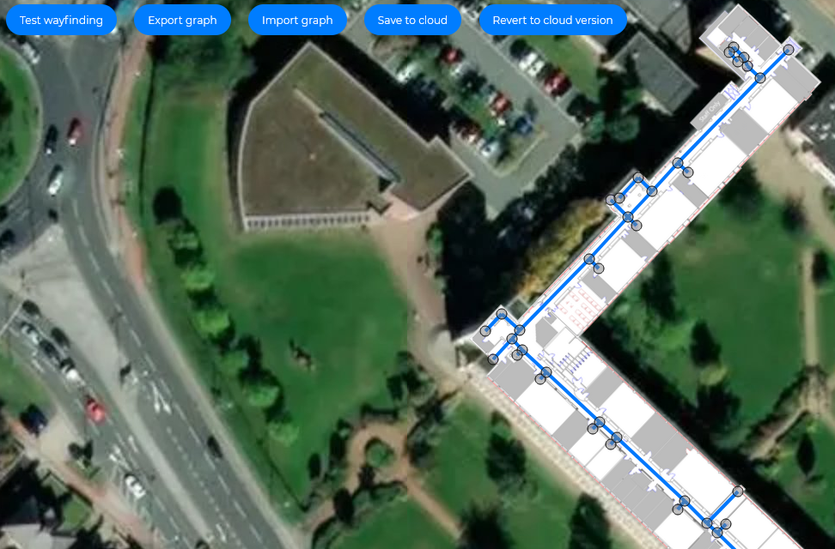

Figure - Ground Floor Top Wayfinding

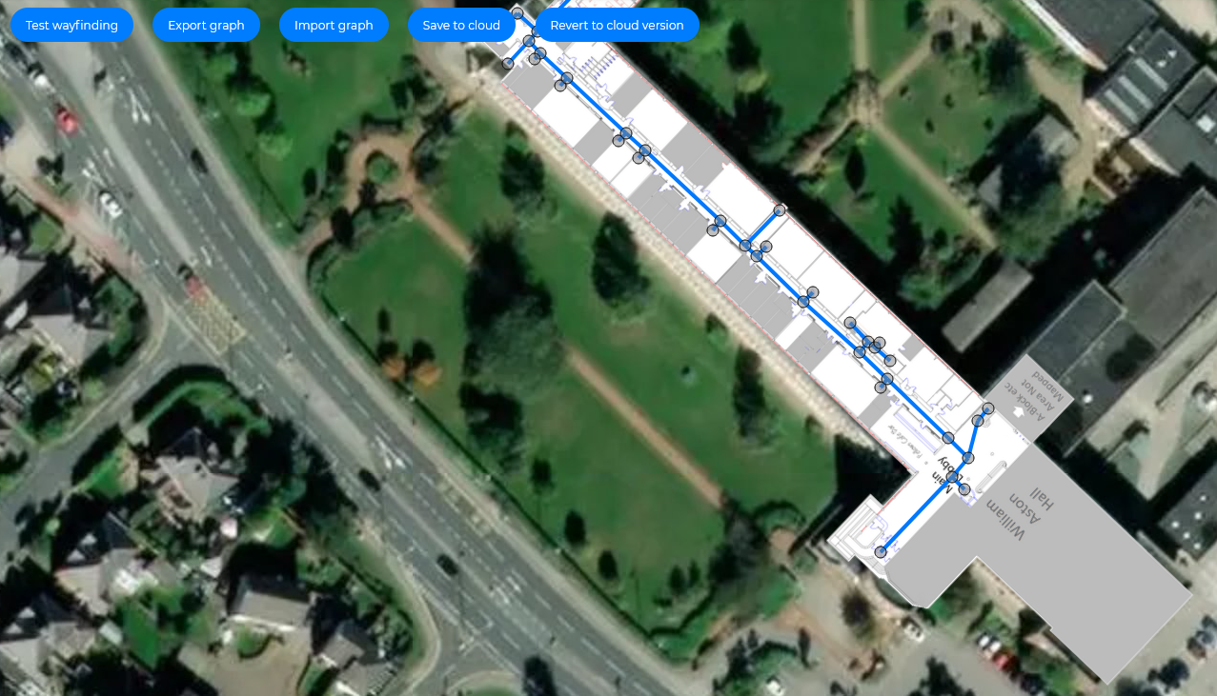

Figure - Ground Floor Bottom Wayfinding

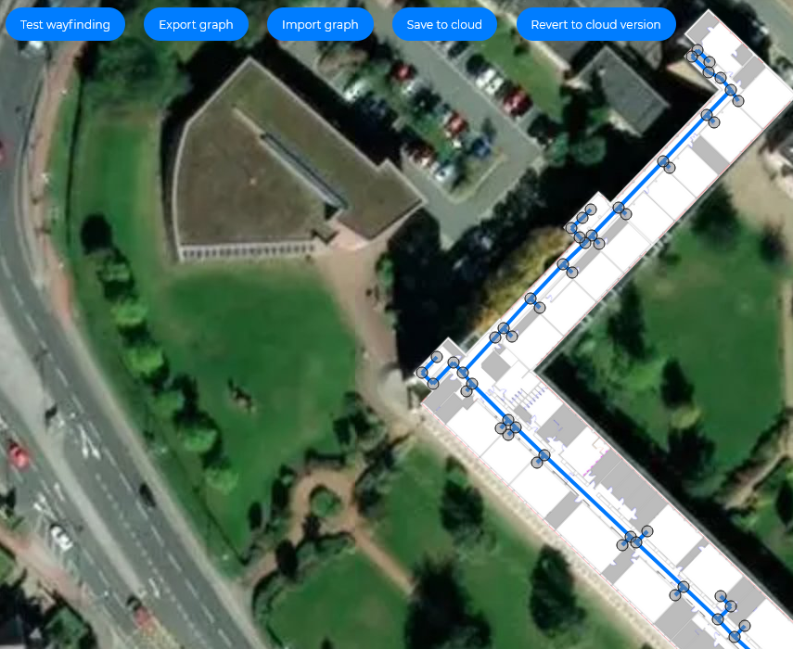

Figure - Top Floor Top Wayfinding

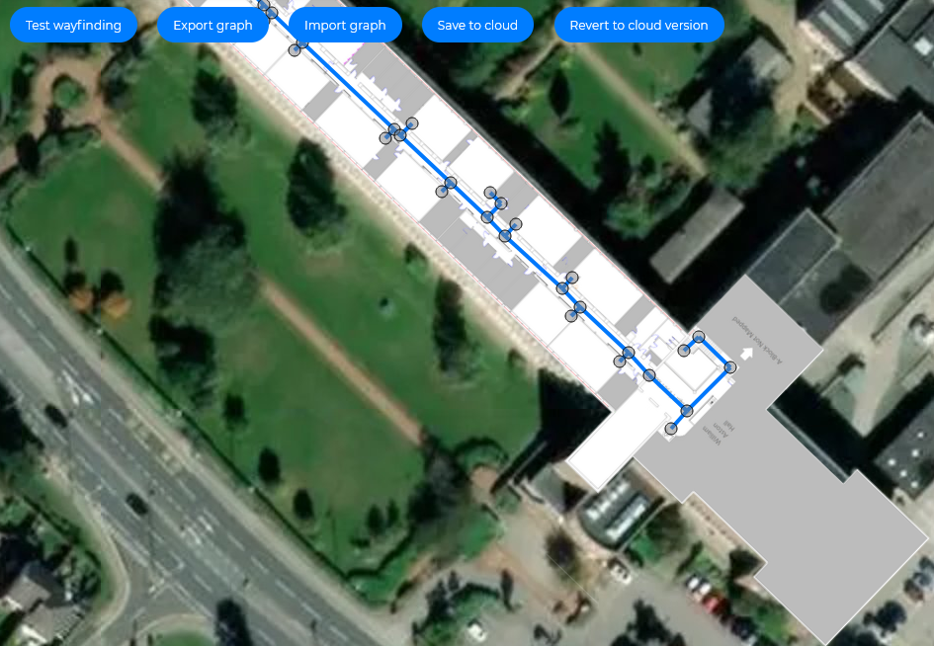

Figure - Top Floor Bottom Wayfinding

#### SQL Database and OpenDatabase Class

Since the designs for the databases have been made, alterations have been made during development to just have the database and two tables which can be immediately created using SQLiteStudio 3.1.1 [81]. The tables are below in Figure 50, and Figure 51.

The alterations include changing the data types to either ‘TEXT’ or ‘INTEGER’, adding an auto-increment ID to the contents table and including the use of Runtime (this includes start to end time) so that a unique table constraint can be made linking ‘EventID’, ‘WeekID’ and ‘Runtime’ such that duplicate records are ignored when web-scraping for timetable contents. This is important as the website which includes the timetable contents are all designed in such a way that weeks are shown in several different formats.

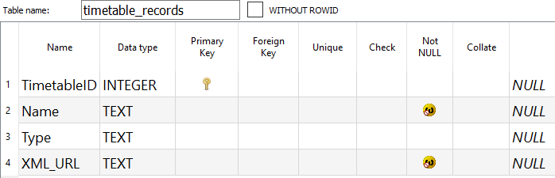

Figure - Timetable Records Database Table

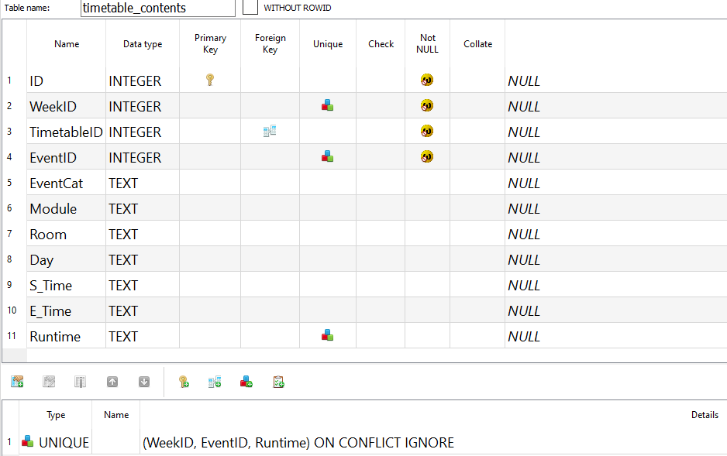

Figure - Timetable Contents Database Table

Once the tables are developed, it is a good idea to develop the class that will deal with CRUD operations for the database and the tables included. This way, classes, and activities to be developed later that are dependent upon this functionality can be implemented right away and changes can be made as development continues.

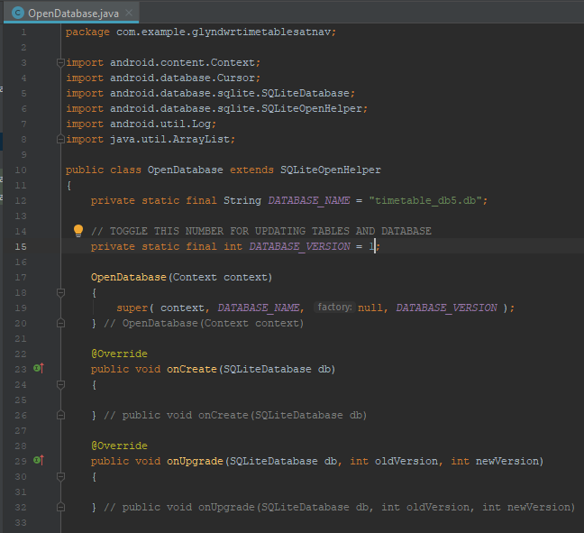**OpenDatabase.java**

This activity deals with the CRUD operations necessary for the timetable list and timetable contents functionality. Since its inception was initially designed (Figure 15), this class has grown to accompany an additional process ‘retrieveWeeks’ in Figure 57. Furthermore, the processes were initially designed to work with three database tables; Timetable Records, Timetable Contents and Timetable Events however they were later adapted to just two tables. As can be seen in Figure 52, this database is on timetable iteration five. This class will make use of androids database library [121], which has a cursor, ‘SQLiteDatabase’ and ‘SQLiteOpenHelper’.

Figure - OpenDatabase Imports, Constructor, onCreate and onUpgrade

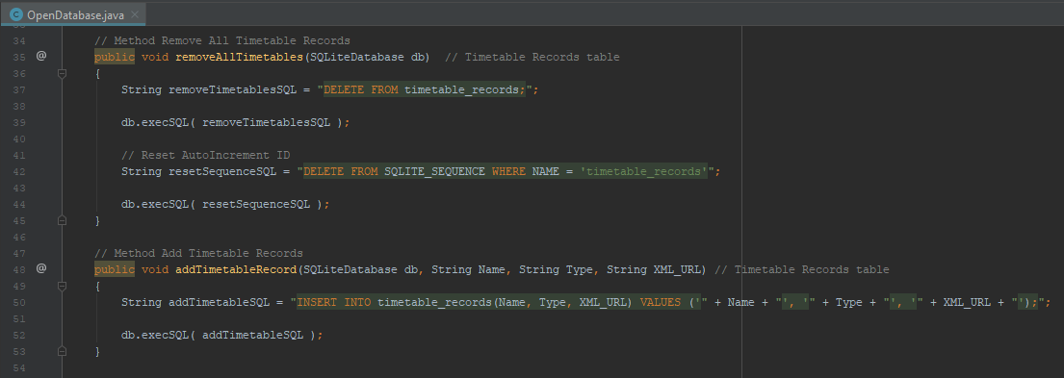

Figure - OpenDatabase removeAllTimetables and addTimetableRecord

The first major methods of this class are described in Figure 53. These methods are used in both clearing and populating the timetable records table during the first initial web scraping process as seen in Figure 65. These methods are predefined SQL statements and are executed when the methods are called. The addTimetableRecord is slightly more complex as it takes in parameters which are concatenated into the predefined statement. This ensures values are inserted into each record with values sent from the timetable web scraping process.

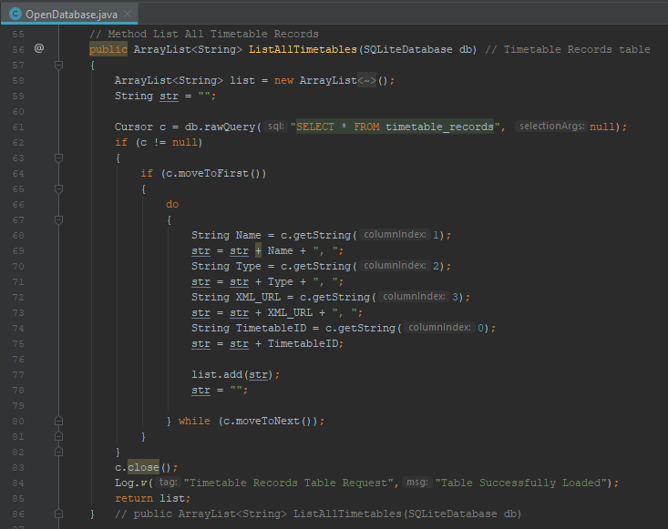

Figure - OpenDatabase ListAllTimetables

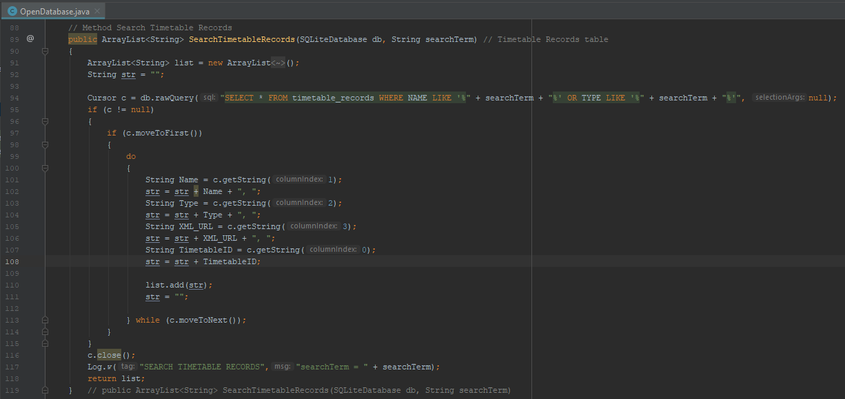

Figure - OpenDatabase SearchTimetableRecords

Figure 54 and Figure 55 demonstrate the functionality needed for the timetable activity. Both methods are similar in primarily using ‘ArrayList<String>’ to store and retrieve an arraylist populated with timetable records. This data type works really well with the ‘ListViews’ that are going to be used in this activity. The predefined SQL statement selects either all timetables or timetables that match a given search term, stores the row as an array and each index point of the array is stored into a string with “, ” used to separate each data point. The string is then added to the list and the cursor moves onto the next row and continues until there are no more rows. Upon completion, the list is returned to the activity it is called from.

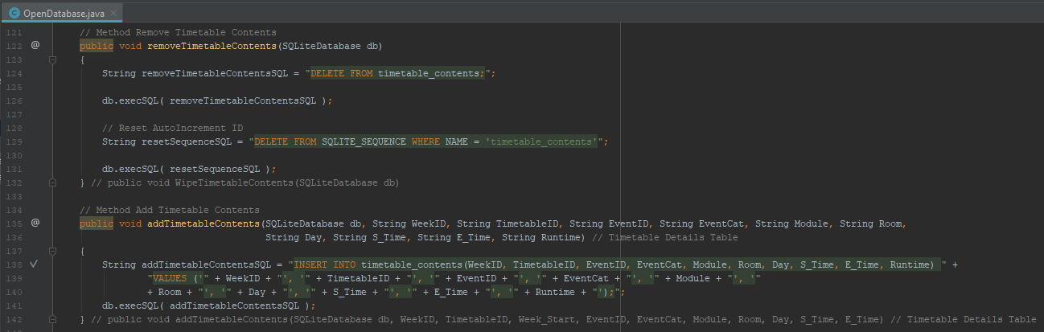

Figure - OpenDatabase removeTimetableContents and addTimetableContents

The same process of removing and adding records like timetables is seen in Figure 56. Except this time, there are far more data fields taken in as a result of the more in depth and descriptive web scraping seen in Figure 66.

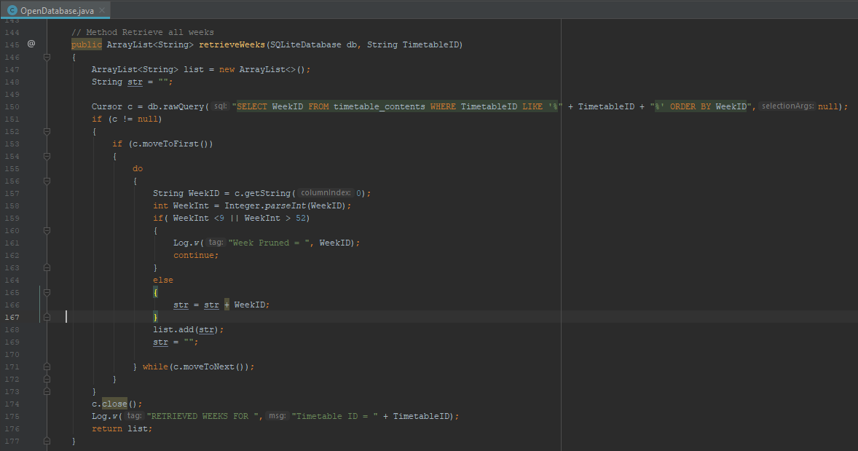

Figure - OpenDatabase retrieveWeeks

Figure 57 shows a new method which was necessary for the spinner interface feature used in Figure 5. Here all the unique weeks of a given timetable can be retrieved if they fall within the given range of weeks 9-52. This list then populates the spinner element of the user interface to allow the user to select a certain week in the timetable.

Ordinarily, for a consistent timetable, this would not be necessary, however, given the ever-changing aspects of university timetables like directed study weeks, new semesters, term breaks and even just differing timetables week to week, this UI element became important.

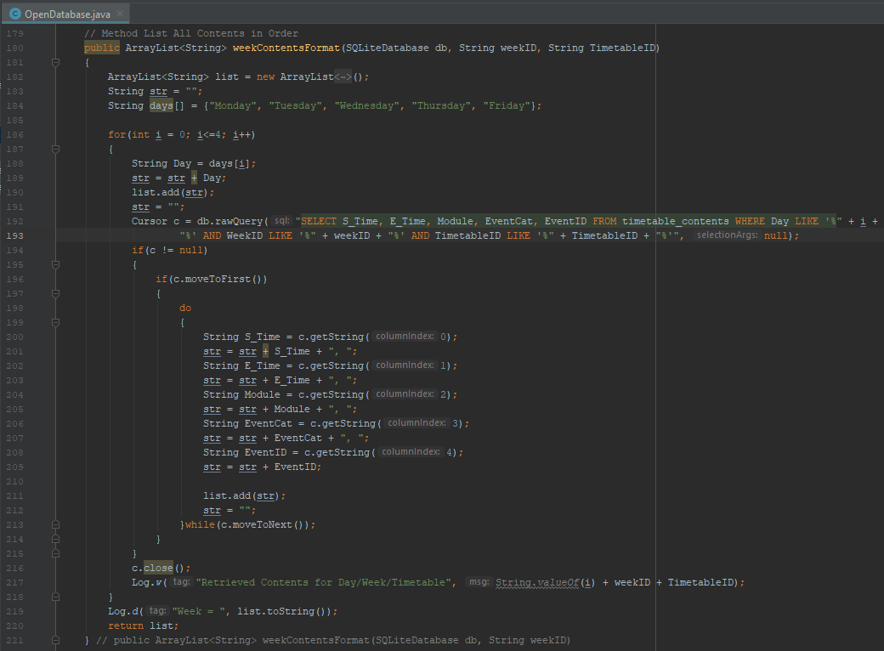

Figure - OpenDatabase weekContentsFormat

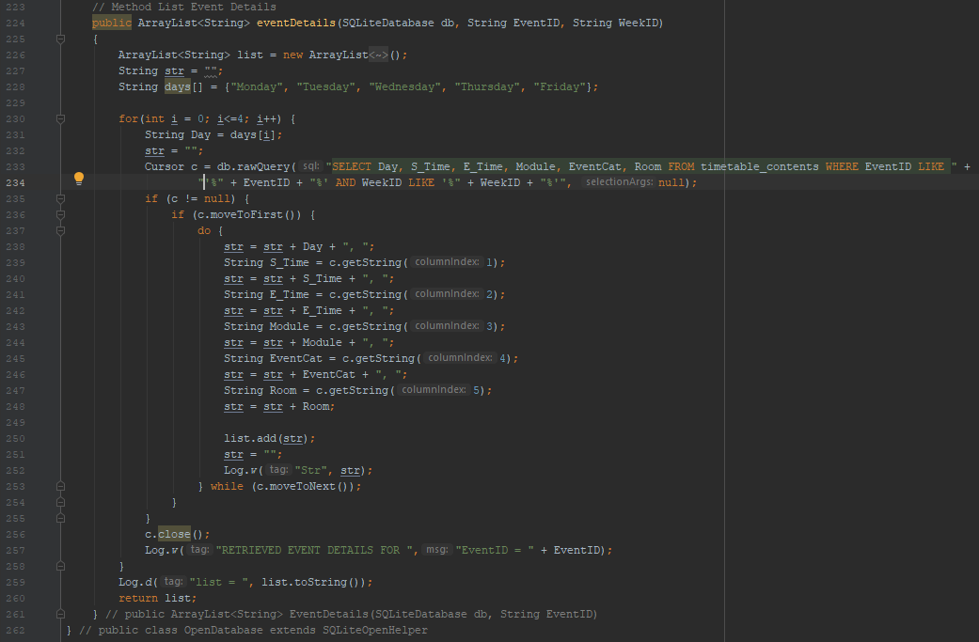

Figure - OpenDatabase eventDetails

Lastly, the database operations for the timetable contents activity can be seen in Figure 58 and Figure 59. The first method – ‘weekContentsFormat’ retrieves basic details needed for showing the timetable contents in a UI. These include Day, Start Time, End Time, Module, Event Category and Event ID. Again, arraylist is used for its ease of use with ‘ListViews’ and each Day is only entered into the list once for each set of events that are on that day which is later shown in Figure 61. The eventDetails method supplies all the stored information about a specific event using ‘EventID’ in a dialog described in Figure 6.

#### Activities and UI/UX

Now that the OpenDatabase class and database has been created, development can move onto implementing the User Interface in the form of Android Activities. These can be implemented as a class for each activity and accompanying layout. Dialog Code will be later address in timetable functionality, but their layouts can also be similarly implemented.

It is important whilst implementing these that good discipline with code structure, variable and element nomenclature are used to create a well-developed app that would be easy for other developers to pick up and expand on if they choose. This means commenting code, indenting appropriately, and following a logical naming pattern.

* 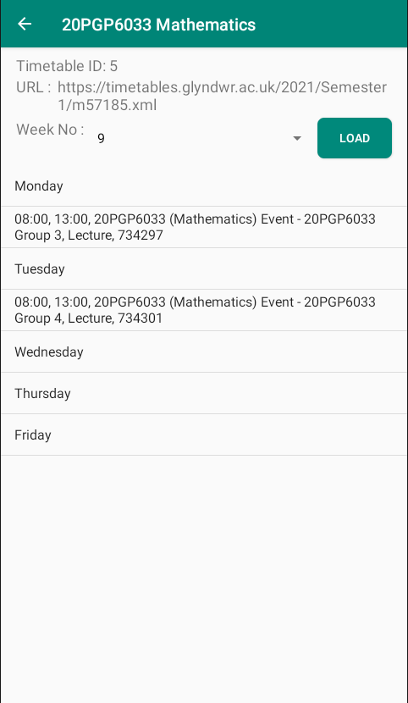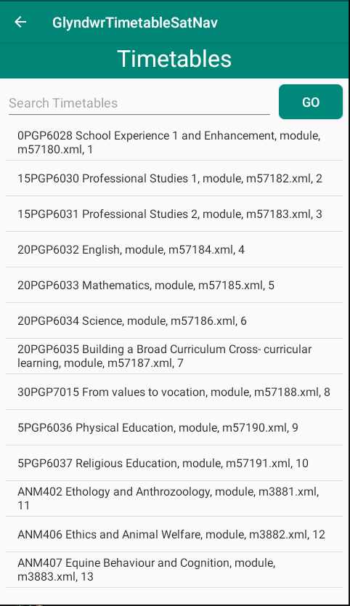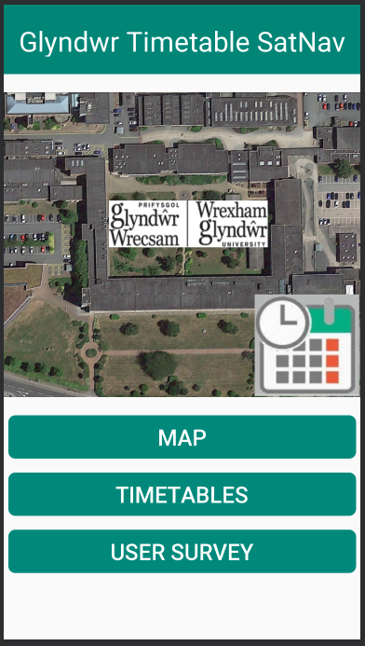**Main Menu / Timetables / Timetable Contents UI’s**

Figure - Main Menu Activity UI

Figure - Timetable Contents Activity UI

Figure - Timetables UI Activity

Figure 61, Figure 60, and Figure 62 are the implemented versions of the timetable and menu activities first designed in chapter 5. They each follow a common theme of white and green colour style and simplistic navigation with the use of toolbars for titles and to navigate back while the main menu has three large buttons to navigate forward. The navigation between the timetables UI and contents UI is somewhat more complex as it involves clicking on a list item to open dialogs which are described below in Figure 63 and Figure 64.

* **Timetables and Timetable Contents Dialogs**

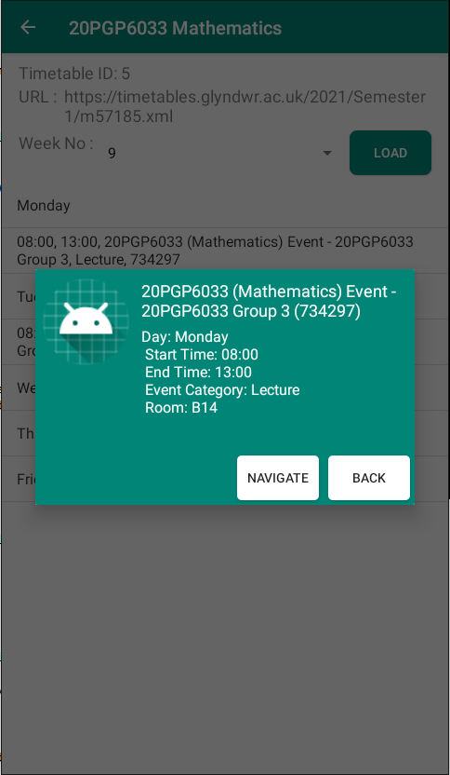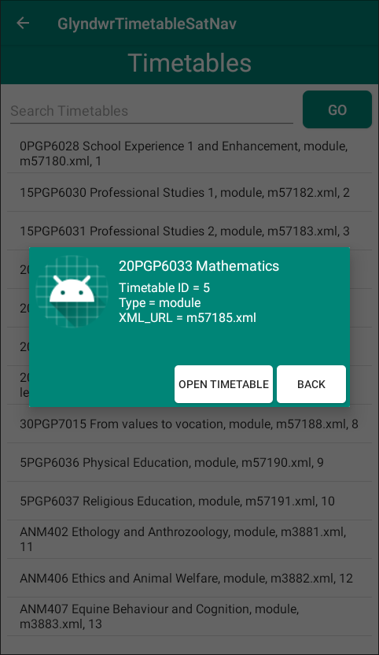

Figure - Timetable Contents Dialog UI

Figure - Timetable Dialog UI

#### Web-Scraping XML

A large component of the functionality of this app is centred around the use of timetables as a wayfinding method for navigating an indoor environment like a university. A simplistic way of doing this would have been a static approach of collecting, collating, and formatting the timetables locally in a database in a usable format to support this functionality.

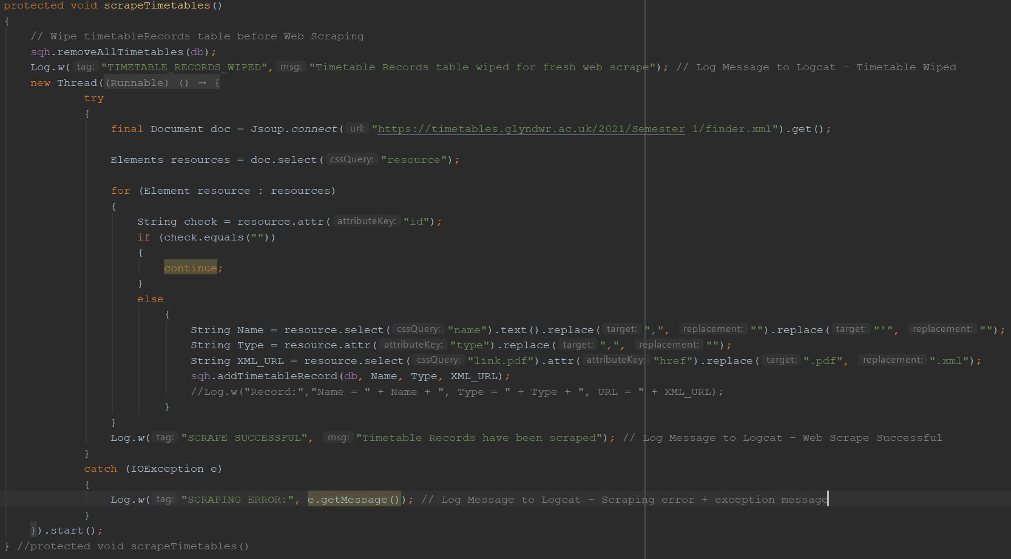This approach, however, means the maintenance of the app and the content would require updates around each quarter-year to support having the latest timetable content and ensuring accuracy to users i.e., timetabled rooms change each semester. A better approach would be to dynamically source the data on-the-fly whilst using the app in an unobtrusive method suitable to the user. This approach is known as web scraping. In this project, JSoup [63] will be used to carry out this web scraping and below is the documented code for the web scraping functionality for both scraping the master list of timetables and all the contents of a chosen timetable.

Figure - Web Scraping Timetables Code

Figure 65 shows the method called in the main class of the app. It is called in this class within the ‘OnCreate’ method to initiate web scraping and populating the timetables prior to their perceived need by the user. This process is lightweight enough on internet connection bandwidth that it seems unnoticeable but for clarity to the user, an alert message is shown to display when timetables are successfully web scraped.

Within this method, the timetables database table is wiped to ensure a fresh set of timetable records can be scraped without duplicates. Upon wiping, a logcat message demonstrates that the table has been wiped as seen in Figure 66 and after successful web scraping a logcat message demonstrates a successful web scrape as seen in Figure 67.

Figure - Pre-Web Scrape Table Clear Log



Figure - Web Scrape Timetables Log

The web scraping itself runs as a new thread separate from the program. At first, it initialises a final variable of type document (from JSoup library) to ‘Jsoup.connect(“URL”).get()’. This scrapes the entire site given in the URL into the variable document. An array of elements called resources is initialised with ‘doc.select(“resource”)’ – this selects all elements in the document called resource which in this case contains all the details relevant to the timetables that are to be web scraped.

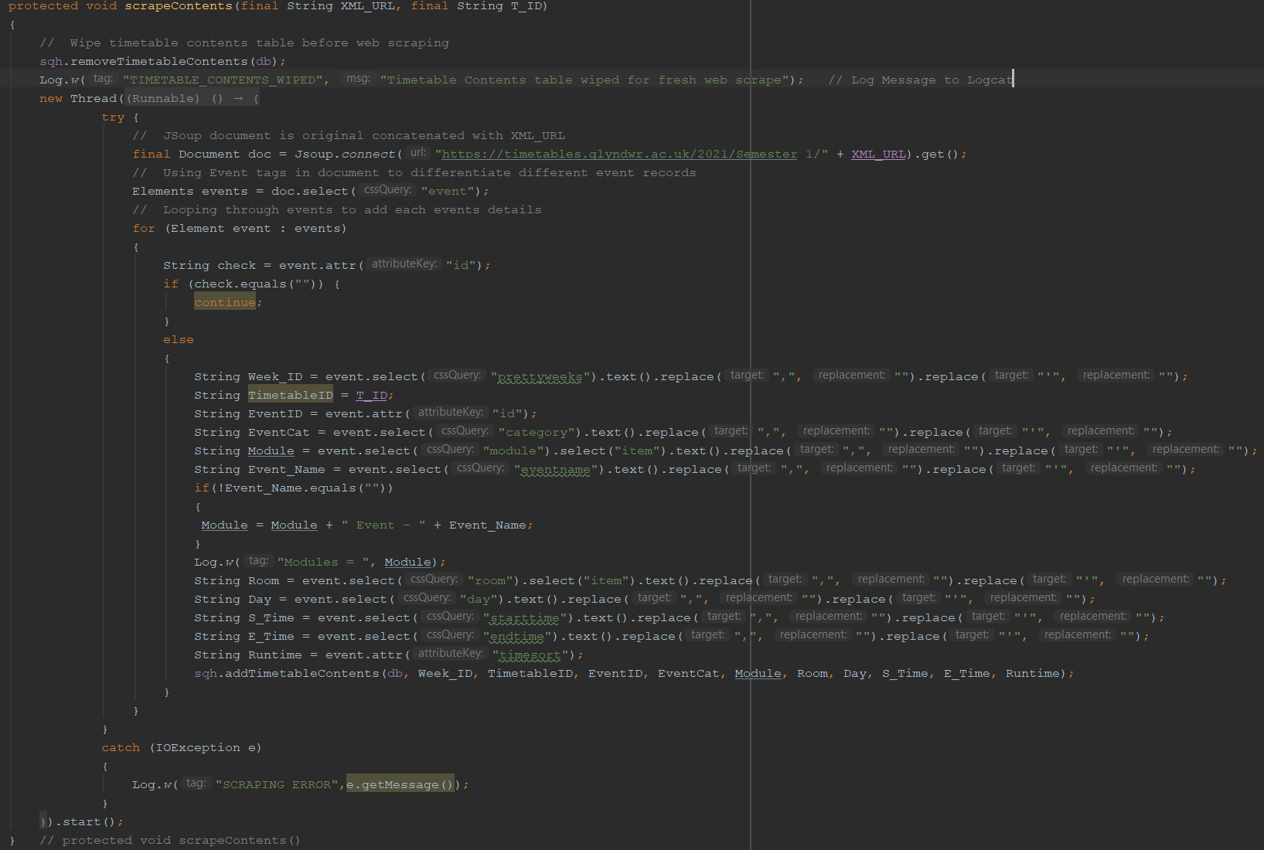Once this array is initialised, it is then looped through, checking id is not null to ensure each record is a genuine timetable whilst discarding null resources. Once a genuine timetable is discovered, the name and XML URL are selected using ‘resource.select(“”)’ – being careful to format the string and remove apostrophes and commas. Furthermore, XML URL is formatted further to replace the .pdf extension of the link with .xml. The type of record is also taken in by selecting an attribute of the resource tag using ‘resource.attr(“”)’. Once a record has been constructed, it is sent to the OpenDatabase class through the ‘sqh’ object using ‘addTimetableRecord’ method, ensuring to pass through the database (db), Name, Type and XML URL.

Figure - Web Scrape Timetable Contents Code

In Figure 68 similarities can be seen throughout the second web scraping process. The only changes specific to this process is the method to connect the document by concatenating a pre-defined URL with the XML URL previously scraped to provide the correct web address to scrape from for the timetable contents and the data fields scraped during the process are also different.

A total of 11 fields are scraped with two fields implementing a select of a nested tag using ‘event.select(“”).select(“”)’ and a tag (Event Name) being selected which is concatenated onto the ‘Module’ variable string if found to be ‘not null’. Logcat tags are also used in this code to demonstrate successful functioning of the web scraping element.

#### Timetable and Contents Functionality

The wayfinding system’s UI consists of two aspects each with an activity and dialog respectively. The UI for which can be seen in Figure 61, Figure 62, Figure 63 and Figure 64. The first aspect is an activity containing a listview, text view for user input and button to update search. The controls are handled in the ‘setUIpControls’ method of the class. The functionality starts with creating an arraylist, connecting it to the list of the layout using an adapter, populating the list using OpenDatabases method ‘ListAllTimetables’ and updating the adapter to show all timetables in the list. This can be seen in Figure 69.

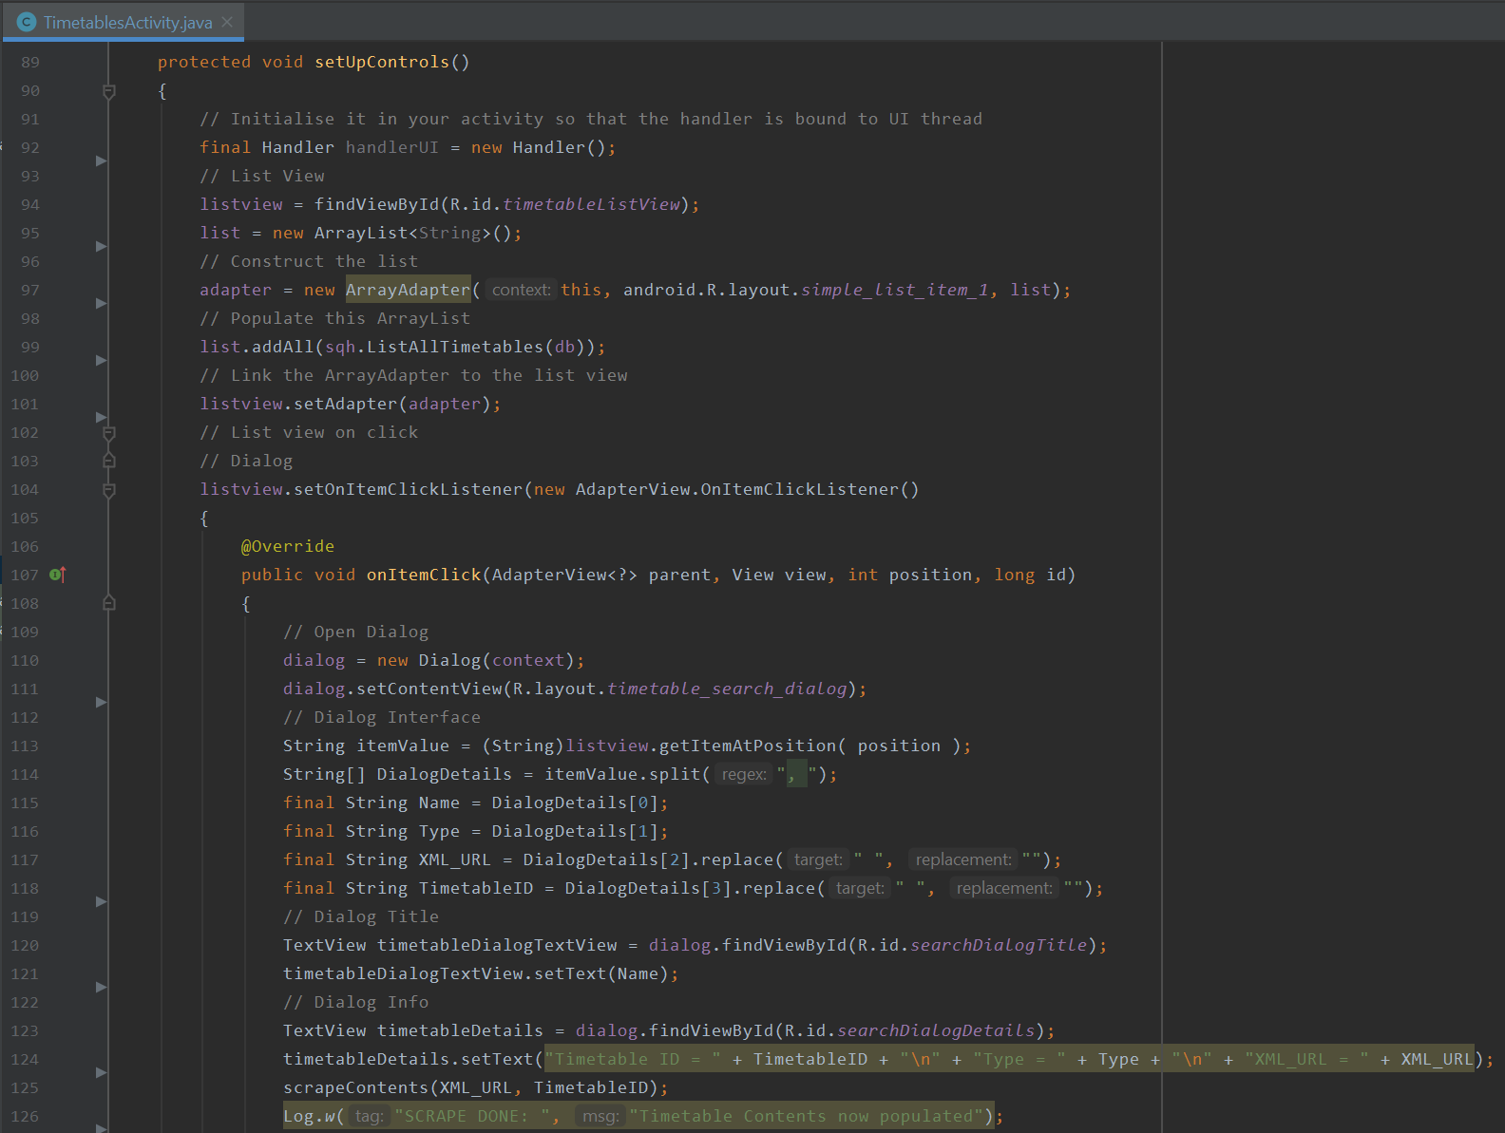

Figure - Timetables Functionality 1/2

Once the list is populated, the user can either scroll through the list to choose a list item or use the textview to input a search term. On clicking the button, the list is repopulated using the same manner as above except for a different method in OpenDatabase being used – ‘SearchTimetableRecords’. This search feature can be seen in Figure 70.

The latter aspect of the timetable class – the dialog – is accessed by the user when selecting an item from the list. This is done by using an ‘onItemClickListener’ that when activated draws a dialog, populates it using details from the list item that is conveniently split using ‘, ’ in the OpenDatabase class. If the user decides to open the timetable, these details are put into a bundle and sent to the timetable contents class and the second web scrape for contents is initiated.

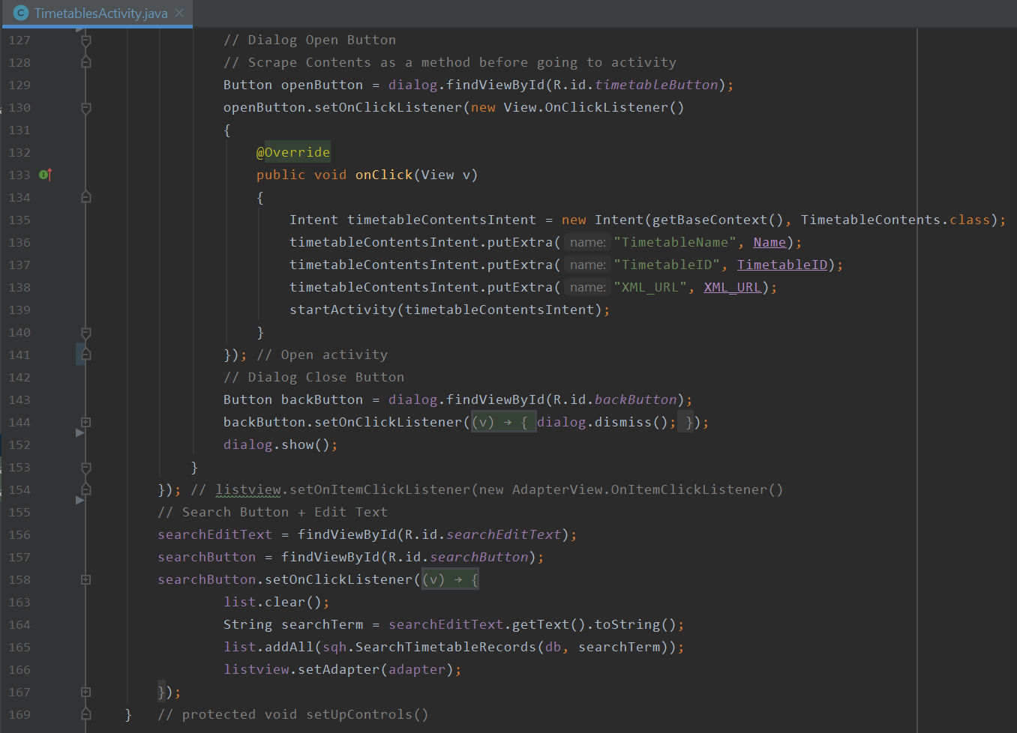

Figure - Timetable Functionality 2/2

**Timetable Contents Functionality**

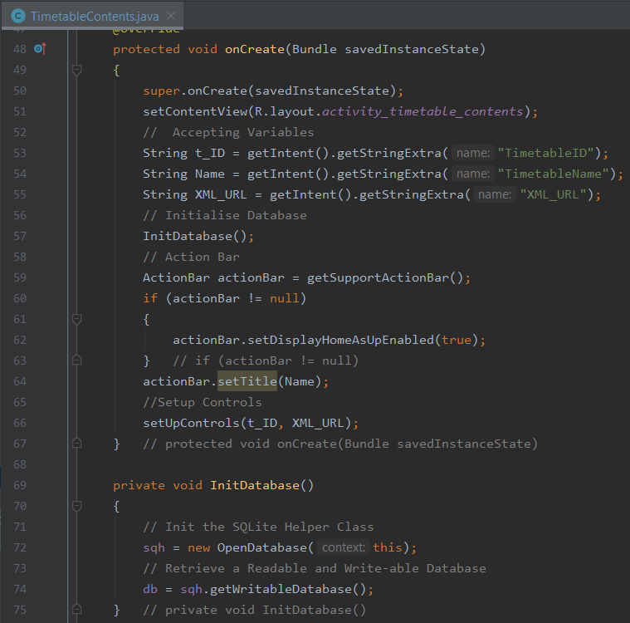

Figure - Timetable Contents Functionality 1/6

Figure 71 shows the contents class starts with setting content view and accepting and assigning variables from the bundle that was sent to this intent. Similar to other classes, the contents class also uses ‘InitDatabase’ method to get a writeable SQL database and an action bar for navigation. The later figures demonstrate the main section of code within the ‘setUpControls’ method.

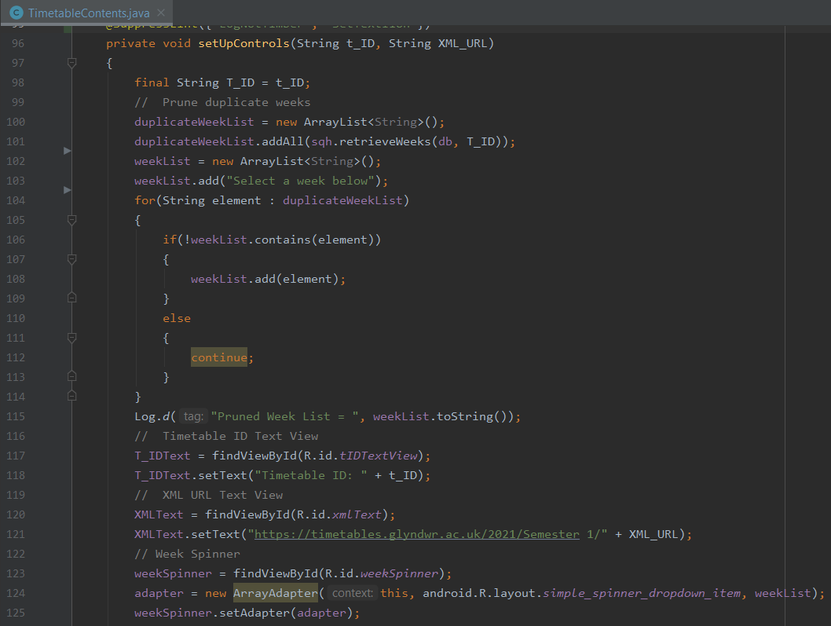

Figure - Timetable Contents Functionality 2/6

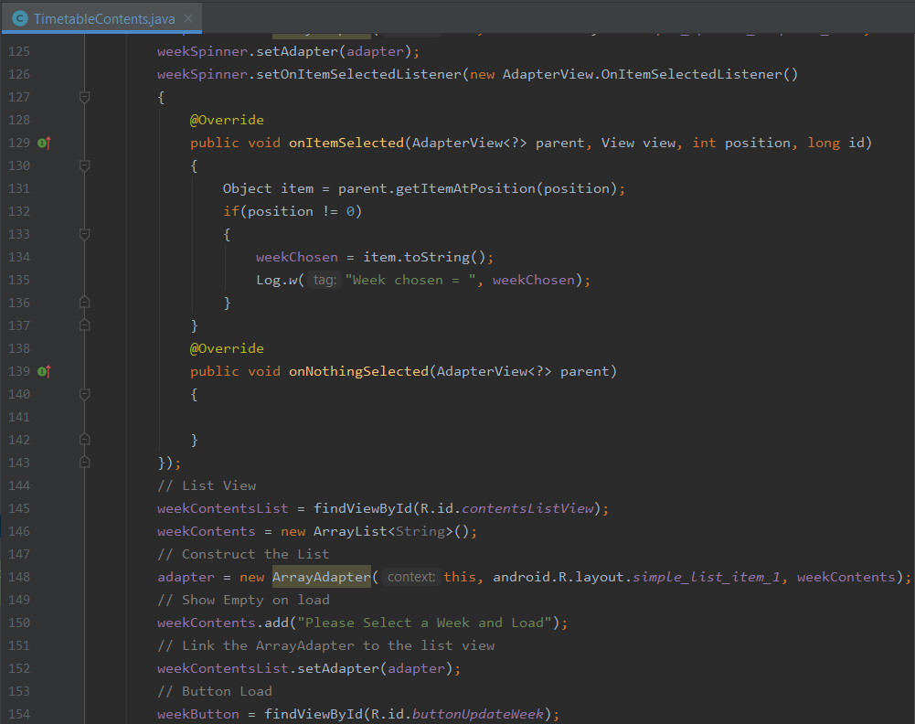

Figure - Timetable Contents Functionality 3/6

Figure 72 and Figure 73 showing the week pruning process to ensure that the spinner element on the timetable contents UI is not populated with duplicate week numbers. This is linked to the ‘ OpenDatabase’ class using ‘retrieveWeeks’. The results of which are returned as a list and the spinner is connected through an Array adapter. If no results are shown, an entry was added separately under “Please select a week and load”. Further developments should see this as displaying either through the display fragment or as a display toast message that the record contains no events.

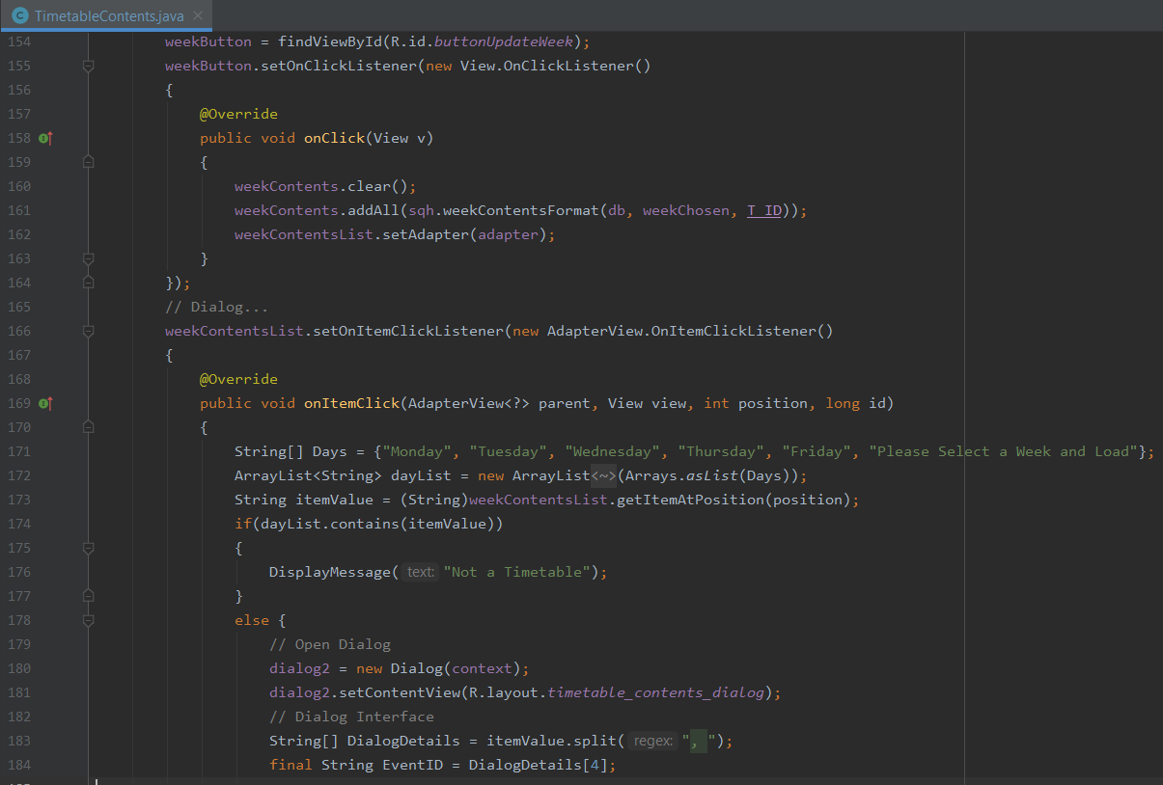

Figure - Timetable Contents Functionality 4/6

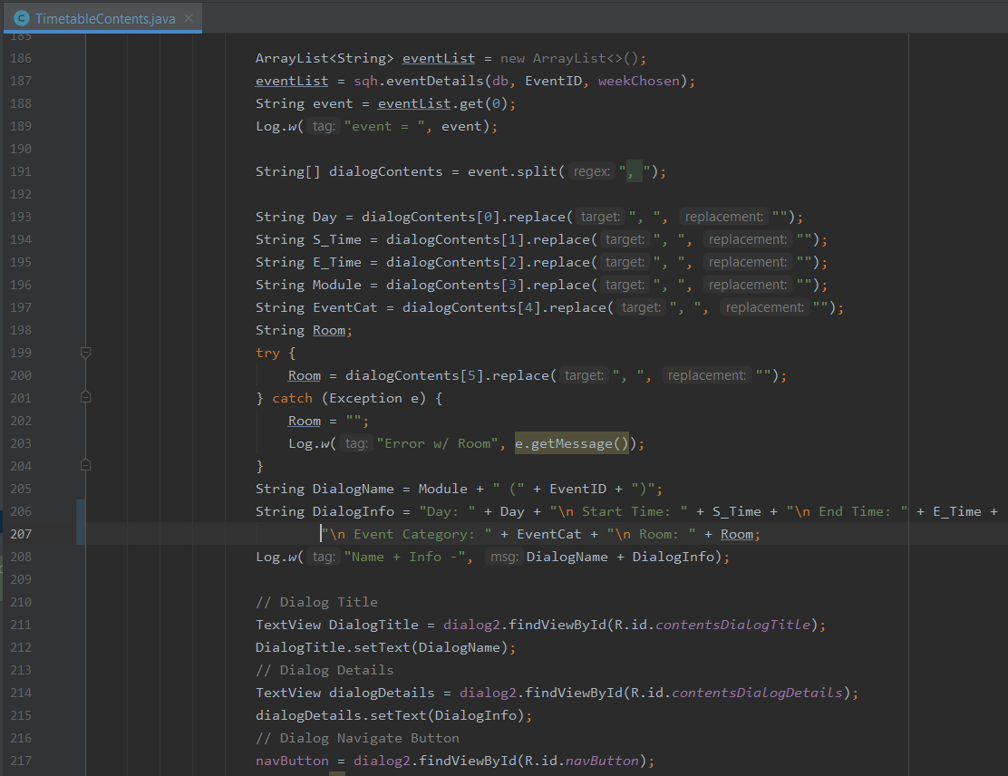

Figure - Timetable Contents Functionality 5/6

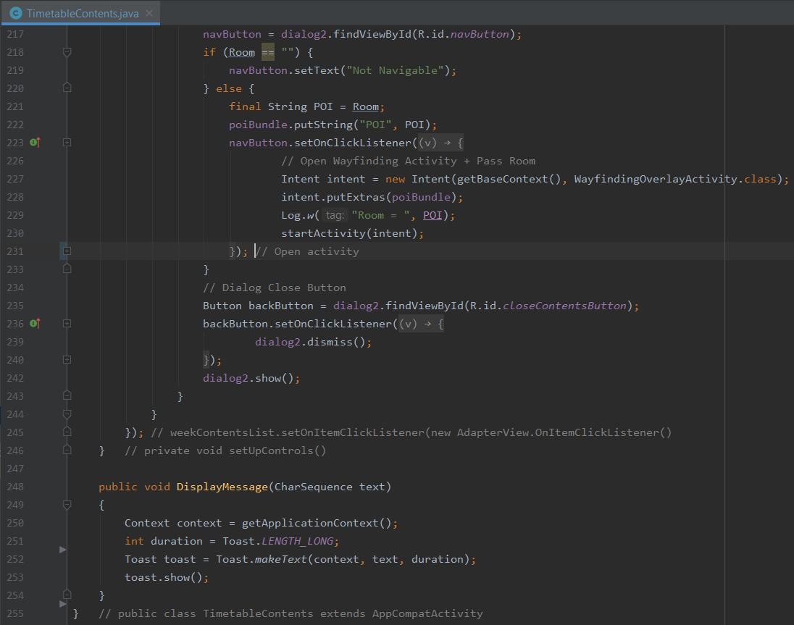

Figure - Timetable Contents Functionality 6/6

Finally, Figure 74, Figure 75 and Figure 76 show the on click logic in code for when a user selects an event from the list. On initial click, a check for whether the list is a non-event item is carried out. This is done by populating an array of values that are sure to be non-event items, the list item at the clicked position is then taken in and compared in an IF statement to see if it’s an element contained in the array. If it is, it’s ignored, and a display message informs the user it’s not a timetable event.

If it passed this statement, a dialog is created and displayed and the list item information as a string is used to create an array – each element split by this set of characters: ‘, ’. This is done to create a set of variables that can be assigned to a given index of the array to populate the dialog interface such as timetable ID, name, module, start, end time and room number.

Finally, there is a check for whether the room number is null or not navigable in Figure 76. For now, it just changes the button’s text to say not navigable and does not allow the user to click through to the wayfinding activity. In future developments, either using display message to do this may be a more elegant solution. If the room is navigable, the room number is bundled and sent to a new intent – the wayfinding activity. This is then used to set the POI name ready for navigating too.

### Sprint One Retrospection

In Table 1 - Risk Analysis, it was stated that in the incident a member of the development team should be injured or ill, the planning should be adjusted to cater for the workload that can reasonably be achieved during that period. Unfortunately, while developing during a pandemic, catching COVID-19 can mean elements of development relying on visiting the university and mapping have been delayed.

This means that not only did sprint one start late due to the overrunning design phase, but everything planned for sprint one could not be achieved due to self-isolation and the inability to undertake mapping in public.

The rest of sprint one was otherwise productive as all functionality aside from the map activity and associated functionality has been implemented. Upon initial testing to ensure code was functioning, these elements run as intended without causing issues or errors. Some alterations were made to the design for some components as features adapted slightly and some research was done on the mapping SDK ready for when isolation would end and sprint two could begin.

## Sprint Two – Indoor Map Functionality

With the setbacks encountered in sprint one, the initial plans for AR functionality laid out in Table 3 - Product Backlog User Stories and set as the third sprint in Figure 14 has to be cut in order to ensure the project reaches an acceptable stage of MVP within the development timeframe and not encroach on any time set aside for testing, evaluation, demonstration and conclusion. This is a tough decision as this feature would be a positive element with regards to accessibility and user experience, however, the projects aim of delivering a real-world solution are a greater priority and any loss in time for testing will affect judgement on whether it determines the hypothesis one way or another.

Sprint two will therefore be the final sprint and will last longer at two weeks to ensure features are well developed and functional ready for software, user testing and the demonstration at the start of august. Below is an adjusted sprint backlog with the major map user story and the last components of the user story concerning navigating via timetable which is dependant of the former story.

### Adjusted Sprint Backlog

Table - Sprint Two Backlog Adjusted

|  |  |  |
| --- | --- | --- |
| Sprint 2 Backlog – 13th July 2021 – 27th July 2021 | Estimation | Priority |
| As a user I want to see the map | 9 | 1 |
| * Identify how to use IA SDK |  |  |
| * Implement Map functionality |  |  |
| * User Location functionality |  |  |
| * Routing and Pathing Functionality |  |  |
| * Test Localization and Pathing |  |  |
| As a user, I want to select a module/event and navigate | 5 | 1 |
| * Navigate Button |  |  |
| * Code Room allocated Check |  |  |
| * Send Room No. as POI to Map activity |  |  |

### Sprint Two Documentation

Sprint two is concerned largely with the navigation and mapping aspects of this project. As such, this documentation will cover everything from initialising and setting up the project from the beginning to end, user localisation functionality, Drawing Map and User pin UI functionality, Plotting POIs, Wayfinding visualisation, tying the timetable event component to the mapping and final UI improvements before user testing and demonstration are to begin.

#### Dependencies, Indoor Atlas SDK, and setup

When using Indoor Atlas SDK, the development team needs to ensure that both the API Key, API Secret and the Gradle dependencies are implemented in the program [122]. An API key (Application Programming Interface) is a unique identifier that can authenticate requests associated with a project for its usage [123]. In this project, two API keys are used for two different services – Google Maps and Indoor Atlas. Depending on how they may be setup, the API keys may also have something called and API secret – this is essentially the password to be able to use the key – thus ensuring that if the key were to be discovered that it can’t be used without the secret.

Indoor Atlas allows you to setup an API key for each app you intend to develop. Figure 77 and Figure 78 shows this process with the former showing an API key, scopes covered, whether it stores session data and its API secret which is mandatory on Indoor Atlas while the latter describes the setup process. Interestingly, we can select the API key to use different APIs and SDKs – in our case we need the SDK and the positioning API – and the session data can be adjusted to store data either never, temporarily for four days or indefinitely with a warning that this last option is by no means GDPR compliant, and it is advised against choosing this option unless the only use is for testing purposes.

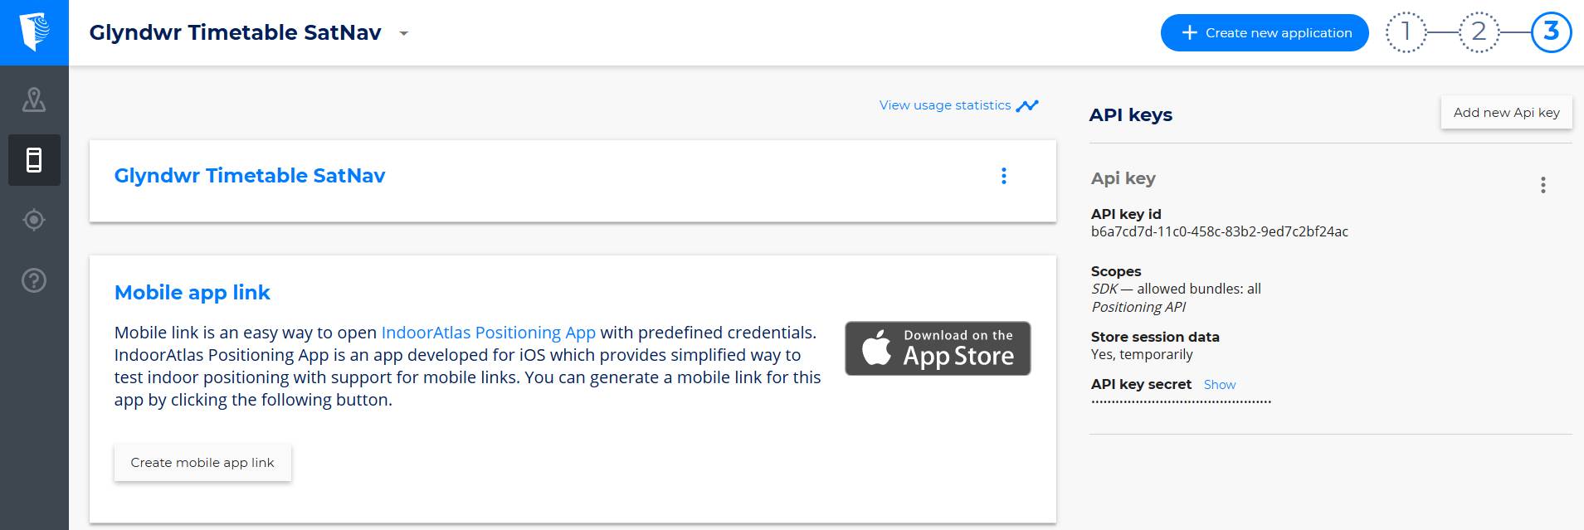

Figure - Indoor Atlas Web Tool API Key Setup

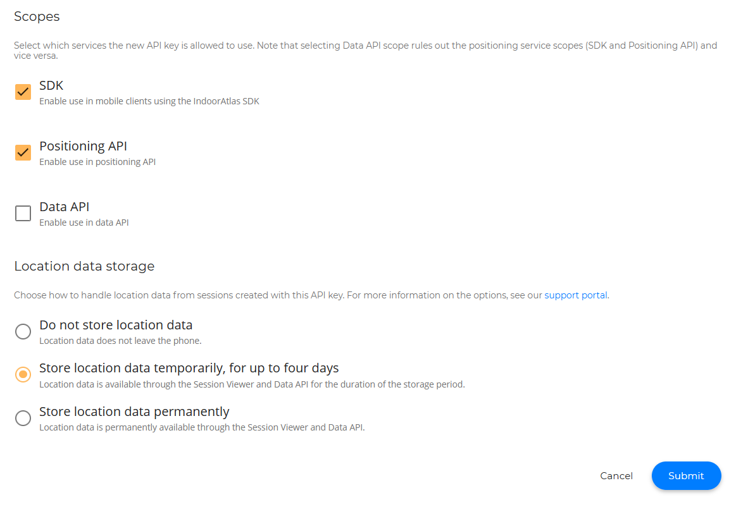

Figure - IA Webtool API Setup Process

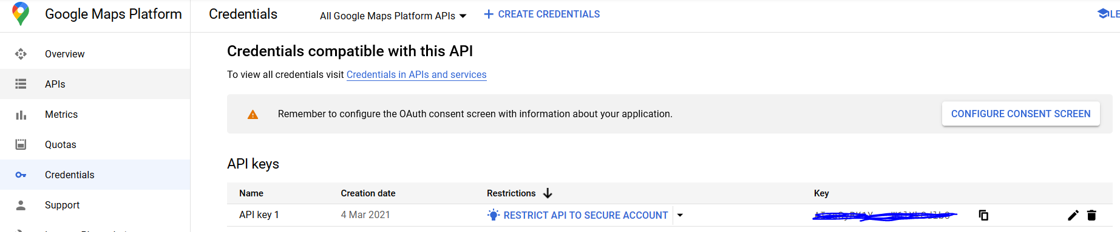

Figure - Google Maps API Credentials

Figure 79 shows the credentials tool for the google maps platform. For any large-scale usage, this is a paid for service but for small scale projects seeking to demonstrate proof of concept, the free use quotas far exceed even what testing this app requires.

Once the API keys are setup, the project needs to have some way to access these keys for when the SDK usage is required. For Indoor Atlas, the API Key and Secret are both stored in the Gradle properties of the projects file as shown in Figure 80.

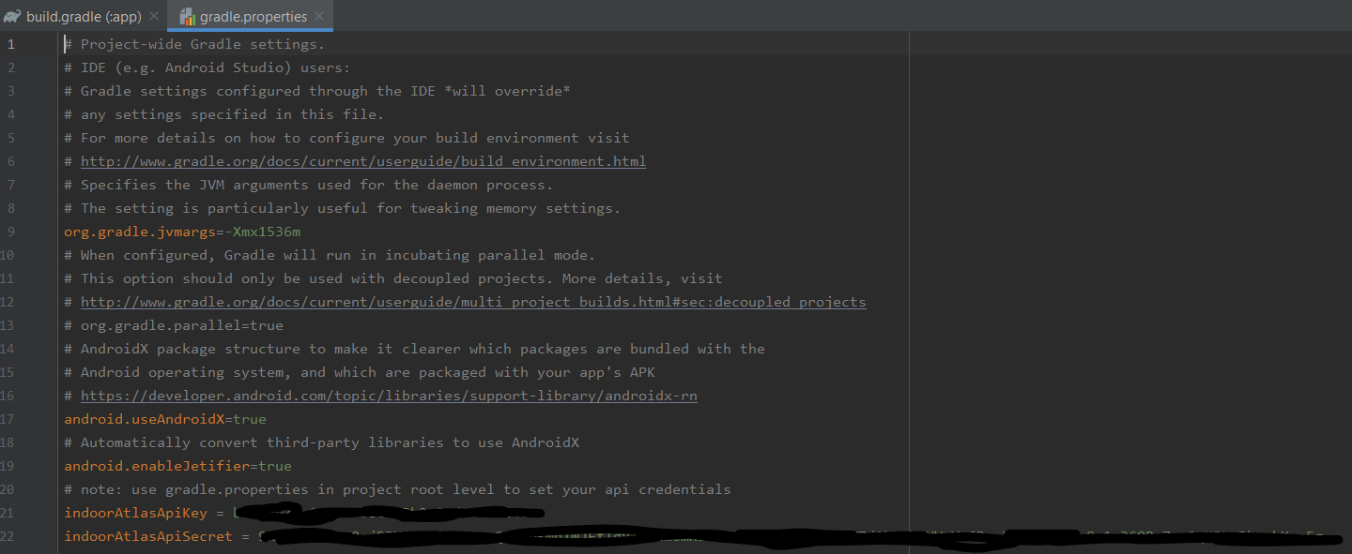

Figure - IA API and Secret Keys

For Google Maps, the API key is stored in the values folder of the project file and has an access name of “google_maps_key” to use like you would access a string. This can be seen in Figure 81.

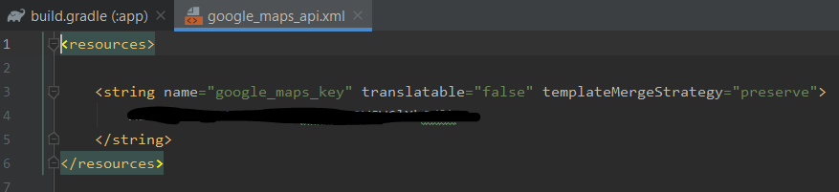

Figure - Google Maps API Key in Values

Once API keys are setup, the project will need to have its dependencies, configurations and build types.

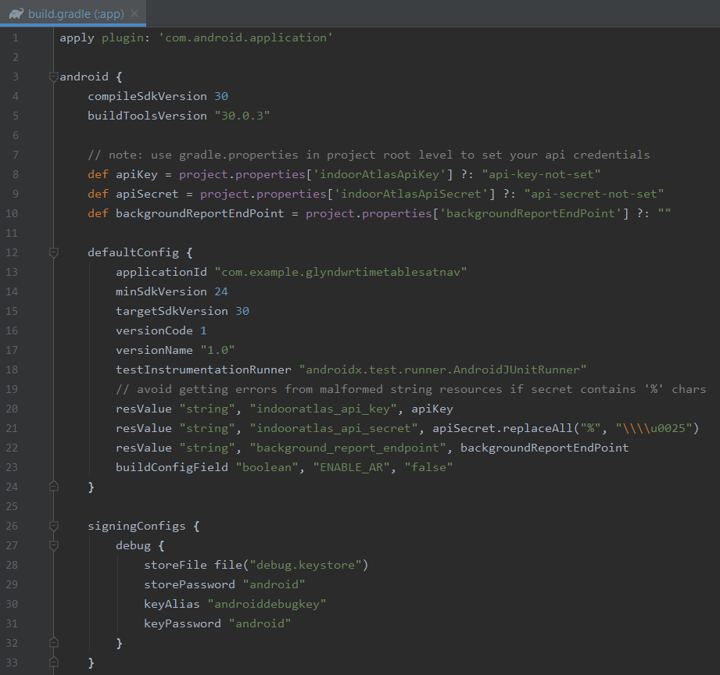

Figure - Build.gradle config 1/3

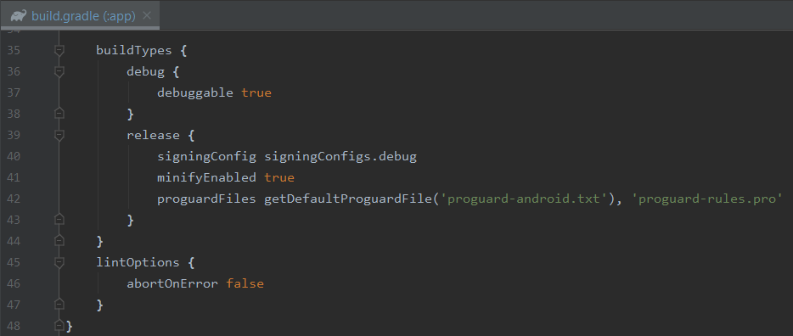

Figure Build.gradle 2/3

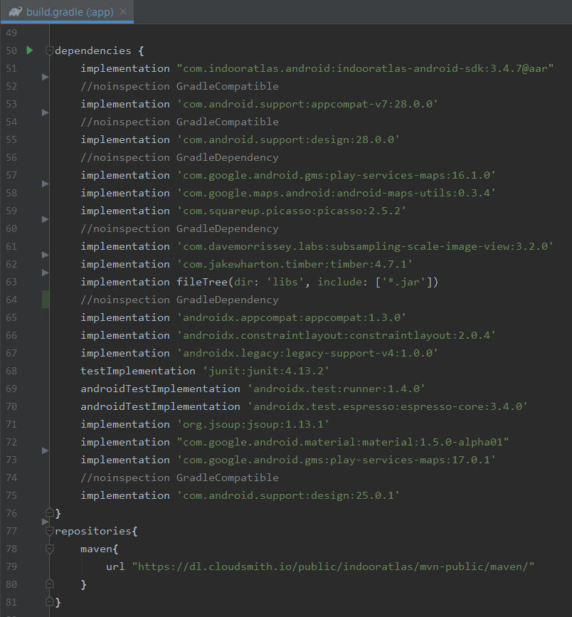

Figure - Build.gradle 3/3 – Dependencies

Figure 82 shows how the app is initially configured to API level 30 for android, it defines three checks for Indoor Atlas API keys to ensure they are set before the app runs, it provides the default configuration for the app to run in ensuring that the minimum Android API level device that can run is API level 24 (Android 7.0+ Nougat) and finally provides the keystore configuration for signing a debug version of the app so there is an APK that can be used for testing and demonstration. Figure 83 shows further details on build types but only the debug build type is necessary.

Figure 84 shows up the dependencies and repository that are needed specifically for this app. In instances where there is ‘no inspection’, the dependency warning is being suppressed as there may be later version update available. Indoor Atlas specific dependencies can be found on lines 51, 59, 61, 62 and 63 for the IA SDK, Picasso (a library used for drawing UI elements), Dave Morrissey’s sub-sampling scale image view for our imageview map [124], Jake Wharton’s timber library for logging [125] and filetree. It also shows the maven repository needed specifically for Indoor Atlas.

Once the dependencies and API keys are configured, it is important to ensure the correct permissions are configured in the android manifest file. These are shown below in Figure 85.

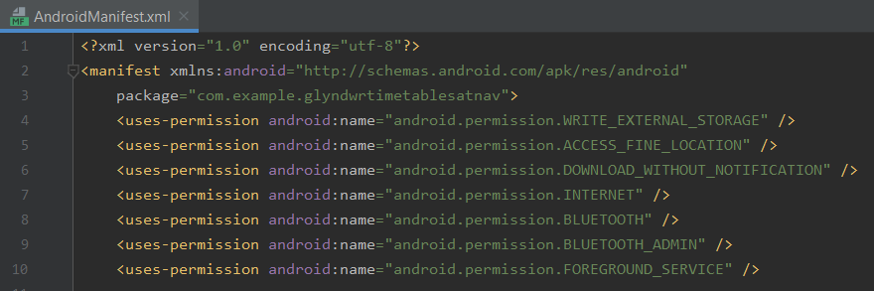

Figure - Android Manifest Permissions

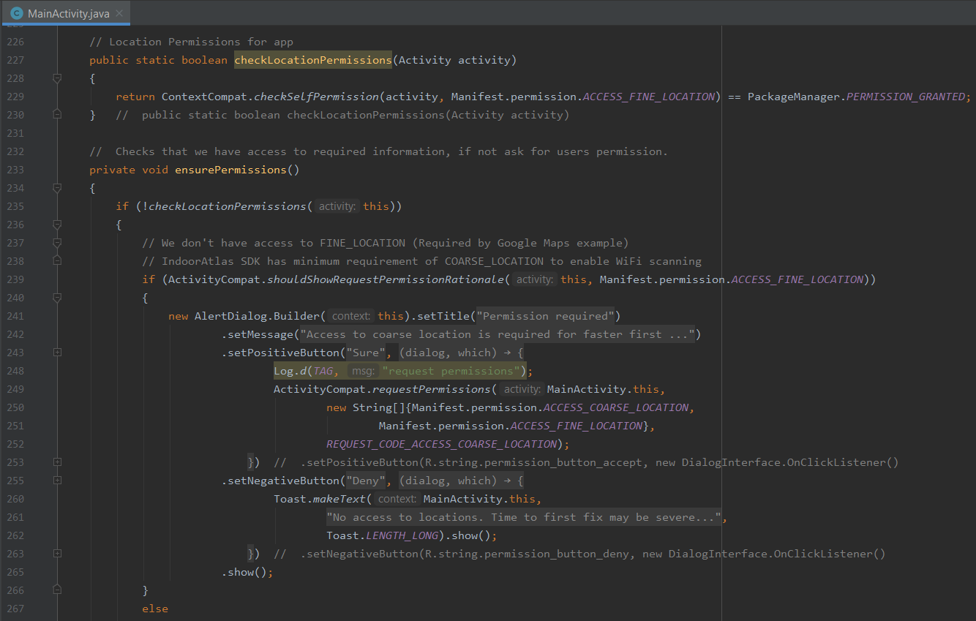

Figure - Main Activity Check Permission Functionality 1/2

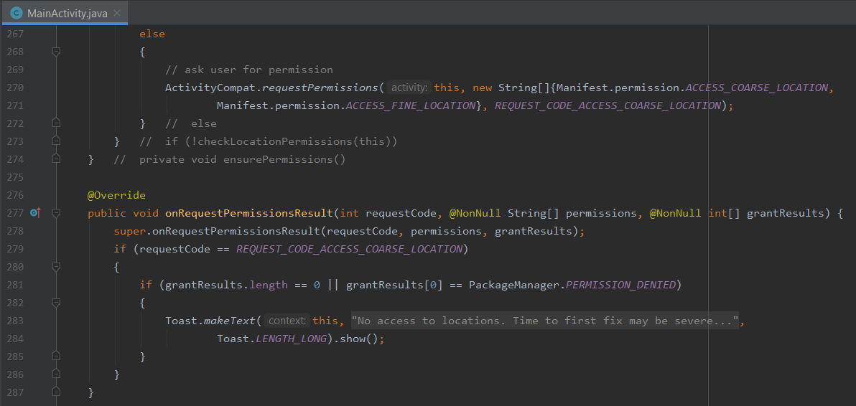

Figure - Main Activity Check Permission Functionality 2/2

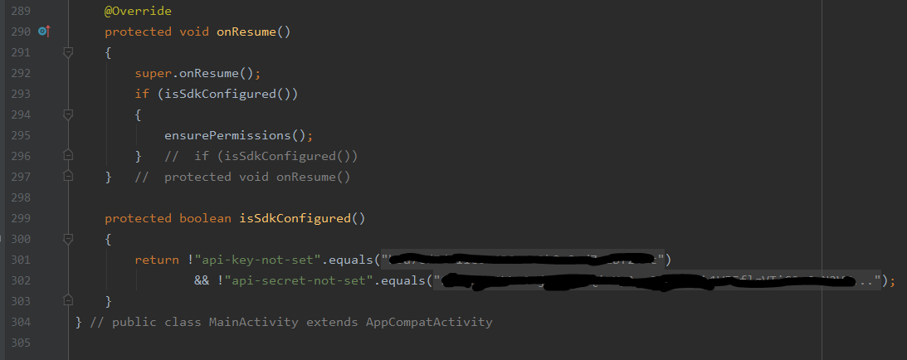

Figure - Main Activity SDK Configuration Check

#### User Location, Regions, and Drawing Map UI

The main component of the Indoor Atlas location framework is the ‘IALocationManager’ class. This class provides access to IAs services, and it must only be called from the main thread [126]. Below Figure 89 shows the ‘onCreate’ method for the wayfinding overlay activity. Here, as the activity has been created, the layout has been drawn and set to keep the screen on, the IALocationManager has been created and initialised. Figure 89 also shows method of showing the map as a support fragment and accepting the POI variables if the class has been called from timetable contents.

**IA Location Manager**

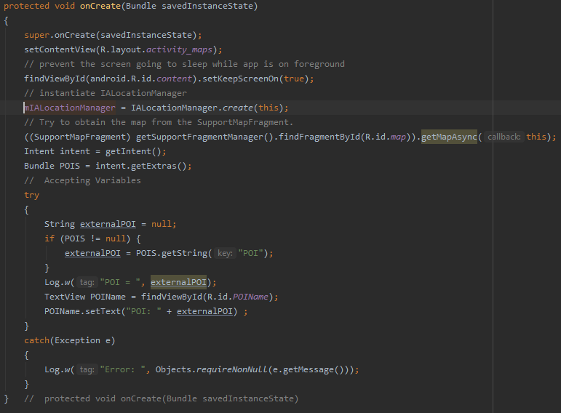

Figure - Wayfinding Activity - onCreate Method

**IA Location Listener**

Once the class has been called, periodic updates of the user’s current location can be gathered using the ‘IALocationListener’ interface [127]. This can be registered and unregistered, so it does not constantly use resources. Below Figure 90 shows how this app creates a listener method to receive updated user locations whenever the location seems to have changed. The location is logged to logcat for testing purposes – ensuring to show longitude and latitude. As it’s the final version of code, this method also shows a check for whether the map is null – ignoring location updates if it is – or if the map is not null.

In the latter case, the cross-over point of the latitude and longitude initialises a ‘centre’ variable and a floor variable is initialised. If the floor received is not on a new floor the route visualisation is updated, if the position is on a new floor, a new floor is created.

Figure 90 also has a certainty feature in acquiring the user location. Rather than simply plotting a best estimate point, a centre point is plotted, and an estimated radius is drawn around the user signifying certainty. The method for determining this can be seen in Figure 91. If the location has significantly changed either through dropout or other factors, a check on a variable called ‘mCameraPositionNeedsUpdating’ to see if the camera position on the map needs to change. If no such significant changes occur, the camera position will stay the same. This variable gets affected either through detected region changes or through the ‘onLocationChanged’ method within the IALocationListener.

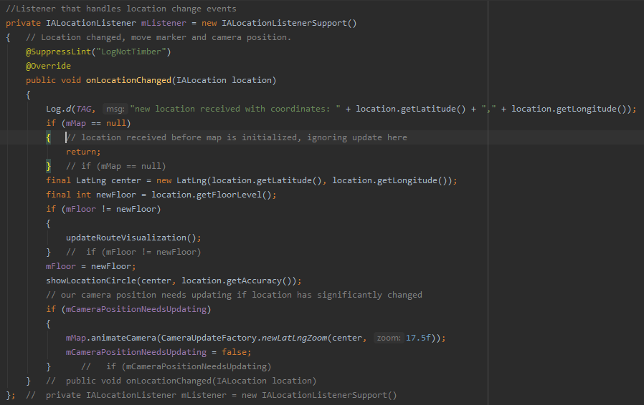

Figure - IALocationListener method

**Show Location Circle**

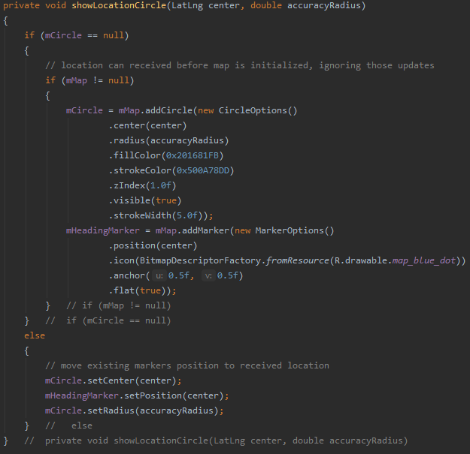

Figure - showLocationCircle Method

Figure 91 shows the Location Circle element of the user localisation functionality. This is an important feature as it shows the user where they are on the map and even more interestingly, the certainty is visually described with a faint radius about the marker. This is done by first checking that the ‘mCircle’ variable is null and ‘mMap’ variable is not null. In this instance a new ‘mCircle’ will be added to the mMap with seven circle options covering; centre, radius, fill colour, stroke colour, ‘zIndex’, visible and stroke width. Additionally, a ‘mHeadingMarker’ (this signifies direction marker seems to be facing, i.e., North) is added to the mMap with marker options; position, icon, anchor and flat.

If the mCircle is not null, there is no need for it to be recreated so the method can just move those markers to the new received location.

When using IndoorAtlas, different venues are differentiated to the service as separate entities called ‘Regions’. Each of these regions have identifier codes known as Location IDs when working in the webtool. To detect changes in region such as entering and exiting a region or whether the user is even within a region to begin with is all done using ‘IARegionListener’. This can make testing tricky if developers are working on the app external to the region but can either be overcome by live testing or by spoofing location with code.

**Region Listener**

Figure 92 demonstrates the region functionality within this app. Here a new listener is initialised, upon entering a region – an if statement checks whether the region type is just a venue or has a floor plan [128]. If a floor plan is found, it is loaded from IAs servers. A log message indicating the region ID is logged to logcat and the previously seen Camera update is changed to true indicating the map camera will need updating as there is a new floorplan.

If the ‘mGroundOverlay’ is currently not null, it will be removed and initialised to null. Then the ‘mOverlayFloorPlan’ will be initialised to the region. Two methods will then be called; firstly, the ‘fetchFloorPlanBitmap’ which is used to draw the map for the current floorplan and secondly, the ‘setupPOIS’ method to add all the POI markers to the current floor of the floorplan.

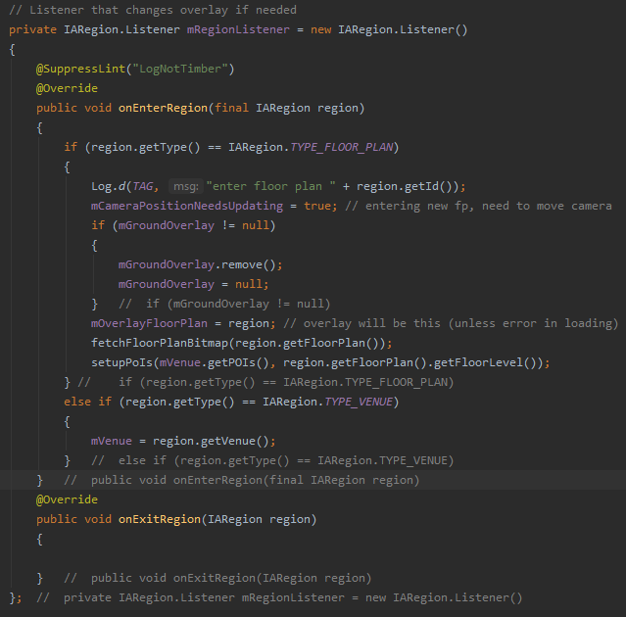

Figure - IARegionListener Region Enter and Exit Methods

**Fetch Floorplan Bitmap**

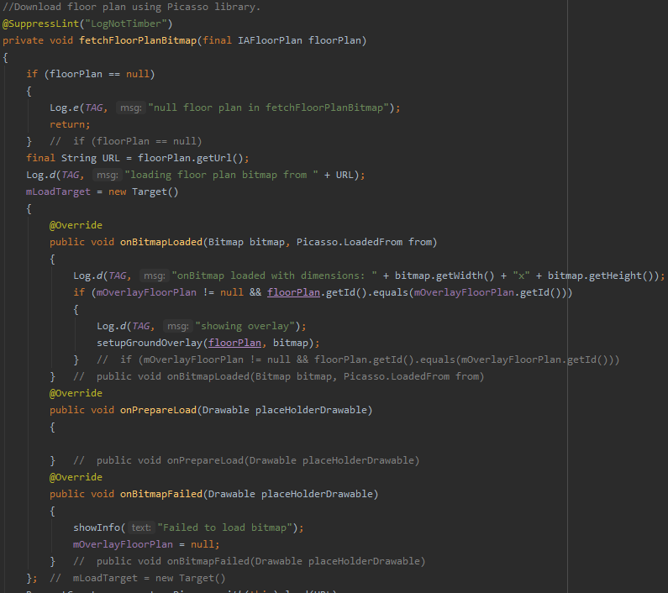

Figure - Fetch Floorplan Bitmap 1/2

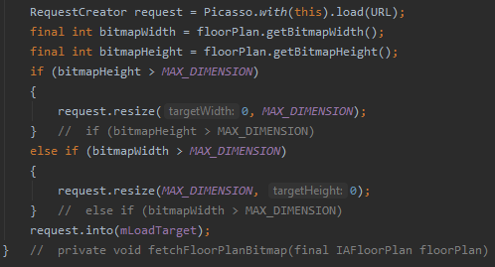

Figure - Fetch Floorplan Bitmap 2/2

Figure 93 and Figure 94 show the method for drawing the Bitmap that will display the floorplan for the user. The floorplan URL is sent to this method from the region listener method and the Picasso library [129] is used to download it [130]. Firstly, the floorplan is checked to ensure it is not null, if true the floorplans URL is assigned to string variable ‘URL’ and a new target variable is created. This target can be thought of as the destination that the map image will be loaded into. If the Bitmap load fails, a message will be displayed notifying the user.

If the Bitmap load is successful, a log message indicating success and dimensions is logged to logcat. A check to ensure ‘mOverlayFloorPlan’ is not null and that the floorplan ID is equal to the ‘mOverlayFloorPlan’ ID is carried out. If successful, the overlay will be shown. If the Bitmap fails to load, the ‘mOverlayFloorPlan’ will be re-initialised to null.

After the target routine has finished, Figure 94 shows a request to Picasso to load the image from the URL, the bitmap width and height are initialised to the floorplan. This class sets a limit on the max dimensions available for a bitmap so if either the width or height exceeds this value, the requested image from Picasso will be downsized using ‘request.resize’. If its smaller than the max dimensions, then it can be directly loaded without issue. These checks ensure the image is not too large and cumbersome to use within the app.

**Set Up Ground Overlay**

When using IndoorAtlas with google maps as is done in this project, a ground overlay is required. The method described below in Figure 95 takes the floorplan and the bitmap created in the ‘IARegionListener’ and ‘fetchFloorPlanBitmap’ methods respectively.

The method first starts by checking for an existing ‘mGroundOverlay’, if there is one it removes it. The second statement checks if the mMap is exists. If true, a new ‘bitmapDescriptor’ is made from the bitmap, the centre point of the map is initialised, and the floorplan overlay is created with four options covering; image (using the bitmap descriptor), ‘zIndex’, position(using centre, floorplan width and floorplan height) and bearing. Once a new ‘mGroundOverlay’ is created, it is added to the mMap.

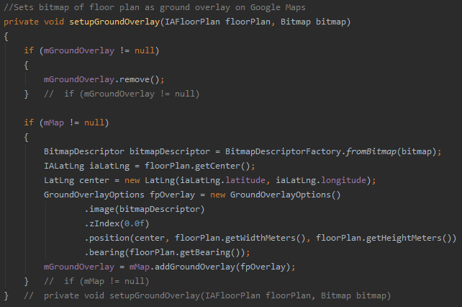

Figure - Set Up Ground Overlay Method

**Activity Lifecycle – onDestroy, onResume, and onPause**

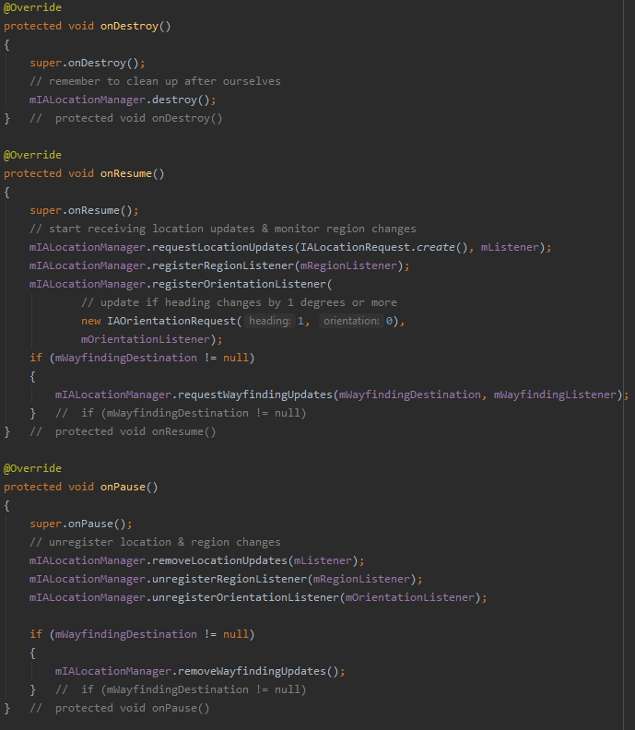

Figure - Map Activity Lifecycle methods

The lifecycle of the activity begins with onCreate which is shown in Figure 89. This is not the only stage of the activity’s lifecycle to have functionality though as Figure 96 shows the ‘onDestroy’, ‘onResume’, and ‘onPause’ aspects of the lifecycle. These four methods are most typical to an activity’s lifecycle alongside ‘onStart’ and ‘onStop’ [131].

When the activity is to be destroyed either through exiting the activity or closing the app, it is important that the IALocationManager connection we created is destroyed to stop further location updates and free up resources. This may be done by the device, but good code practice dictates than cleaning up after usage is important.

onResume is entered when the activity is resumed and brought to the foreground [131]. In Figure 96, onResume is used to restart three listeners for the IALocationManager: Location Updates, Region Listener and Orientation Listener. A check is also carried out on ‘mWayfindingDestination’, if it is not null, wayfinding updates will be requested.

onPause is called as the first indicator that a user is leaving the activity (this does not necessarily mean that the activity is to be destroyed though). In Figure 96, onPause is used to do three things to the IALocationManager; remove location updates, unregister the Region Listener and unregister the Orientation Listener. Additionally, if there is a wayfinding destination currently set, it will remove wayfinding updates from IALocationManager.

**Google Maps – onMapReady and onMapClick**

Aside from the typical lifecycle of an activity, this class implements both ‘GoogleMap.OnMapClickListener’ and ‘OnMapReadyCallBack’. These can be thought of as an extension to the lifecycle specific to the usage of google maps in this class. The former is a callback interface for when the user taps on the map [132] and the latter a callback interface for when the map is ready to be used [133].

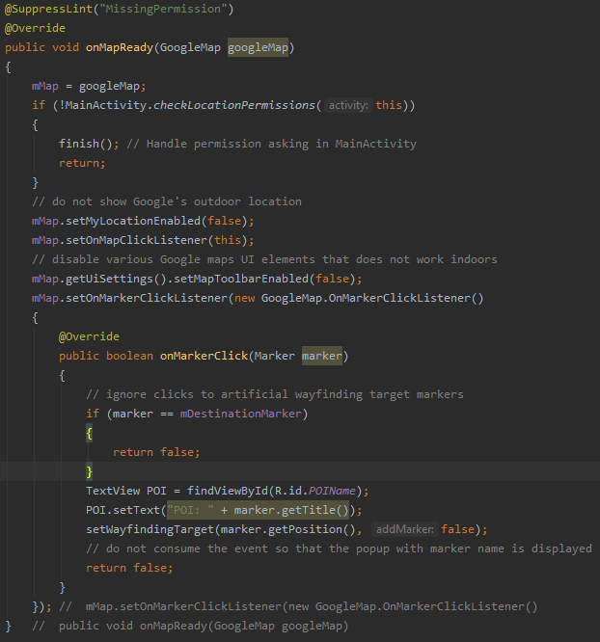

Figure - OnMapReady Method

Figure 97 shows the ‘onMapReady’ method, this method is called when the google map is ready to be used. It starts by initialising the mMap to the googleMap. Before any location gathering is started, it next checks for whether location permissions were granted by the user in the main activity when the app was first loaded. If successful, it continues on to disabling some features of the google map to stop showing outdoor location.

UI elements of the google map which don’t work indoors are then disabled such as map toolbar. Once the map is configured in a way that’s desirable for the program, a marker click listener is initiated. A marker represents a point on a google map such as a point of interest. Here the programs ignore artificial wayfinding target markers, initialises the POI text label to either the variable sent from the timetable contents or to the title of a marker that the user has clicked. Once a marker is selected, the ‘setWayfindingTarget’ method is called.

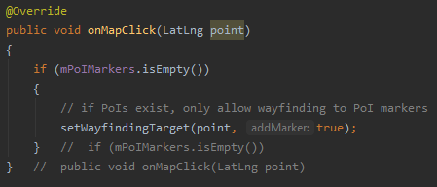

Figure - OnMapClick Method

Figure 98 allows the user to select a point of their choosing on the map to navigate to if the array of POI markers is empty. Thus, allowing artificial wayfinding markers that ‘OnMapReady’ suppressed.

#### POIs List, Wayfinding, and the Timetable connection

Now that the map is drawn and user localisation is implemented, wayfinding and route visualisation need to be implemented. This starts with first giving the user a set of POI markers that they can click on the navigate to. POIs are delivered to the app through region events [134].Figure 99 describes this method. It begins by removing any existing markers then using a for loop to go through each POI in a ‘IAPOI’ list. If the POI has the same floor level as the current shown floor level it gets added to an array called ‘mPOIMarkers’ using ‘mMap.addMarker’ with marker options; title, position (consisting of latitude and longitude of the poi) and icon.

**Set Up POIs**

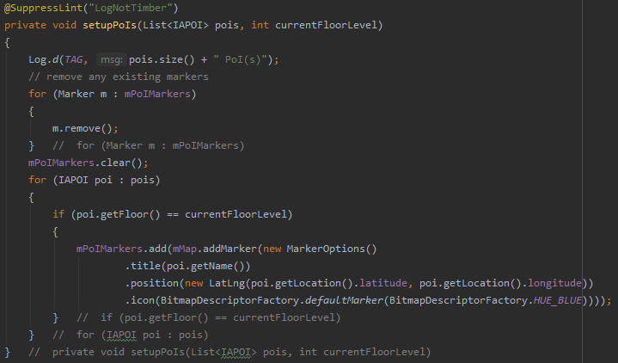

Figure - Set Up POIs Method

**Set Wayfinding Target**

If POIs have successfully loaded – or in the instance there are no pois, and a user selects an artificial waypoint – the ‘setWayfindingTarget’ method is called. Figure 100 shows this method. Firstly, a check is carried out to ensure that the mMap is not null (if it is, its logged to logcat).

A new wayfinding destination is then created using ‘IAWayfindingRequest.Builder’ with options; floor, latitude, and longitude for to marker selected [135]. IALocationManager’s request wayfinding updates is called with the parameters ‘mWayfindingDestination’ and ‘mWayfindingListener’. After calling this, more good code practice is used by clearing destination marker and the destination is logged to logcat.

Figure 101 shows the wayfinding listener method, this starts by initialising the current route to route provided from the visualisation. Wayfinding is stopped if this route has arrived at destination and a message notifies the user of their arrival and the current route are destination are made null and IALocationManager’s wayfinding updates are removed. If this statement is still false, route visualisation is updated for the user.

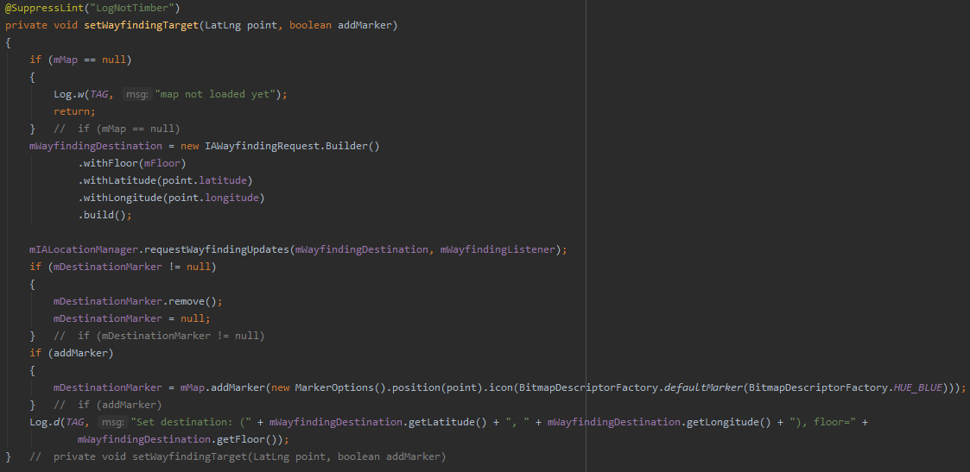

Figure - Set Wayfinding Target Method

**IA Wayfinding Listener**

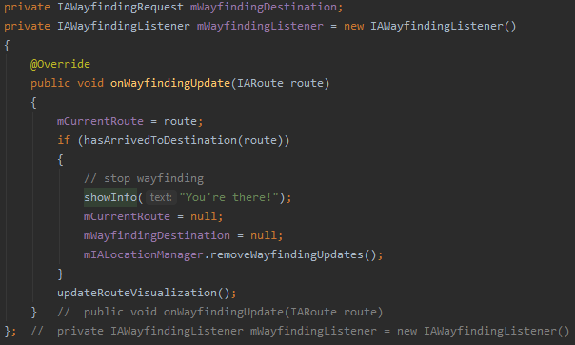

Figure - IA Wayfinding Listener Method

**IA Orientation Listener**

Figure 102and Figure 103deal with heading and bearing components of navigation, in this activity, only heading is needed for functionality so each time the orientation listener detects a heading change ‘updateHeading’ is called. When called, this method checks whether the heading marker is null, if it’s not then the rotation of the marker is updated to the new heading.

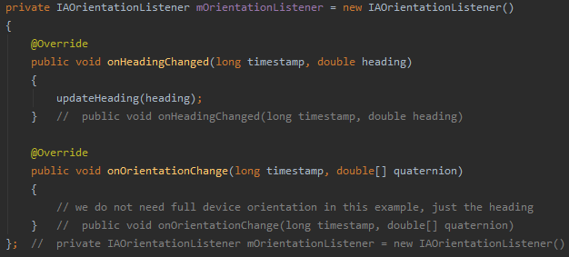

Figure - IA Orientation Listener Method

**Update Heading**

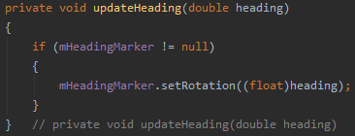

Figure - Update Heading Method

##### 7.2.3.2.1. Route Visualisation

Route Visualisation is an important graphical element to the user and amounts to be the major component of this app that provides navigational assistance to the user. These methods make use of earlier development described in Figure 46, Figure 47, Figure 48, and Figure 49 where the wayfinding graph was created using nodes as points and edges as connections between nodes [136].

The first aspect of this visualisation in described in Figure 104 as ‘updateRouteVisualisation’. This method is called from both the IALocationListener and the IAWayfindingListener methods and its main purpose is to visualise the wayfinding route on top of the map and overlay.

The method starts by clearing any existing route visualisation, checking that current route is not null and if successful the route building starts from the first for loop. The current route is built of legs which are the edges between nodes from the above-mentioned graph. For each leg in the IARoute it first checks if the leg has an edge (if it does not it’s usually a starting or ending point).

‘PolyLineOptions’ are used to create a line from a beginning point of the node (using its latitude and longitude) to an end point of the next node. If the next node happens to be on a different floor, the line will be in a semi-transparent colour. Once a line is configured, it is added to the mMaps Polyline. Once the for loop is finished, the entire route’s line should be shown.

**Update Route Visualisation**

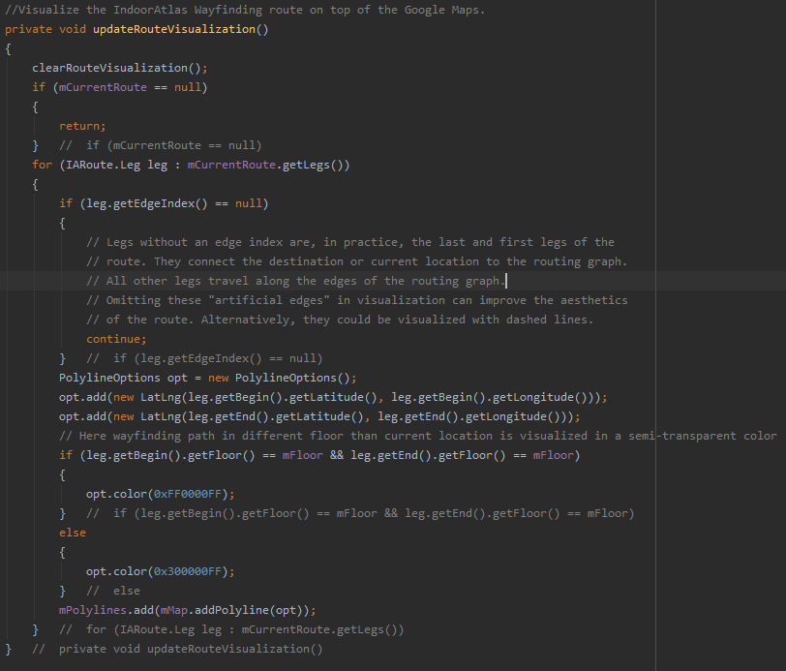

Figure – Update Route Visualisation Update

**Clear Route Visualisation**

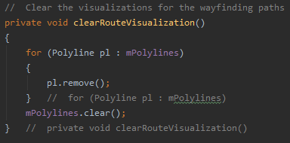

Figure - Clear Route Visualisation Method

**Has Arrived at Destination**

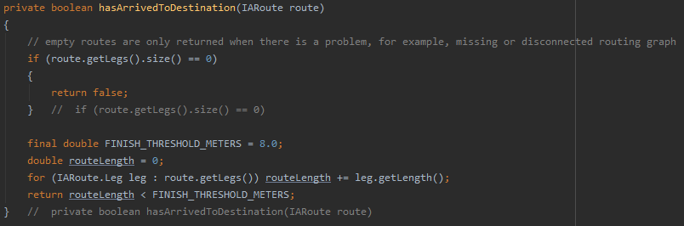

Figure - Arrived at Destination Method

Figure 105 describes the clear route visualisation method that is called to clear existing routes before plotting. Figure 106 shows the ‘has Arrived at Destination’ method called from the wayfinding listener when the user location matches the end node of the route. This method begins by checking for route issues like missing or disconnected graphs and returns false. The threshold for successfully arriving is being within eight meters, the final part of this method checks how many meters it anticipates is left of the route and if the routes length is less than this threshold, navigation is deemed to be successful.

#### UI Improvements

In chapter 6.1.1, consideration was given for good practice design principles for users with accessibility issues. This highlighted different fonts and the need for careful colour selection for house style to make app design and development more accessibly friendly. Before sprint two was adapted and AR functionality was delayed to third sprint and the next tier of MVP, the design assumed AR functionality would provide the bulk amount of accessibility friendly features.

To ensure that this sprints MVP has some level of accessibility, the remaining time within the sprint was used to improve UI elements to better suit this goal. To do this, the style sheet for the project as seen in Figure 107 has added style line to force text view’s and buttons throughout the project to use font ‘Roboto’. This font was identified in the above-mentioned chapter as a font suitable for those with dyslexia due to the increased space between letters and the sans serif style [104].

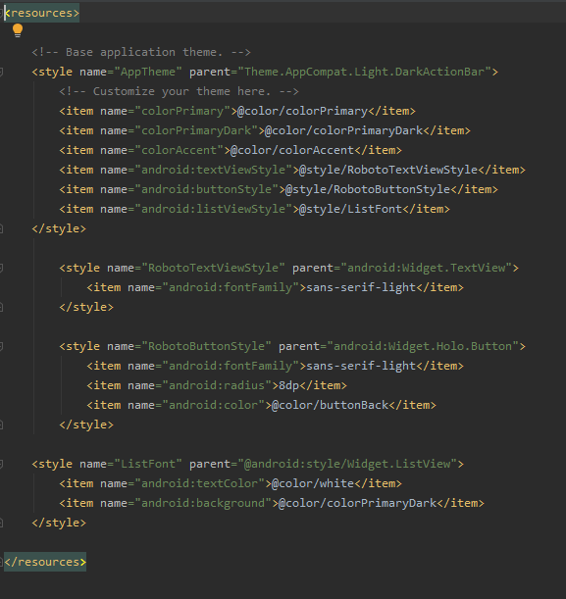

Figure - Style Resource

Aside from this change, the UI’s colour scheme has also adapted somewhat to take out black text on white background which is an issue for dyslexia and replace it with the existing ‘colorPrimaryDark’ as background throughout and white text for all text elements. There are four main types of colour blindness that are; Trichromacy, Anomalous Trichromacy, Dichromacy and Monochromacy [137]. Trichromacy uses all three cones correctly to see all three types of light and normal people are considered Trichromats.

Anomalous Trichromacy have ‘faults’ with one or more of these cones resulting in either; protanomaly (reduced sensitivity to red light), deuteranomaly (reduced sensitivity to green light) or tritanomaly (reduced sensitivity to blue light). The latter is extremely rare whereas those who fall in the former category are collectively known as red-green colour blind and have difficulty with reds, greens, browns, and oranges [137]. People with the rarer tritanomaly have issues with; blue and yellow; violet and red; and blue and green.

People with dichromatic colour vision has only two types of cones and fall into three types; Protanopia, Deuteranopes and Tritanopes. Finally, people with monochromatic vision can see only in shades of grey through black and white [137].

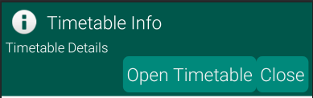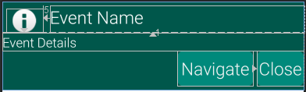When designing for colour blindness it is best to avoid bad colour combinations such as; Green & Red, Green & Brown, Blue & Purple, Green & Blue, Light Green & Yellow, Blue & Grey, Green & Grey and Green & Black [138]. Therefore, the choice made to use dark green and white for text should be more than suitable in a decent approach to improving accessibility. Below are figures 108 to 112 that demonstrate this change in house style.

Figure - Timetable Dialog updated UI

Figure - Event Dialog updated UI

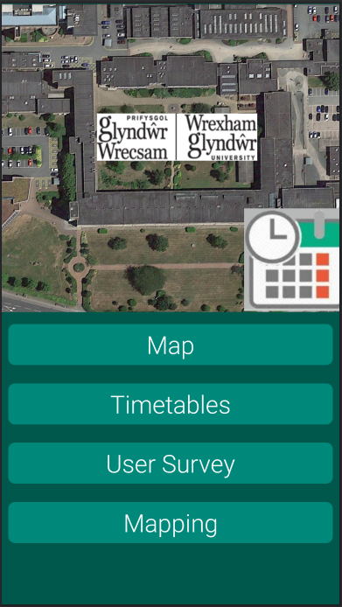

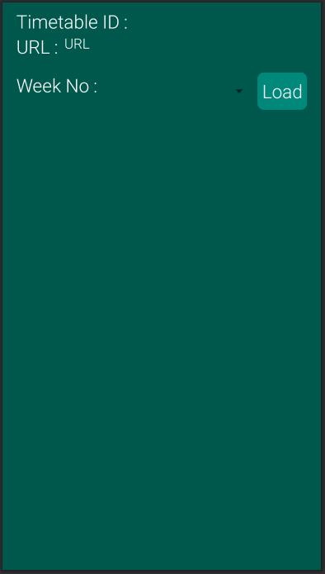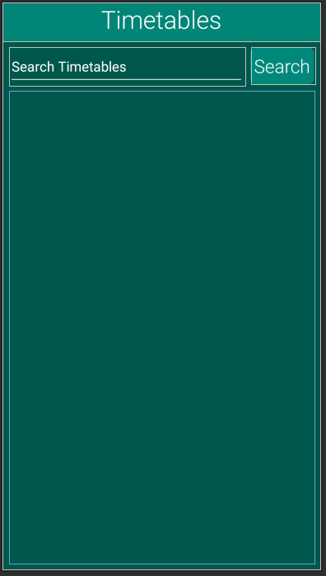

Figure - Timetable Contents UI

### Sprint Two Retrospection

Figure - Timetables updated UI

Figure - Main Menu updated UI

Sprint two has achieved nearly all of its goals within the timeframe chosen. All user stories set out in Table 5 have working functionality and additionally, the UI has been overhauled to cover more accessibility elements such as colour blindness and dyslexia.

Unfortunately, despite some small testing whilst development that shows the navigation and localisation is functioning really well, there are occasional dropouts, but the location marker catches up quickly when the location is re-localised. The timetable connection is primitive in comparison to what was initially desired of the functionality as the POI is simply labelled below the map while the desire was for the route to initialise as the map is loaded from timetable contents. This was, in part, due to limited logic design in this area as Indoor Atlas was found later on in the literature review period and also due to limited demonstration of functionality to be found online.

If more time and planning were available within the projects timeframe, implementation of this could be done by creating a table in the database populated with all the known POI names, longitude, latitude, and floor number. Then when the map is opened from the timetable, the resulting POI record is called from the database by searching for it with the POI variable.

This variable and all its fields can then be used similar to how POIs are set up with mMap.addMarker with options; title, position (longitude and latitude) and icon. This marker can then be set as the wayfinding target by calling the ‘setWayfindingTarget’ method.

Additionally, after further testing, rooms that are timetabled but external to the scope of the application are still included. Luckily, this doesn’t break functionality and the user can see the room as the POI but can’t navigate to it.

## Sprint Reviews and MVP

After sprints one and two, the artefact has reached Stage 2 Minimum Viable Product as laid out in chapter 4.4. At this point, there is no time left within the project timeframe to continue with further sprints and as such this artefact should be considered as ‘proof of concept’ which should sufficiently determine after testing whether the hypothesis ‘It is possible to create a ‘Timetable Satnav’ Android application’ is true.

## Future Development: Improvements and Points to Consider

As with any project, there have been shortcomings due to limited timeframe and the scope of this application is deliberately narrow due to the large applicability of its underlying technologies in varying settings.

If someone were to take this application as it is now, there are areas for improvement and additional features that could provide a much fuller and positive user experience. These cover areas such as; Augmented Reality navigation, Accessibility issues, the wayfinding system, indoor-outdoor detection, and improved infrastructure.

1. **Augmented Reality navigation – AR**

Having previously looked during the literature research, many successful indoor navigation artefacts have made excellent use of augmented reality on smartphones through various solutions such as Google’s ARCore [49], Apple’s ARKit [51] and other offerings from smaller companies like Vuforia [139].

Augmented reality toolkits are useful for two major elements; accurate centimetre scale accuracy in movement and it is a very capable form of UI for users with accessibility issues like visual impairments [27]. On its own, AR cannot be accurate without knowledge of its environment, an accurate environmental feature can lend to that or using AR in a hybrid approach to indoor navigation can make use of both solutions to increase accuracy and provide an intuitive UI for users.

1. **Accessibility – Lifts, Ramps and Fire Exits**

Other accessibility issues that have not been dealt with in this app are specialised routes like ramps, lifts and fire exits routes. Implementing these can be done using Indoor Atlas web tool and added into the wayfinding graph. The application will then need user options to enable accessibility routes and a button for finding near fire exit route and wayfinding for it. At the very least, the UI was overhauled in sprint two to be accessible to colour-blind and dyslexic individuals.

1. **Wayfinding**

This app achieves all it needs to regarding timetables but not elegantly. Some third party solutions like ‘weekview’ [140] or first party routes using ‘TabLayout’ [141] with ‘ViewPager2’ [142] can be used to construct an interface with five tabs for each weekday. Upon each click, a fragment or list fragment can show the content for that given day below the tabs.

Aside from timetables for this university, the wayfinding system can be adapted to suit all sorts of environments from museums and historical sites with tours to public transit such as planes, buses and trains to school, college, universities, music venues, and sports events.

1. **Indoor-Outdoor Detection and Improved Infrastructure**

Last but not least, indoor navigation systems like this one do not have to be closed off and concerned with one area alone. Solutions like Google Indoor Maps [3] and Apple’s Indoor Maps [11] are small steps towards a future where many different venues can be mapped by businesses and users for different purposes. With indoor-outdoor detection, these experiences can be seamlessly explored and provide the user a vibrant way to explore different areas and events.

Infrastructure is always improving with more quantity and quality of Wireless Access Points but for venues who are drawn to indoor navigation should seriously consider implementing Bluetooth beacons or RFID tags. These greatly increase accuracy and offload a lot of the heavy processing workload off the smartphone, thus improving battery life. This infrastructure also enables ‘offline’ usage where Wi-Fi may have blackspots.

# Testing

Stage 3 – Postgame Phase

The testing phase is considered the third phase to any development cycle. In this instance, using the Scrum methodology this phase is known as the Post game phase. In this chapter, two types of testing will be undertaken on the developed artefact. Firstly, Software testing will help determine the main research hypothesis as only a correctly functioning artefact will suit as proof of concept. In chapter 6.4.1, test plans have been derived to best test this artefact in line with project timeline and resources. Down below in Appendix C – Test Plan Document and Appendix D – Testing Incident Report, the document for the test plan and the associated test incident report can be found for initial results.

## Software Testing

For software testing, the plan is to carry out at least two-unit tests, a system and integration test (this will be done using a decision table to guide a consistent path), data flow testing using Logcat messages on the open database class, a user acceptance test by equivalence testing different aspects like timetable search and beta testing which will overlap with user surveying. Beta testing will overlap as initial feedback about functionality will be fed through incident reports while the user’s opinion and experience with the app will be recorded anonymously on a google forms survey.

### Unit Testing

After having gone over the project code, a lot of what could be considered units are actually dependent upon other modules, although, two main unit tests and an instrumented test have been found and tested using android Junit testing [143] and an instrumented unit test [144]. The former is used to directly test a unit of code and ensure that expected results arise whilst the latter uses the android device instrument to run the code and ensure expected results arise.

#### Web Scrape Timetables and Timetable Contents Unit Tests

The Web scraping unit tests directly take their respective methods from the main activity and timetables activity with very little changes. Where there were parameters passed from other methods or classes like in the contents scrape with URL these have been hardcoded. A positive result will only arise provided each of the scraped fields return a not null variable. The results are below in Figure 113.

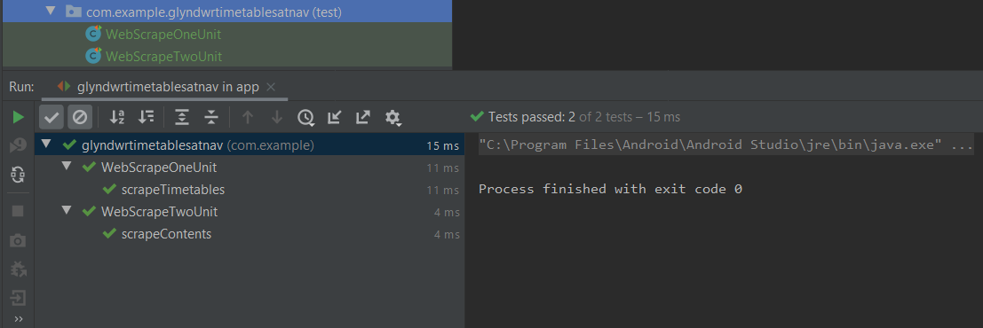

Figure - Web Scraping Unit Tests

#### Map Instrumented Test

The Map test was slightly different in that it tested the whole class as a unit. Assertions that variables were not null were made for; Load Target in fetching floorplan bitmap, ground overlay in set up ground overlay, that the array storing the POI Markers was not null, and that first location ping for latitude, longitude, and the determined centre point of each was not null. This is as far of a test as can be done as a unit with this class and the remaining features require human interaction. The test was successful as Figure 114shows below, the location was successful because an instrumented test uses the device to carry out the unit test.

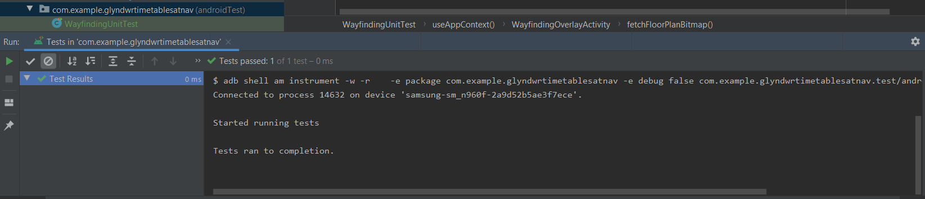

Figure - Instrumented Unit Test - Maps

### Systems and Integration Testing

Decision Tables

Table - Integration Test Decision Table

|  |  |  |
| --- | --- | --- |
| Navigate to B118 from Timetables – Decision Table | | |
| Stage 1: Main Menu | Decision | Result |
| * Click Map | False | Opens Map |
| * Click Timetables (Opens Stage 2) | True | ✓ |
| * Click Survey | False | Opens Survey |
| Stage 2: Timetables |  |  |
| * Click Record | False | Opens random record |
| * Search B118 | True | ✓ |
| * Click Record | False | No active search results, opens random record |
| * Click Search | True | ✓ |
| * Click Record (Opens Stage 3) | True | ✓ |
| Stage 3: Timetable Dialog |  |  |
| * Click Open (Opens Stage 4) | True | ✓ |
| * Click Close | False | Goes back to timetables |
| * Tap Off | False | Goes back to timetables |
| Stage 4: Timetable Contents |  |  |
| * Click Record | False | List item alert popup: “Not an item” |
| * Select Week | True | ✓ |
| * Click Record | False | List item alert popup: “Not an item” |
| * Click Load | True | ✓ |
| * Click Record (Opens Stage 5) | True | ✓ (Selected Week 15 – Wednesday lecture) |
| Stage 5: Timetable Contents Dialog |  |  |
| * Click Open (Opens Stage 6) | True | ✓ |
| * Click Close | False | Goes back |
| * Tap Off | False | Goes back |
| Stage 6 - Maps |  |  |
| * Click on POI marker that matches POI below (Starts correct navigation) | True | Floor detection off by marginal amount, detected ground floor at first. After moving, B118 was accessible to navigate |
| * Click anything | False | POI changes and starts navigation to other room |

After integration testing, the test proved fully functional for the user to navigate to a room using the timetable wayfinding system. Although, the floor detection at the end mistakenly thought it was ground floor level until the device started moving somewhat. This changed the floor level to the correct floor and navigation to B118 could begin.

### Data Flow Testing

To demonstrate successful data flow for the SQL database. A figure showing what is to be expected after a successful test and a figure showing the logcat with the successful log message will be shown for each aspect of the Open Database class.

#### Remove Timetables



Figure - Remove Timetables expected Log Message



Figure - Remove Timetables Log Results

#### Add Timetable

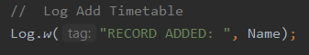

Figure - Add Timetable expected Log Message

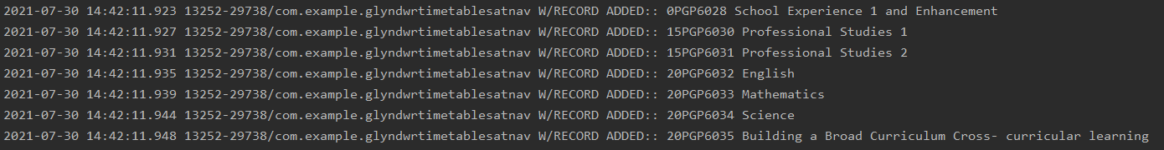

Figure - Add Timetable partial Log Results

#### List All Timetables



Figure - List All Timetables expected Log Message



Figure - List All Timetables Log Results

#### Search Timetables

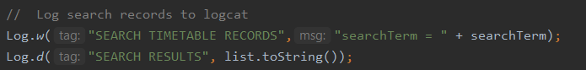

Figure - Search Timetables expected Log Message



Figure - Search Timetables Log Results

#### Remove Timetable Contents



Figure - Remove Timetable Contents expected Log Message



Figure - Remove Timetables Log Results

#### Add Timetable Event

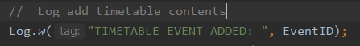

Figure - Add Timetable Event expected Log Message(s)

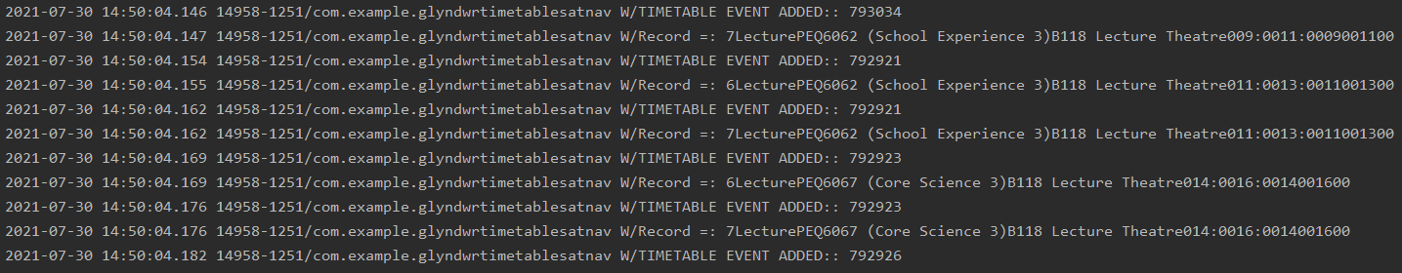

Figure - Add Timetable Event Partial Log Results

#### Retrieve Weeks



Figure - Retrieve Weeks expected Log Message



Figure - Retrieve Weeks Log Results

#### Week Contents

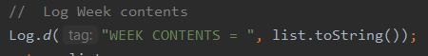

Figure - Week Contents expected Log Message



Figure - Week Contents Log Results

#### Retrieve Event Details

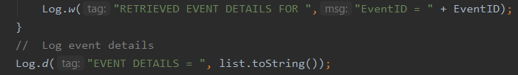

Figure - Retrieve Event Details expected Log Message

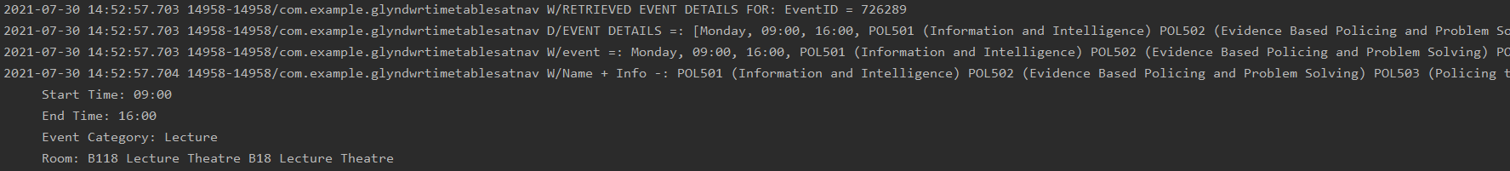

Figure - Retrieve Event Details Log Results

Figure 115 to Figure 132 show a very successful data flow test. Each component had passed expectation, showing data flow in and out of the table as well as CRUD operations performed on the database. Some tests like Figure 118 and Figure 126 only show partial log results as they created a log message for each iteration in the for loop and perhaps a more efficient test would be to log the list with a message after the loop reaches completion.

### User Acceptance

This section was added in the hopes that the app could be made more intuitive and fool proof and has highlighted the most issues during the software testing to this point. In Appendix D – Testing Incident Report, some issues have arisen out of trying to use the app unintuitively such as clicking on week numbers that are pointers like “select a week” to selecting a list item like “Please select a week and load” in the timetable contents. Issues like searching for ‘modul’ instead of ‘module’ were easily handled as the SQL search carries out a ‘%like%’ search for terms that are or at least include that term.

As its designed to be proof of concept, no testing has been done to determine whether the search feature is vulnerable to SQL injection attacks as users familiar with such attacks could devise several terms to potentially affect the database. It is however, of no value to do so as the data is publicly available, extracted from the source and always dynamically loaded so no lasting changes can be made.

### Beta Testing – Initial Feedback

During user testing, Appendix D – Testing Incident Report has also been filled in with some user feedback. Initial testing has shown the floor detection is slightly off as the default separation distance of 5.4m is greater than the actual difference between floors. An initial distance of 5m has been put in and it seems to work better for floor detection though further testing is needed.

Also, the map seems to drop out along the first floor B corridor. This is slightly to be expected due to the very poor Wi-Fi signal quality as seen in Figure 45. If the issue continues to persist, more mapping paths for that corridor should be made and the upper floor map regenerated to try and improve detection. It could also be that the user is mistaking a dropout with the arrival to destination alert as it’s a smaller popup at the bottom of the screen.

### Software Testing and the Research Hypothesis

Given that all software testing has been successful - including the overlapping beta testing showing success as can be seen in Figure 134 – it suggests that the research hypothesis that was originally formulated in Chapter 3.1 - Research Hypothesis of “It is possible to create a ‘Timetable Satnav’ Android application” has been proven to be true.

In this project, an android application that can navigate indoor environments through the use of timetable wayfinding has been successfully designed, developed, and demonstrated. This not only highlights the possibility of such a system but suggests an area of exploration for indoor navigation apps to make use of venue specific information in order to improve the users experience.

## User Testing and Survey

The user testing strategy is aimed at gathering user opinion and experience in an anonymous survey after initial experience with the app. The final design for the survey can be found in Appendix E – Final Survey Design. This survey is hosted on Google forms and takes in no personal data, full results of the survey are made available only to the developer and project supervisor with tabulated results found in Appendix F – Survey Results and later analysed in Chapter 8.3.

Due to the Covid19 Pandemic, user testing will be carried out either one-to-one or in small groups due to the need to fill in track and trace at the university reception. Moreover, social distancing, face masks and directed routes around the university will be followed to stay in compliance with Welsh Coronavirus Regulations [145] and the universities own Coronavirus policies [146]. Though the university already seems empty when visits have been made for development and testing save for staff.

The surveys final design ensures to inform the user of the intention of the survey, the requirements to participate (being over age of consent and 18+), informs them of what will be done with their responses and asks that they first ensure they have used the app and developed their own opinion ready for the survey.

The first two questions ask about functionality and tie in with chapter 8.1.5 of testing. Here users can say if the app was non-functional and why just like a user may report a ticket to an IT support engineer as it gets picked up by the developer, written into the incident report and a fix should be implemented soon if it’s seen as a major bug.

Following that, the survey asks Likert scale-based questions on how accurate the user thinks the location and navigation was, whether they thought the timetables functionality was easy to use and whether they prefer navigating via timetables or via the map.

The users are then asked how well they agree with three statements on whether they can find their own way around easily, did the app improve their navigational capabilities and would they use the app again. The last two questions were centred around how useful they found the app and in long answer form, what improvements if any, do they suggest could be implemented to improve the whole experience.

## Initial Results

After the testing stage was complete, a total of 9 users had user tested the app and put in a survey response. If the research type was more concentrated and qualitative like interviewing or a focus group, this number of testers would be considered good, however, for a survey this number falls short, and no real conclusive data and trends can be extracted without a margin of error.

This limitation of user numbers was anticipated in the risk assessment in Table 1 - Risk Analysis as a risk that could occur as a result of the restrictive environments caused by Covid19. The limitation of people available to test was affected by three main factors; social distancing and contact tracing in the university, the summer semester and digital learning framework meant few if any students were around within the university, and the lack of emphasis trying to get many users via promotion of the survey with its lessened priority in terms of research goals and resources that could be put aside for it during the development process.

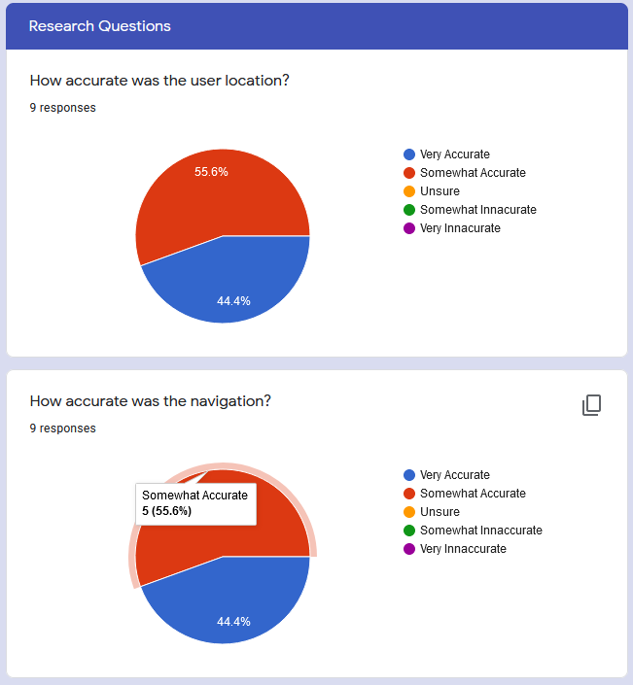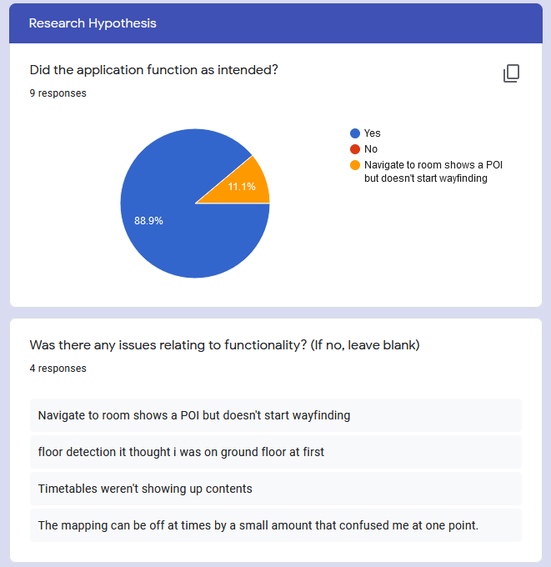The full results for the user survey can be found in

Figure - Accuracy Questions

Figure - Functionality Questions

. Interestingly, as user testing was carried out alongside software testing the first two questions highlighted bugs to fix during testing. These came up in Figure 134 and the fixes for those bugs are in the incident report in Table 7. This acceptance of working functionality only serves to better back up the findings in software testing that the research hypothesis proves true.

The location functionality was surprisingly quite accurate owing to the hybrid nature of IPS used – Indoor Atlas used magnetic field, Wi-Fi and IMU sensors. This can be seen in Figure 133 and was one of the better positive UX elements for most users.

As for the research questions, Figure 133 backs up the notion that Wi-Fi is viable as part of a hybrid system but as an example what can be seen in Figure 45 where Wireless quality is really poor along the Computing corridor, Wi-Fi should not be solely relied upon. If the question were to ask, “Is indoor navigation viable in a place with no prior design for it?”, then certainly the user testing would suggest that this would be true.

As for the second research question on wayfinding via timetables, the way in which it was implemented was primitive and on the day of demonstration it didn’t work entirely as expected due to changes in Glyndwr’s Timetabling system for the new year. Although inconclusive, the limited user testing seemed to suggest in Figure 135 that the timetable functionality was fairly easy to use, but users would still prefer to navigate via the map itself.

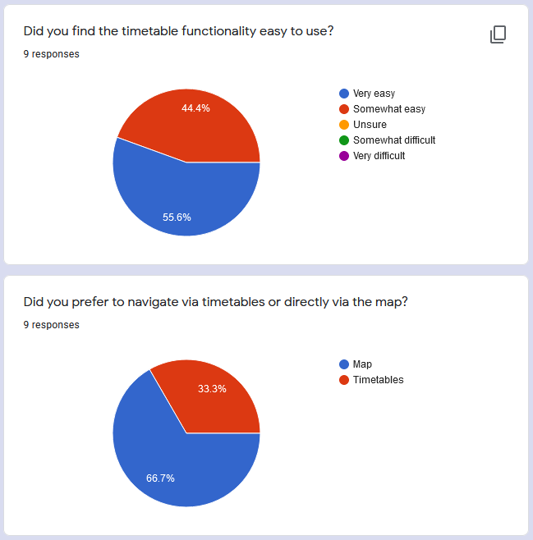

Figure - Timetable Functionality and User Preference

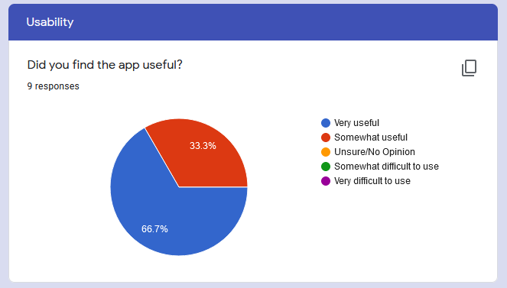

Figure - Usability question

The app was successful in being a useful tool as can be seen by the latter question concerned with usability in Figure 136. And the user testing seen an improvement in user perception of the navigational capability as far more either agreed or strongly agreed that they could navigate better using the app and that the app is useful in guiding them to their destination to compared to a mixed ratio of users having varying difficulties of navigating the university. This can be seen in Figure 137.

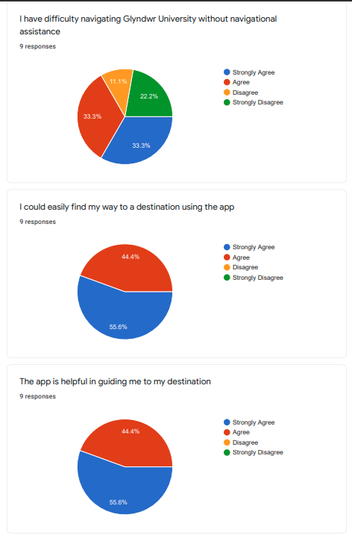

Figure - Destination assistance

# Evaluation

To properly evaluate my own work, I need to be unbiased, reflective, and critical of journey I have taken, regardless of whether it was positive or not. As an effective evaluator, I must highlight both the mistakes and achievements made, and demonstrate what has been learnt or propose alternative ways to tackle future problems. A reflective toolkit – much like a methodology – such as Gibb’s Reflective Cycle is one of the more famous models of cyclical reflective models available to us [147].

This model was developed in 1988 as a “structured debriefing” intended to support experiential based learning, it was also cyclical in nature so a practitioner can keep using it continuously for improvements on repeated experiences like you find in methodologies like SCRUM [148].

Gibb found that common problems with evaluations after an experience lurched to superficial descriptions and premature conclusions without proper thought for reflection and analysis [149]. He found that if the reflective evaluation is broken into 6 stages; Description, Feelings, Evaluation, Analysis, Conclusion and Action Plan then the person discussing their experience can provide a ‘structured debriefing’ that covers most parts of a reflective experience in a guided format [149].

## Description

This project was undertaken to form part of the Dissertation course for the MSc Computer Science course at Wrexham Glyndwr University. In this project, I sought to develop an android application that would provide an indoor navigation experience, a timetable informational tool and a timetable wayfinding system for the user’s navigation.

The research and development goals were laid out in Chapter 3 - Research Hypothesis and Questions where I proposed the hypothesis “It is possible to create a timetable satnav android application”. Additionally, the research questions that were also proposed include; “Is Wi-Fi viable enough for indoor navigation?” and “Is wayfinding via timetables an effective method of navigation?”.

In the introduction (Chapter 1.1), I highlighted that I would like to develop an app that explores the viability of Indoor Mapping and Navigation at its current level of development commercially in a largely unique method of wayfinding. Initially, I had been quite ambitious and had wanted to deliver an AR based navigation app that would be well suited to accessibility users and provided a very intuitive and positive user experience. However, this proved to be difficult to achieve as a first stage of MVP and if I was to attempt it, there could have been an unfinished artefact as a deliverable. After looking at other AR hybrid IPS systems, I chose to first develop the wayfinding and simpler IPS system first and if time permitted, add AR functionality onto the app.

These research goals have all been achieved to some degree with the hypothesis proving true. Despite the research questions having inconclusive data from the user survey, I found trends in the survey results to suggest that even with the wayfinding system being easy to use, participants still preferred using the map to navigate and although the participants had largely responded saying the app is very accurate, the research questions centred around Wi-Fi is erroneous as the IPS used was a hybrid system of Wi-Fi, magnetic field, and inertial sensors.

The other goals for this artefact were laid out as minimum viable product stages in Chapter 4.4 - Development with four stages of acceptable end product ranging from proof of concept covering timetable scraping, selection, and search as well as show location of room on map and current user location. This first stage would be limited to upper B corridor only. As stated in Chapter 7.3, the project reached stage 2 of minimum viable product which expanded the covered area to nearly 2500 square meters over two floors for B and C corridors.

With the digital learning framework in place during the academic year 2020-21 due to Covid19, a blend of in-person and online lessons was meant to be the common delivery method for lessons. However, due to regulations, lessons were online throughout the academic year. The dissertation proposals began in January 2021 with the official start of the dissertation project in May 2021. The development and documentation for which was done from home whilst sprint two onwards had the map functionality developed on campus. Later testing and demonstration would also need to be done on campus.

The development was a solo undertaking from initial specification and proposal right through to evaluation and conclusion. I had regular online meetings weekly via MS Teams with my supervisor Julie Mayers who provided helpful guidance on advice on varying matters. Also, I had corresponded with a few staff at the university, namely, Vic Grout, Jason Matthews and Nigel Houlden who provided initial support during the proposal phase and prior to confirmation of my supervisor.

For the duration of this project, I wrote the projects preamble covering introduction, literature review, research goals, methodology and ethical aspects. I then designed, documented, developed, and tested the artefact during the main phase of the project and will be evaluating and concluding the findings in the post amble phase.

The project was largely successful in delivering the apps main goals, tested well during software testing and provided a positive experience to user testers. Despite this, due to the Covid19 pandemic, very few user testers were found to test the app thoroughly which provided inconclusive data on the additional research questions about the quality of IPS and whether timetable wayfinding was a good method that provided a good user experience.

## Feelings and Thoughts

I had felt confident and motivated going into the project because of my earlier experiences doing an undergraduate project, a more recent project-like assignment in mobile app development and part of the wayfinding system I had developed was inspired by the mobile app project that I had previously undertaken. I had also spent a long time prior to beginning the project exploring various ideas and had an idea of what I wanted to do. I had a proactive tutor who gave praise where necessary and great advice, so I regularly met deadlines I set for myself for stages of the project. If anything, I may have started to take too long on these areas, and I believe some aspects of the artefact may have been overdesigned.

Towards the end, the sections of development that were new to me began to show some flaws in initial research and designs. Additionally, with the added delay in development due to catching Covid19, I made the judgement call to not develop any of the less important accessibility and AR functionality. To make up for this shortcoming, I made the choice to develop the app so it’s more suitable for dyslexic and colour-blind individuals . This stress didn’t affect the project significantly as I had planned for these eventualities in my risk assessment as seen in Table 1 - Risk Analysis. The SCRUM methodology that I had chosen in Chapter 4 - Methodology that I was following allowed me to adjust my sprints to better suit a lesser stage of MVP.

I believe this confidence and motivation during the early stages of the project allowed me to quickly pursue my eventual hypothesis quickly. This is because the base idea just needed to change to suit the complexity and ambitiousness required at master’s level. After the development, it was clear that my fears around lack of testers that I had considered in the risk analysis (Chapter 4.9 - Risk Analysis) were proving true, I put more emphasis on software testing and an accurate evaluation. Even going so far as to provide two demonstrations; One live to supervisors in the university following covid regulations and another as a pre-recorded demo video for external assessors to see the artefact in use.

Once the testing was all complete, I felt no regret but only relief as all the planning I had undertaken alongside actual development helped guide me and helped me deal with issues which could cause some projects to fail.

Consistently, each week my supervisor had provided a positive response to where I was at in development. Whether this was to boost my confidence and keep me on track or her genuine view of my progress, it seemed an appropriate dialogue for me and really helped. Others such as family and friends were positive towards what I discussed with them, but I believe that’s tied to how enthusiastic I may have seemed when discussing my work with them.

During the demonstration, both my supervisor and another lecturer who was present had seemed impressed with the artefact developed and the progress achieved. The development aspects related to accessibility like the choice of colour scheme being dark green and white alongside the font choice of Roboto which is better suited for dyslexic people (see chapter 7.2.2.4) seemed to be an approved choice. Where functionality may have been mis functional or slightly fall short of expectations, reasoning was given for the shortcomings and I was told that despite these, the artefact will still of great quality and in the case of the misfunctioning aspect – it was clear to see how it should function normally.

Throughout the project, I have felt a small level of stress that I believe has kept me motivated to keep working to schedule and complete each task I have set myself to completion. The weekly meetings have aided in motivating me to complete report sections in good time for each stage. The most difficult and worrying part of the project is the responsibility of the student to go out and develop this artefact alone. Students are pushed to research methodologies and routes to ease this process as I had done in Chapter 4 - Methodology for Scrum and in Chapter 4.5 - Testing with research approaches.

Personally, having followed SCRUM relatively closely and planning out the whole project from start to finish (see Figure 1 for initial plan and Figure 12, Figure 13, and Figure 14 for later sprint plans), I have provided adequate time at each stage that if I were to have difficulty with elements of the development, changes can and have been made. Changes in this project have been tied to personally contracting Covid19 before I undertook my second sprint where I was to begin mapping the university (see Chapter 7.1.3). This risk was accounted for in the risk analysis which can be found in Table 1 and sprint two was delayed whilst sprint three was cancelled altogether.

Having now completed the major components of this project, I feel relieved to have finished these, but I also think I have learnt valuable things throughout the experience. Up until this project, I had never successfully followed a methodology, used version control systems like GitHub and had never really undertaken such an ambitious project to personally develop.

Even though I had planned to deliver an AR solution at higher levels of minimum viable product, it was never prioritised over the research goals and as such the end artefact is fully functional in all aspects that is required from its specification. I feel the project is a great success given the timeframe and issues I have come up against and that a professional-level artefact was delivered.

## Evaluation

The project has had its good and bad points in varying amounts. The good points include developing a very accurate indoor positioning system that had a significant role in the user experience. Additionally, through following a stricter plan of action and following a methodology, the project has consistently kept on track, delivered an artefact, and had worked to minimise risks and eventual issues that had arose.

The experience of undertaking this project also had its bad points. The solo undertaking left a lot of research and solo development work that I had to undertake myself and the wealth of literature had been addressed to find the best solutions to use. Underestimating this approach can cause major issues. During the proposal stage, a couple IPS solutions had shown promise but if I had taken time to experiment with them, it would become clear quickly which one would be best to use – in this case, I found that it was Indoor Atlas.

With no prior experimentation before undertaking the project, my design was not initially thorough enough and had to be revisited. Additionally, the interface I created for the timetables seems somewhat clunky due to my over reliance on lists and array lists. Most timetabling apps using a week view like what is found in a calendar or a tab layout with a tab for everyday of the week. I wasted sometime during the first sprint attempting to develop the timetable contents to work as five list fragments with each fragment being associated with a tab and day of the week. Once a week is selected and loaded, the user would have been able to click or swipe through these days with tab layout and viewpager2. I later settled for a list with days added as items to separate different day’s events as it came close to the end of sprint one.

The mapping functionality went really well. I had found examples demonstrating some Indoor Atlas functionality that was produced directly by Indoor Atlas under Apache 2.0. license. This license is copyright free, allows modification and testing to demonstrate the technology. I took these examples as inspiration in developing my map. Examples of which can be found at <https://github.com/IndoorAtlas/android-sdk-examples>.

On the day of demonstration, the timetabling system had been updated on Glyndwr’s timetabling website. This meant that content for most timetables did not exist as it was not yet the new semester. This functionality worked during development and initial testing, though it would have been good to see it functioning during this demonstration. Additionally, instead of a destination being selected for the user when navigating, the POI was simply listed below the map and only markers that existed on the floor the app believes you’re on is shown. This latter aspect would prove difficult to users navigating to another floor using timetables.

As I was having weekly meetings with my supervisor, I was being provided useful advice and if I was unsure about certain things, I could ask them questions which they were always helpful in answering. It was incredibly helpful that my supervisor had agreed to review some chapters of my report throughout as this gave another perspective. This helped early on with carrying out my literature review by pointing things out that I had overlooked, or by correcting areas where my writing changed between first and third person. This set the tone for the rest of the project report as I had not known originally that third person was required throughout the report save for the evaluation chapter.

## Analysis

The mapping functionality went well as I had example programs to take inspiration from that used the technology. The project delivered an artefact wherein all elements covering literature searching, design, development and testing went really well as I had followed strict planning and methodologies that kept me on track.

The timetabling systems had updated on the day of demonstration ensured timetables had no content to demonstrate functionality. The way in which POIs were shown for navigating via timetables was primitive because although I believe I could develop what I had planned, I had run out of time set aside for developing the artefact. This holds true for the latter stages of MVP where I had hoped to develop AR navigation guidance on top and improve accessibility though introducing routes like fire exits, lifts, entrances and exits.

## Conclusion

By undertaking this project, I have furthered my skill in android app development, android studio, and Java. Additionally, I have discovered what IPS’ are, how they work and how to develop on to navigate an indoor environment. I have further solidified my grounding in successfully applying methodologies and a systematic approach to developing and testing artefacts to further research goals.

If the artefact would have reached a higher level of minimum viable product, I would have learnt how to develop and code using the ARCore toolkit and learnt how to develop AR apps. These types of apps have wide-reaching positive impacts on people with visual impairments and those who may struggle with the typical UI. Additionally, using AR in this hybrid system would have made the navigation even more accurate and active route guidance could be provided either through following and AR animation or with AR directions provided at convenient waypoints.

If I was more confident in my approach to development and were more knowledgeable, I could have lessened the longest component – the development phase - of the project’s timeframe. With consideration for my existing skill at the time of starting and how well planned the project had been, only more time and potentially the aid of expert advice in this particular area of technology could have pushed me to this level.

## Action Plan

If I had to undertake this project again, I would take the time between proposal and officially starting the project to seek expert advice, try out alternatives available and see how they work and experiment with the technologies that I propose to use to develop a better understanding of the technologies and what I can achieve within a timeframe. To garner these skills, I would have to learn through experimentation, review literature, seeking expert advice and apply what I learn in a methodological approach that would allow me to prototype and iterate an ever-improving artefact.

In my next project scale undertakings, I should seek to make full use of my time regardless of whether the project had yet officially started or not. This way, I could get exposure to the technologies I may seek to use and start to develop a greater understanding in them prior to needing to use them.

# Conclusion

To conclude, the results from both software testing and limited user testing suggest that the simple hypothesis “It is possible to create a ‘Timetable Satnav’ Android application” is proven true. This means that it is indeed possible to create an indoor navigation tool that makes use of venue information to enhance the user experience.

The additional research questions are slightly more complex. These questions were; “Is Wi-Fi viable enough for indoor navigation?” and “Is wayfinding via timetables an effective method of navigation?”. Both questions have no definitive results from the survey of user testers as the number of participants was very limited due to Covid19 regulations and restrictions.

Additionally, the first question would have been better proposed as “Are current hybrid solutions viable enough for indoor navigation?”. This is because this project used Indoor Atlas which has a hybrid fusion of IPS technologies covering magnetic field, Wi-Fi, and Inertial sensors (if infrastructure was in place, Bluetooth is another field that could be made use of here).

The initial survey results do seem to suggest that the artefact developed was quite accurate given the general-purpose Wi-Fi infrastructure (particularly on the top floor of B corridor as seen in Figure 45). Additionally, the results suggest there is certainly room in Indoor Navigational tools to make use of venue information to enhance user experience. In this instance, this was making use of timetables for wayfinding. Other possibilities may include venues like museums showing tours, music venues showing seating and concession stands, stadiums and sporting events showing schedules and transport like buses, trains and airports showing schedules and navigation to the correct depos or stands.

## Current State of the Artefact and Areas for Improvement

As stated in Chapter 7.3 - Sprint Reviews and MVP, the stage of MVP reached was stage two. This stage had a fully formed Indoor Navigational tool using timetable wayfinding covering 2500 square metres. It made use of three types of IPS in a hybrid fusion; Magnetic Field, Wi-Fi, and Inertial sensors. This system was quite accurate in initial testing. In Chapter 7.4 - Future Development: Improvements and Points to Consider, the future of the application was explored and areas for improvement were suggested.

Improvements fall into three categories generally; accessibility, improvement of the wayfinding system, and improvement of the user localization and navigation. The first aspect was initially going to be covered by the use of AR technology. This technology not only improves the accuracy of location tracking but has been proven to be more intuitive to users especially those who may have accessibility difficulties like visual impairments or dyslexia. AR can also improve the navigation by providing overlay directions as active route guidance, users can see overlayed information above a corridor they may be walking down.

Accessibility can also be improved by implementing routes that use lifts, ramps, and stairs more appropriately for differing requirements such as disability aids, shortest route, or fastest route. Similarly, emergency functionality like closest fire exit navigation or even in other countries that are more at risk of flooding, hurricanes and earthquakes more specific emergency functionality like Shelter navigation could be very useful.

Secondly, the wayfinding system could be improved with a better UI for timetable contents, better checks on navigable rooms and even allowing wayfinding to external aspects outside of timetabled rooms such as; study areas, food halls, coffee shops, vending machines, and other areas significant to a student’s university experience like the student union, library, and other services available.

The IPS system can be improved by leveraging Indoor-Outdoor detection and floorplans for the multiple external buildings also on campus can provide a more thorough experience. Additionally, if infrastructure was planned according to providing this experience, BLE beacons and an increased number of modern access points (like those that support Googles RTT technology) can vastly improve IPS initialisation and quality.

# References

|  |  |
| --- | --- |
| [1] | S. O'Dea, “• Mobile OS market share 2019 | Statista,” Statista, 08 02 2021. [Online]. Available: https://www.statista.com/statistics/272698/global-market-share-held-by-mobile-operating-systems-since-2009/. [Accessed 05 03 2021]. |
| [2] | S. Pichler, “ArcGIS Indoors 2D/3D Indoor Maps powered by Esri,” 30 04 2019. [Online]. Available: https://www.esri.com/arcgis-blog/products/arcgis-indoors/mapping/what-is-indoor-mapping/. [Accessed 05 03 2021]. |
| [3] | Google Maps, “Indoor Maps availability - Google Maps Help,” Google, [Online]. Available: https://support.google.com/maps/answer/1685827?hl=en-GB. [Accessed 05 03 2021]. |
| [4] | B. Ray, “How Indoor Positioning Systems Work & Types of Location Tracking,” 16 08 2018. [Online]. Available: https://www.airfinder.com/blog/indoor-positioning-system. [Accessed 05 03 2021]. |
| [5] | NTNU, “Campus guide - NTNU,” 31 08 2011. [Online]. Available: https://www.ntnu.edu/news/campus-guide. [Accessed 02 04 2021]. |
| [6] | University of West Scotland, “News | UWS introduce new app for indoor navigation,” [Online]. Available: https://www.uws.ac.uk/news/uws-introduce-new-app-for-indoor-navigation/. [Accessed 02 04 2021]. |
| [7] | L. Hodge, “Lancaster University and MazeMap: Paving the Way for Innovation,” 08 09 2020. [Online]. Available: https://blog.mazemap.com/lancaster-university-and-mazemap/. [Accessed 02 04 2021]. |
| [8] | MazeMap, “Indoor positioning,” [Online]. Available: https://www.mazemap.com/solutions/indoor-positioning. [Accessed 02 04 2021]. |
| [9] | P. Julia, “What is the Indoor Mapping - Blog Geographica,” 27 04 2017. [Online]. Available: https://geographica.com/en/blog/indoor-mapping/. [Accessed 04 04 2021]. |
| [10] | S. Zlatanova, G. Sithole, M. Nakagawa and Q. Zhu, “Problems in Indoor Mapping and Modelling,” in *ISPRS Acquisition and Modelling of Indoor and Enclosed Environments*, Cape Town, South Africa, 2013. |
| [11] | Apple, “Apple Business Register,” [Online]. Available: https://register.apple.com/indoor. [Accessed 04 04 2021]. |
| [12] | WRLD3D, “3D Indoor Maps | WRLD3D,” [Online]. Available: https://www.wrld3d.com/3d-maps/indoor-mapping#Indoor-3D-Maps. [Accessed 04 04 2021]. |
| [13] | Mapwize, “Indoor mapping & Wayfinding for Smart Buildings,” [Online]. Available: https://www.mapwize.io/. [Accessed 04 04 2021]. |
| [14] | Mapspeople, “MapsIndoors - Indoor navigation with Google Maps - MapsPeople,” [Online]. Available: https://www.mapspeople.com/mapsindoors/. [Accessed 04 04 2021]. |
| [15] | IndoorAtlas, “Positioning technology – IndoorAtlas,” [Online]. Available: https://www.indooratlas.com/positioning-technology/. [Accessed 25 05 2021]. |
| [16] | K. Georgiou, T. Constambeys, C. Laoudias, L. Petrou, G. Chatzimilioudis and D. Zeinalipour-Yazti, “Anyplace: A Crowdsourced Indoor Information Service,” in *16th IEEE International Conference on Mobile Data Management*, Pittsburgh, 2015. |
| [17] | Princeton, “Microsoft Word - gnss-2-09-06 final.doc - GNSS.pdf,” 14 02 06. [Online]. Available: https://www.princeton.edu/~alaink/Orf467F07/GNSS.pdf. [Accessed 04 04 2021]. |
| [18] | Rewire Security, “Accuracy, Precision and Reliability of GPS Tracking and GPS Tracker,” 07 02 2019. [Online]. Available: https://www.rewiresecurity.co.uk/blog/gps-tracking-tracker-satellite-accuracy-precision. [Accessed 04 04 2021]. |
| [19] | G. Dedes and A. Dempster, “Indoor GPS positioning - challenges and opportunities,” in *IEEE 62nd Vehicular Technology Conference*, Dallas, 2005. |
| [20] | M. Piras and A. Cina, “Indoor Positioning using low cost GPS receivers: Tests and statistical analyses,” in *International Conference on Indoor Positioning and Indoor Navigation*, Zurich, 2010. |
| [21] | L. Batistic and M. Tomic, “Overview of indoor positioning system technologies,” in *41st International Convention on Information and Communication Technology, Electronics and Microelectronics (MIPRO)*, 2018, 2018. |
| [22] | infsoft, “Indoor Positioning and Indoor Navigation Using Wi-Fi,” [Online]. Available: https://www.infsoft.com/technology/positioning-technologies/wi-fi. [Accessed 04 06 2021]. |
| [23] | Android Developers, “Wi-Fi location: ranging with RTT | Android Developers,” 18 05 2021. [Online]. Available: https://developer.android.com/guide/topics/connectivity/wifi-rtt. [Accessed 04 06 2021]. |
| [24] | C. Morabito, “Accurate Navigation Coming to a Phone Near You - Woolpert,” [Online]. Available: https://woolpert.com/media/blogs/geospatial/accurate-navigation-coming-to-a-phone-near-you/. [Accessed 04 06 2021]. |
| [25] | NetSpot, “What is WiFi RTT (round-trip time) and How it Works,” [Online]. Available: https://www.netspotapp.com/what-is-wifi-rtt.html#Which_Devices_Support_WiFi_RTT. [Accessed 04 06 2021]. |
| [26] | M. Kotaru, K. Joshi, D. Bharadia and S. Katti, “SpotFi: Decimeter Level Localization using Wi-Fi,” in *Proceedings of the 2015 ACM Conference on Special Interest Group on Data Communication*, New York NY, 2015. |
| [27] | B.-C. Huang, J. Hsu, E. T. Chu and H.-M. Wu, “ARBIN: Augmented Reality Based Indoor Navigation System,” *Sensors,* vol. 20, 2020. |
| [28] | Estimote, “What is the accuracy of Indoor Location? – Estimote Community Portal,” [Online]. Available: https://community.estimote.com/hc/en-us/articles/201302836-What-is-the-accuracy-of-Indoor-Location-. [Accessed 04 06 2021]. |
| [29] | Z. Yin, C. Wu, Z. Yang and Y. Liu, “Peer-to-peer indoor Navigation using Smartphones,” *IEEE Journal on Selected Areas in Communications,* vol. 35, no. 5, pp. 1141-1153, 2017. |
| [30] | X. H. Ng and W. N. Lim, “Design of a Mobile Augmented Reality-based Indoor Navigation System,” in *4th International Symposium on Multidisciplinary Studies and Innovative Technologies (ISMSIT)*, Istanbul, 2020. |
| [31] | D. Campbell, “Indoor positioning with WiFi RTT and Google WiFi | by Darryncampbell | Medium,” 4 10 2019. [Online]. Available: https://medium.com/@darryncampbell_83863/indoor-positioning-with-wifi-rtt-and-google-wifi-a638f1147b84. [Accessed 07 04 2021]. |
| [32] | S. Saab and Z. Nakad, “A Standalone RFID Indoor PositioningSystem Using Passive Tags,” *IEEE Transactions on Industrial Electronics,* vol. 58, no. 5, pp. 1961-1970, 2011. |
| [33] | M. N. Lionel, Y. Liu, Y. Lau and A. Patil, LANDMARC: Indoor Location Sensing Using Active RFID, Netherlands: Kluwer Academic Publisher, 2004. |
| [34] | J. Hightower, C. Vakili, G. Borriello and R. Want, Design and Calibration of the SpotON Ad-Hoc Location Sensing System, 2001. |
| [35] | P. Daas and D. Agrawal, “RFID for Indoor Position Determination,” in *Second International Conference on Advanced Computing, Networking and Informatics*, Kolkata, 2014. |
| [36] | C. Medina, J. C. Segura and A. d. l. Torre, “Ultrasound Indoor Positioning System Based on a Low-Power Wireless Sensor Network Providing Sub-Centimeter Accuracy,” *Sensors,* vol. 13, no. 3, pp. 3501-3526, 2013. |
| [37] | D. Gualda, J. M. Villadangos, J. Urena, A. Jimenez, F. Seco and A. Hernandez, “short47.pdf,” 2019. [Online]. Available: http://ceur-ws.org/Vol-2498/short47.pdf. [Accessed 07 04 2021]. |
| [38] | A. A. Kalbandhe and S. Patil, “Indoor Positioning System using Bluetooth Low Energy,” in *International Conference on Computing, Analytics and Security Trends (CAST)*, Pune, 2016. |
| [39] | D. Wagstaff, “The 6 Disadvantages of Using Beacons for Proximity Marketing,” PocketStop, 12 11 2018. [Online]. Available: https://blog.pocketstop.com/the-6-disadvantages-of-using-beacons-for-proximity-marketing. [Accessed 06 06 2021]. |
| [40] | Y. Sun, Y. Zhao and J. Schiller, “An Indoor positioning system based on inertial sensors in smartphone,” in *IEEE Wireless Communications and Networking Conference (WCNC)*, New Orleans, 2015. |
| [41] | J. Chung, M. Donahoe, C. Schmandt, I.-J. Kim, P. Razavi and M. Wiseman, “Indoor location sensing using geo-magnetism,” in *Proceedings of the 9th International Conference on Mobile Systems, Applications, and Services (MobiSys 2011)*, Bethesda, 2011. |
| [42] | C. Hallstrom, “What is Indoor Navigation? The Complete Guide 2020 - NEARMOTION,” 06 06 2020. [Online]. Available: https://nearmotion.com/news/what-is-indoor-navigation/. [Accessed 07 04 2021]. |
| [43] | M. H. V. Le and D. Saragas, “Indoor_Navigation_System_for_Handheld_Devices.pdf,” 22 10 2009. [Online]. Available: https://web.wpi.edu/Pubs/E-project/Available/E-project-102209-164024/unrestricted/Indoor_Navigation_System_for_Handheld_Devices.pdf. [Accessed 07 04 2021]. |
| [44] | Y. Zhou, H. Chen, Y. Huang, Y. Luo, Y. Zhang and X. Xie, “An Indoor Route Planning Method with Environment Awareness,” in *IEEE International Geoscience and Remote Sensing Symposium (IGARSS)*, Valencia, 2018. |
| [45] | H.-y. Zhang, W.-m. Lin and A.-x. Chen, “Path Planning for the Mobile Robot: A Review,” *Symmetry in Engineering Sciences,* vol. 10, no. 10, p. 450, 2018. |
| [46] | J. Sun and X. Li, “Indoor Evacuation routes planning with a grid graph-based model,” in *19th International Conference on Geoinformatics*, Shanghai, 2011. |
| [47] | D. Zeinalipour-Yazti, C. Laoudias, K. Georgiou and G. Chatzimillioudis, “Internet-Based Indoor Navigation Services,” *IEEE Internet Computing,* vol. 21, no. 4, pp. 54-63, 2017. |
| [48] | V. Ahmed, H. Kawai, T. Murao and R. Suzuki, “Autonomous Transportation Carts using Indoor Positioning System with Hybrid Pathfinding,” in *IEEE 7th Global Conference on Consumer Electronics (GCCE)*, Nara, Japan, 2018. |
| [49] | Google, “ARCore overview | Google Developers,” 06 11 2020. [Online]. Available: https://developers.google.com/ar/discover. [Accessed 17 05 2021]. |
| [50] | A. Corotan and J. J. Z. Irgen-Gioro, “An Indoor Navigation Robot Using Augmented Reality,” in *5th International Conference on Control, Automation and Robotics (ICCAR)*, China, 2019. |
| [51] | R. Cervenak and P. Masek, “ARKit as indoor positioning system,” in *11th International Congress of Ultra Modern Telecommunications and Control Systems and Workshops (ICUMT)*, Dublin, 2019. |
| [52] | M. J. Kim, X. Wang, S. Han and Y. Wang, “Implementing an augmented reality-enabled wayfinding system through studying user experience and requirements in complex environments,” *Visualisation in Engineering,* vol. 3, no. 1, 2015. |
| [53] | A. Morar, M. A. Balutoiu, A. Moldoveanu, F. Moldoveanu, A. Butean and V. Asavei, “Evaluation of the ARCore Indoor Localization Technology,” in *19th RoEduNet Conference: Networking in Education and Research (RoEduNet)*, Bucharest, 2020. |
| [54] | J. Lin, Z. Chen, Y. Wang and Y. Liao, “Research on SLAM Drift Reduction Mechanism Based on Point Cloud Segmentation Semantic Information,” *Journal of Physics Conference Series,* vol. 1570, 2020. |
| [55] | T. Feigl, A. Porada, S. Steiner, C. Loffler, C. Mutschler and M. Phillipsen, “GRAPP_2020_33_CR.pdf,” 09 01 2020. [Online]. Available: https://www.researchgate.net/profile/Tobias-Feigl-2/publication/340047854_Localization_Limitations_of_ARCore_ARKit_and_Hololens_in_Dynamic_Large-scale_Industry_Environments/links/5ed0f4dd45851529451b89ec/Localization-Limitations-of-ARCore-ARKit-and-Holole. [Accessed 17 05 2021]. |
| [56] | X. Zhang, X. Yao, Y. Zhu and F. Hu, “An ARCore Based User Centric Assistive Navigation System for Visually Impaired People,” *Applied Sciences,* vol. 9, no. 5, p. 989, 2019. |
| [57] | C. Yoon, R. Louie, J. Ryan, M. Vu, H. Bang, W. Derksen and P. Ruvolo, “Leveraging Augmented Reality to Create Apps for People with Visual Disabilities: A Case Study in Indoor Navigation,” in *The 21st International ACM SIGACCESS Conference on Computers and Accessibility*, New York, 2019. |
| [58] | IndoorAtlas, “MappingGuideEN.pdf,” [Online]. Available: https://docs.indooratlas.com/MappingGuideEN.pdf. [Accessed 07 06 2021]. |
| [59] | IndoorAtlas Github, “IndoorAtlas,” 28 05 2021. [Online]. Available: https://github.com/IndoorAtlas. [Accessed 07 06 2021]. |
| [60] | M. V. Bramhe, J. Gan, N. Ghodpage, A. Nawale and G. Bahe, “Indoor Positioning System using Magnetic Positioning and BLE Beacons,” *International Research Journal of Engineering and Technology (IRJET),* vol. 4, no. 3, 2017. |
| [61] | J. Hurtuk, J. Cervenak, M. Stancel, M. Hulic and P. Fecil'ak, “Indoor Navigation using IndoorAtlas library,” in *IEEE 17th International Symposium on Intelligent Systems and Informatics (SISY)*, Subotica, Serbia, 2019. |
| [62] | R. Diouf, E. N. Sarr, O. Sall, B. Birregah, M. Bousso and S. N. Mbaye, “Web Scraping: State-of-the-Art and Areas of Application,” in *IEEE International Conference on Big Data*, Los Angeles, 2019. |
| [63] | JSoup, “jsoup Java HTML Parser, with the best of HTML5 DOM methods and CSS selectors.,” [Online]. Available: https://jsoup.org/. [Accessed 09 04 2021]. |
| [64] | T. Naeem, “PDF Data Scraping: Extracting Unstructured Data from PDFs Simplified,” 26 03 2021. [Online]. Available: https://www.astera.com/type/blog/pdf-scraping/. [Accessed 09 04 2021]. |
| [65] | PDFBox, “Apache PDFBox | A Java PDF Library,” 01 04 2021. [Online]. Available: https://pdfbox.apache.org/. [Accessed 09 04 2021]. |
| [66] | IPIN, “IPIN Conference,” 21 05 2021. [Online]. Available: https://ipin-conference.org/. [Accessed 03 08 2021]. |
| [67] | GeoIT.org, “About us,” 10 2019. [Online]. Available: https://geoit.org/association-for-geoinformatics-geoit-and-navigation/. [Accessed 03 08 2021]. |
| [68] | Microsoft, “Microsoft Indoor Localization Competition - IPSN 2018 - Microsoft Research,” 11 04 2018. [Online]. Available: https://www.microsoft.com/en-us/research/event/microsoft-indoor-localization-competition-ipsn-2018/. [Accessed 03 08 2021]. |
| [69] | V. Renaudin, M. Ortiz, J. Perul, J. Torres-Sospedra, A. R. Jimenez and A. Perez-Navarro, “Evaluating Indoor Positioning Systems in a Shopping Mall: The Lessons Learned From the IPIN 2018 Competition,” *IEEE Access,* vol. 7, no. 1, pp. 148594-148628, 2019. |
| [70] | Microsoft, “microsoft.com/en-us/research/uploads/prod/2017/12/RELEASED_2018-Microsoft-Indoor-Localization-Competition.pptx,” 11 04 2018. [Online]. Available: https://www.microsoft.com/en-us/research/uploads/prod/2017/12/RELEASED_2018-Microsoft-Indoor-Localization-Competition.pptx. [Accessed 03 08 2021]. |
| [71] | Y. Landau, B. Ben-Moshe and I. Rosenberg, “Yael_Landau_2018.pdf,” 11 02 2018. [Online]. Available: https://www.microsoft.com/en-us/research/uploads/prod/2017/12/Yael_Landau_2018.pdf. [Accessed 03 08 2021]. |
| [72] | X. Qu, X. Gong, Z. Wang, E. Liu and R. Wang, “abstract_PDR with initilization.dvi - Xinyu_Qu_2_2018.pdf,” 09 02 2018. [Online]. Available: https://www.microsoft.com/en-us/research/uploads/prod/2017/12/Xinyu_Qu_2_2018.pdf. [Accessed 03 08 2021]. |
| [73] | J. Miller, N. Rajagopal, K. Kumar, A. Luong and A. Rowe, “John_Miller_2018.pdf,” 12 02 2018. [Online]. Available: https://www.microsoft.com/en-us/research/uploads/prod/2017/12/John_Miller_2018.pdf. [Accessed 03 08 2021]. |
| [74] | F. Gao, Z. Xu and S. Zhang, “Feng_Gao_2018.pdf,” 11 02 2018. [Online]. Available: https://www.microsoft.com/en-us/research/uploads/prod/2017/12/Feng_Gao_2018.pdf. [Accessed 03 08 2021]. |
| [75] | P. Lazik, N. Rajagopal, S. Chayapathy, B. Sinopoli and A. Rowe, “lazik.pdf,” 21 01 2016. [Online]. Available: https://www.microsoft.com/en-us/research/wp-content/uploads/2015/10/lazik.pdf. [Accessed 03 08 2021]. |
| [76] | D. Zeinalipour-Yazti and C. Laoudias, “The anatomy of the anyplace indoor navigation service,” *SIGSPATIAL Special,* vol. 9, no. 2, pp. 3-10, 2017. |
| [77] | D. Cairns, “HardSys.ppt - HardSys.pdf,” 04 04 2006. [Online]. Available: http://www.cs.stir.ac.uk/~dec/teaching/CSC9T4/lectures/HardSys.pdf. [Accessed 23 04 2021]. |
| [78] | K. Sureshchandra and J. Shrinivasavadhani, “Moving from Waterfall to Agile,” in *Agile 2008 Conference*, Toronto, 2008. |
| [79] | M. Gannon, “An agile implementation of SCRUM,” in *2013 IEEE Aerospace Conference*, Big Sky, MT, USA, 2013. |
| [80] | D. R. Moogk, “Minimum Viable Product and the Importance of Experimentation in Technology Startups,” *Technology Innovation Management Review,* vol. 2, no. 3, pp. 23-26, 2012. |
| [81] | SQLite, “About SQLite,” [Online]. Available: https://www.sqlite.org/about.html. [Accessed 15 04 2021]. |
| [82] | Oracle, “Java Programming Language,” [Online]. Available: https://docs.oracle.com/javase/7/docs/technotes/guides/language/. [Accessed 15 04 2021]. |
| [83] | N. Walliman, Research Methods: The Basics: 2nd edition, Routledge, 2017. |
| [84] | M. Dixon-Woods, S. Agarwal, D. Jones, B. Young and A. Sutton, “Synthesising qualitative and quantitative evidence; A review of possible methods,” *Journal of Health Services Research & Policy,* vol. 10, no. 1, pp. 45-53, 2005. |
| [85] | J. Schoonenboom and R. B. Johnson, “How to Construct a Mixed Methods Research Design,” *KZfSS Kölner Zeitschrift für Soziologie und Sozialpsychologie,* vol. 69, no. 2, pp. 107-131, 2017. |
| [86] | Public Health England, “Mixed methods study - GOV.UK,” 02 06 2020. [Online]. Available: https://www.gov.uk/guidance/mixed-methods-study. [Accessed 23 04 2021]. |
| [87] | Anyplace, “AnyPlace | Indoor Information Service,” [Online]. Available: https://anyplace.cs.ucy.ac.cy/. [Accessed 15 04 2021]. |
| [88] | Navigine, “Precise indoor navigation and location tracking | Best indoor positioning system IPS by Navigine,” [Online]. Available: https://navigine.com/. [Accessed 21 04 2021]. |
| [89] | R. L. Mendez, “Indoor Real Time Navigation with SLAM on your Mobile - Graphics and Gaming blog - Graphics and Gaming - Arm Community,” 07 11 2018. [Online]. Available: https://community.arm.com/developer/tools-software/graphics/b/blog/posts/indoor-real-time-navigation-with-slam-on-your-mobile. [Accessed 21 04 2021]. |
| [90] | Raccoons, “Creating an ARCore powered indoor navigation application in Unity,” [Online]. Available: https://blog.raccoons.be/en/arcore-powered-indoor-navigation-unity. [Accessed 23 04 2021]. |
| [91] | R. A. Popa, H. Balakrishnan and A. J. Blumberg, “VPriv: Protecting Privacy in Location-Based Vehicular Services,” in *Proceedings of the 18th conference on USENIX security symposium*, Montreal, Canada, 2009. |
| [92] | C. S. Jensen, H. Lu and B. Yang, “Indoor - A New Data Management Frontier,” *IEEE Data Eng. Bull,* vol. 33, no. 2, pp. 12-17, 2010. |
| [93] | Rajkumar, “What Is Software Testing - Definition, Types, Methods, Approaches,” 09 01 2021. [Online]. Available: https://www.softwaretestingmaterial.com/software-testing/. [Accessed 16 04 2021]. |
| [94] | S. Avdoshin and E. Y. Pesotskaya, “Software risk management,” in *Software Engineering Conference in Russia (CEE-SECR)*, 7th Central and Eastern European, 2011. |
| [95] | Wrexham Glyndŵr University, “Course: Research Ethics,” 2020. [Online]. Available: https://moodle.glyndwr.ac.uk/course/view.php?id=26703. [Accessed 21 04 2021]. |
| [96] | G. L., “Applying for ethical approval for research: the main issues,” *Nursing Standard,* vol. 30, no. 20, pp. 40-44, 2016. |
| [97] | B. T. L and C. J. F, Principles of Biomedical Ethics, Oxford University Press, 2009. |
| [98] | K. Kelley, B. Clark, V. Brown and J. Sitzia, “Good practice in the conduct and reporting of survey research,” *International Journal for Quality in Health Care,* vol. 15, no. 3, pp. 261-266, 2003. |
| [99] | Fordham University, “sample_consent_for_an_internet_survey_1-22-15pdf.pdf,” 10 08 2015. [Online]. Available: https://www.fordham.edu/download/downloads/id/2430/sample_consent_for_an_internet_survey_1-22-15pdf.pdf. [Accessed 21 04 2021]. |
| [100] | Gov.uk, “Data protection - GOV.UK,” [Online]. Available: https://www.gov.uk/data-protection. [Accessed 21 04 2021]. |
| [101] | P. Koopman, “18-642 - 14_sw_architecture.pdf,” 27 9 2018. [Online]. Available: https://users.ece.cmu.edu/~koopman/lectures/ece642/14_sw_architecture.pdf. [Accessed 21 05 2021]. |
| [102] | J. T. Hackos, “An Application of the Principles of Minimalism to the Design of Human-Computer Interfaces,” in *Software-Ergonomie '99*, Waldorf, 1999. |
| [103] | MLSDev, “UI/UX Design for Users with Dyslexia | by MLSDev | Medium,” 27 05 2016. [Online]. Available: https://mlsdev.medium.com/ui-ux-design-for-users-with-dyslexia-53f8ba487737. [Accessed 16 06 2021]. |
| [104] | mygov.scot, “Typography – mygov.scot | resources,” [Online]. Available: https://resources.mygov.scot/design-standards/design-essentials/typography/. [Accessed 16 06 2021]. |
| [105] | M. Sikka, “The fall and rise of Roboto, Android’s default font,” 7 10 2019. [Online]. Available: https://www.xda-developers.com/roboto-android-fall-rise-default-font/. [Accessed 16 06 2021]. |
| [106] | C. Geerlings, “How to create an accessible app (and why you should) | by Caspar Geerlings | Oberon | Medium,” 21 10 2019. [Online]. Available: https://medium.com/oberonamsterdam/how-to-create-an-accessible-app-and-why-you-should-5493f41f8bdb. [Accessed 16 06 2021]. |
| [107] | B. Kemler, “Our all-new TalkBack screen reader,” 23 02 2021. [Online]. Available: https://blog.google/products/android/all-new-talkback/. [Accessed 16 06 2021]. |
| [108] | Irlen, “Irlen Colored Overlays App,” [Online]. Available: https://irlen.com/irlen-colored-overlays-android-app-helpdesk/. [Accessed 16 06 2021]. |
| [109] | Glyndwr University, “Timetable Finder - TT_2021,” CELCAT, 10 06 2021. [Online]. Available: https://timetables.glyndwr.ac.uk/2021/Semester%201/finder.html. [Accessed 10 06 2021]. |
| [110] | IPMA USA, “Build Your Project Using Scrum Methodology - A3_AboutScrum.pdf,” 25 10 2009. [Online]. Available: https://www.ipma-usa.org/articles/A3_AboutScrum.pdf. [Accessed 08 06 2021]. |
| [111] | Atlassian, “Jira | Issue & Project Tracking Software | Atlassian,” [Online]. Available: https://www.atlassian.com/software/jira. [Accessed 09 06 2021]. |
| [112] | K. Bashir, F. Kanwal, A. H. Ali, S. Gul and A. Bashir, “Transition between flow charts and Jackson Structured Program (JSP),” in *International Conference on Open Source Systems and Technologies*, Lahore, Pakistan, 2012. |
| [113] | N. Ourusoff, “Using Jackson Structured Programming (JSP) and Jackson Workbench to Teach Program Design,” in *Informing Science + IT Education Conference*, 2003. |
| [114] | Surrey University, “s14sad.pdf,” 20 10 2008. [Online]. Available: http://info.ee.surrey.ac.uk/Teaching/Courses/ee2.sad/s14sad.pdf. [Accessed 14 06 2021]. |
| [115] | L. Copeland, A Practitioner's Guide to Software Test Design, Artech House, 2004. |
| [116] | IEEE, “610.12-1990 - IEEE Standard Glossary of Software Engineering Terminology,” *IEEE Std 602.12-1990,* pp. 1-84, 1990. |
| [117] | T. Ryber, Essential Software Test Design, Unique Publishing, 2007. |
| [118] | Software Testing Help, “Sample Test Plan Document (Test Plan Example with Details of Each Field),” 28 06 2021. [Online]. Available: https://www.softwaretestinghelp.com/test-plan-sample-softwaretesting-and-quality-assurance-templates/. [Accessed 10 07 2021]. |
| [119] | StarAgile, “Overview of Scrum Phases | StarAgile,” 23 10 2020. [Online]. Available: https://staragile.com/blog/scrum-phases. [Accessed 22 06 2021]. |
| [120] | Wrexham glyndwr University, “Campus 2025 - Wrexham Glyndwr University,” [Online]. Available: https://www.glyndwr.ac.uk/en/AboutGlyndwrUniversity/Campus2025/. [Accessed 22 06 2021]. |
| [121] | Android Developers, “Save data using SQLite | Android Developers,” 18 06 2021. [Online]. Available: https://developer.android.com/training/data-storage/sqlite. [Accessed 24 06 2021]. |
| [122] | IndoorAtlas Support, “Setup Positioning SDK with Android : Support,” IndoorAtlas, 08 10 2019. [Online]. Available: https://indooratlas.freshdesk.com/support/solutions/articles/36000050564-setup-positioning-sdk-with-android. [Accessed 29 07 2021]. |
| [123] | Dev.google.com, “Using API Keys | Maps SDK for Android | Google Developers,” Google, 23 07 2021. [Online]. Available: https://developers.google.com/maps/documentation/android-sdk/get-api-key#restrict_key. [Accessed 27 07 2021]. |
| [124] | D. Morrissey, “davemorrissey/subsampling-scale-image-view: Android library (AAR). Highly configurable, easily extendable deep zoom view for displaying huge images without loss of detail. Perfect for photo galleries, maps, building plans etc.,” 30 12 2020. [Online]. Available: https://github.com/davemorrissey/subsampling-scale-image-view. [Accessed 27 07 202]. |
| [125] | J. Wharton, “JakeWharton/timber: A logger with a small, extensible API which provides utility on top of Android's normal Log class.,” 21 07 2020. [Online]. Available: https://github.com/JakeWharton/timber. [Accessed 27 07 2021]. |
| [126] | IndoorAtlas Support, “Initializing SDK with Android : Support,” IndoorAtlas, 12 10 2018. [Online]. Available: https://indooratlas.freshdesk.com/support/solutions/articles/36000051238-initializing-sdk-with-android. [Accessed 29 07 2021]. |
| [127] | IndoorAtlas Support, “Getting Location Updates with Android : Support,” IndoorAtlas, 08 10 2019. [Online]. Available: https://indooratlas.freshdesk.com/support/solutions/articles/36000051239-getting-location-updates-with-android. [Accessed 29 07 2021]. |
| [128] | IndoorAtlas Support, “Automatic Floor Detection with Android : Support,” IndoorAtlas, 17 02 2020. [Online]. Available: https://indooratlas.freshdesk.com/support/solutions/articles/36000051240-automatic-floor-detection-with-android. [Accessed 29 07 2021]. |
| [129] | Picasso, “square/picasso: A powerful image downloading and caching library for Android,” Picasso, 10 08 2020. [Online]. Available: https://github.com/square/picasso. [Accessed 29 07 2021]. |
| [130] | IndoorAtlas Support, “Fetching Floor Plan Images with Android : Support,” IndoorAtlas, 08 10 2019. [Online]. Available: https://indooratlas.freshdesk.com/support/solutions/articles/36000051242-fetching-floor-plan-images-with-android. [Accessed 29 07 2021]. |
| [131] | developers.android.com, “Understand the Activity Lifecycle | Android Developers,” 06 05 2021. [Online]. Available: https://developer.android.com/guide/components/activities/activity-lifecycle. [Accessed 29 07 2021]. |
| [132] | developers.google.com, “GoogleMap.OnMapClickListener | Google Play services,” Google, 27 04 2021. [Online]. Available: https://developers.google.com/android/reference/com/google/android/gms/maps/GoogleMap.OnMapClickListener. [Accessed 29 07 2021]. |
| [133] | developers.google.com, “OnMapReadyCallback | Google Play services | Google Developers,” Google, 27 04 2021. [Online]. Available: https://developers.google.com/android/reference/com/google/android/gms/maps/OnMapReadyCallback. [Accessed 29 07 2021]. |
| [134] | IndoorAtlas Support, “Using POIs in Android : Support,” IndoorAtlas, 17 02 2020. [Online]. Available: https://indooratlas.freshdesk.com/support/solutions/articles/36000210100-using-pois-in-android. [Accessed 29 07 2021]. |
| [135] | IndoorAtlas Support, “Using Wayfinding with Android : Support,” IndoorAtlas, 19 07 2021. [Online]. Available: https://indooratlas.freshdesk.com/support/solutions/articles/36000095621-using-wayfinding-with-android. [Accessed 29 07 2021]. |
| [136] | IndoorAtlas Support, “Wayfinding Overview : Support,” IndoorAtlas, 08 10 2019. [Online]. Available: https://indooratlas.freshdesk.com/support/solutions/articles/36000051251-wayfinding-overview. [Accessed 29 07 2021]. |
| [137] | Colour Blind Awareness, “colourblindawareness.org/colour-blindness/types-of-colour-blindness/,” [Online]. Available: https://www.colourblindawareness.org/colour-blindness/types-of-colour-blindness/. [Accessed 29 07 2021]. |
| [138] | R. Collinge, “How to Design for Color Blindness - GetFeedback,” 17 01 2017. [Online]. Available: https://www.getfeedback.com/resources/ux/how-to-design-for-color-blindness/. [Accessed 29 07 2021]. |
| [139] | Vuforia Developer Library, “Getting Started | VuforiaLibrary,” [Online]. Available: https://library.vuforia.com/. [Accessed 20 07 2021]. |
| [140] | alamkanak, “alamkanak/Android-Week-View: Android Week View is an android library to display calendars (week view or day view) within the app. It supports custom styling.,” 04 01 2016. [Online]. Available: https://github.com/alamkanak/Android-Week-View. [Accessed 20 07 2021]. |
| [141] | developer.android.com, “TabLayout | Android Developers,” 07 07 2021. [Online]. Available: https://developer.android.com/reference/com/google/android/material/tabs/TabLayout. [Accessed 20 07 2021]. |
| [142] | developer.android.com, “Create swipe views with tabs using ViewPager2 | Android Developers,” 10 08 2020. [Online]. Available: https://developer.android.com/guide/navigation/navigation-swipe-view-2. [Accessed 20 07 2021]. |
| [143] | Developers.android.com, “Build local unit tests | Android Developers,” 28 07 2021. [Online]. Available: https://developer.android.com/training/testing/unit-testing/local-unit-tests. [Accessed 30 07 2021]. |
| [144] | Developers.android.com, “Build instrumented unit tests | Android Developers,” 28 07 2021. [Online]. Available: https://developer.android.com/training/testing/unit-testing/instrumented-unit-tests. [Accessed 30 07 2021]. |
| [145] | gov.wales, “Coronavirus (COVID-19) | Topic | GOV.WALES,” [Online]. Available: https://gov.wales/coronavirus. [Accessed 30 07 2021]. |
| [146] | glyndwr.ac.uk, “Covid19 - Wrexham Glyndwr University,” Wrexham Glyndwr University, [Online]. Available: https://www.glyndwr.ac.uk/en/AboutGlyndwrUniversity/Newsandmediacentre/Latestnews/Covid19/. [Accessed 30 07 2021]. |
| [147] | University of Edinburgh, “Gibbs' Reflective Cycle | The University of Edinburgh,” 11 11 2020. [Online]. Available: https://www.ed.ac.uk/reflection/reflectors-toolkit/reflecting-on-experience/gibbs-reflective-cycle. [Accessed 04 08 2021]. |
| [148] | University of Cumbria, “ReflectiveCycleGibbs.pdf,” 02 07 2020. [Online]. Available: https://my.cumbria.ac.uk/media/MyCumbria/Documents/ReflectiveCycleGibbs.pdf. [Accessed 04 08 2021]. |
| [149] | G. G, Learning by Doing: A guide to teaching and learning methods. Further Education Unit., Oxford: Oxford Polytechnic, 1988. |
| [150] | Manchester Metropolitan University, “Applying-the-Gibbs-Model-2018.pdf,” 25 09 2018. [Online]. Available: https://www.mmu.ac.uk/media/mmuacuk/content/documents/careers/Applying-the-Gibbs-Model-2018.pdf. [Accessed 04 08 2021]. |

# Appendices

*Below I have included the ethical approval form for research projects in taught programmes at Wrexham Glyndwr University. Also included is my initial survey design which may change at a later date.*

## Appendix A – Ethical Approval Form

Also available on request



**Ethical approval of research projects in taught programmes**

There are 3 routes for review and approval:

1. RESC (Research Ethics Sub-Committee) - for staff and postgraduate research student proposals involving human subjects; all research involving animals, and all research requiring formal external approval [use the full RESC application form]
2. Staff and postgraduate research students Low Risk research [i.e., not covered by 1. above – use a Checklist and Cover Sheet form]
3. ***Research done by undergraduate and taught Masters students [use a Checklist and Cover Sheet form]***

**All proposals through all routes involve completing the relevant sections of the Checklist, to highlight any potential ethical risk factors.**

|  |  |  |  |
| --- | --- | --- | --- |
| Programme | MSc Computer Science | | |
| Module | COM738: Dissertation | | |
| Student Name | Connor Liam Laurence | Student ID | S15000373 |
| Research Project Title | Timetable Satnav | | |

I give approval for this research project to proceed, on the grounds that:

* it is consistent with the programme specification
* a suitable and sufficient risk assessment has been carried out
* the checklist has been fully completed
* it does not contain any ethical risk factors which may cause harm of any kind to research subjects, the researcher, the University or any other person or organisation

**AND/OR**

any risk factors have been clearly identified and appropriate measures put in place for their management and mitigation

* where relevant, appropriate, and robust plans have been made to gain informed consent from prospective research subjects
* it is not required to be submitted for approval to the Research Ethics Sub-Committee

|  |  |  |  |
| --- | --- | --- | --- |
| Project Tutor Name |  | | |
| Signature |  | Date |  |

**Significant changes**

I approve the changes proposed by the student, on the grounds specified above.

|  |  |  |  |
| --- | --- | --- | --- |
| Project Tutor Name |  | | |
| Signature |  | Date |  |

**Notes:**

1. This form must be completed before primary data collection / experimental work begins.
2. The Checklist which follows must be fully completed.
3. The person approving the research must be satisfied that any ethical risk factors have been clearly identified and appropriate measures put in place for their management and mitigation.
4. This signed form should be filed with the student’s project proposal.
5. The University’s Code of Practice on Ethical Standards for Research is available at: <https://moodle.glyndwr.ac.uk/course/view.php?id=26703>

**Glyndŵr University - Checklist for ethical approval of a research project**

**Checklist 1 – to be completed for ALL proposals [answer ALL questions]**

|  |  |  |
| --- | --- | --- |
|  | **Yes** | **No** |
| 1. Does the research comply with the University’s Code of Practice on Ethical Standards for Research? [<https://moodle.glyndwr.ac.uk/course/view.php?id=26703>] | ü |  |
| 1. Does this research comply with the requirements of any relevant professional body’s code of conduct? [If Not Applicable’, mark ‘Yes’] | ü |  |
| 1. Has a suitable and sufficient risk assessment been carried out (including potential harm to the researcher)? |  |  |
| 1. Will the study require the co-operation of a ‘gatekeeper’ for initial permission / access to the people, animals, places, data, or other resources required for the research? |  | ü |
| 1. Does this research require the formal approval of an external body? |  | ü |
| 1. Could the research have an impact on people living or working in the immediate locality? |  | ü |
| 1. Will anyone other than the researcher (the applicant) and the research supervisor (if relevant) have access to the raw data produced by the research? |  | ü |
| 1. Is there a sponsor? |  | ü |
| 1. Is there a collaborating organisation? |  | ü |
| 1. Will any research be undertaken outside UK legal jurisdiction? |  | ü |
| 1. Will your research involve investigation of or engagement with terrorist or violent extremist groups? |  | ü |

**Does the proposed research:-**

|  |  |  |
| --- | --- | --- |
|  | **Yes** | **No** |
| Directly involve people? (Go to Checklist 2) | ü |  |
| Directly involve animals or animal by-products? (Go to Checklist 3) |  | ü |
| Have a potential impact on the environment? (Go to Checklist 4) |  | ü |

|  |  |  |
| --- | --- | --- |
| **Checklist 2 Research directly involving people [answer ALL questions]** | **Yes** | **No** |
| 1. Will you use social media to interact with participants? |  | ü |
| 1. Does the study involve NHS patients, staff, or premises? |  | ü |
| 1. Does the study involve participants who are particularly vulnerable (e.g., children, victims of crime, homeless, mental illness etc.)? Please carefully read the Code of Practice. |  | ü |
| 1. Does the study involve participants who would find it difficult to give informed consent (e.g., children, people with learning difficulties)? Please carefully read the Code of Practice. |  | ü |
| 1. Is a Disclosure and Barring Service (DBS) check required? |  | ü |
| 1. Will it be necessary for participants to take part in the study without their knowledge or consent at the time? (e.g., covert observation of people in non-public places) |  | ü |
| 1. Will the study require any deception of participants? |  | ü |
| 1. Will the study involve discussion of topics which the participants may find sensitive? (e.g., sexual activity, personal drug use, income etc.) |  | ü |
| 1. Are there cultural or religious issues associated with the research? |  | ü |
| 1. Will financial inducements (other than reasonable expenses and compensation for time) be offered to participants? |  | ü |
| 1. Are drugs, placebos, or other substances (e.g., food substances, vitamins, Chinese medicine) to be administered to the study participants? |  | ü |
| 1. Will the study involve invasive, intrusive, or potentially harmful procedures of any kind? (e.g., Acupuncture, fitness testing) |  | ü |
| 1. Will blood or tissue samples be obtained from participants? |  | ü |
| 1. Does the proposed research involve human tissue or human embryos? |  | ü |
| 1. Is pain or more than mild discomfort to participants likely to result from the study? |  | ü |
| 1. Could the study induce psychological distress or anxiety or cause harm or negative consequences beyond the risks encountered in normal life? |  | ü |
| 1. Will the study involve prolonged or repetitive testing? |  | ü |

|  |  |  |
| --- | --- | --- |
| **Checklist 3: Research directly involving animals [answer ALL questions]** | **Yes** | **No** |
| 1. Does the research involve any procedure that may have the potential effect of causing the animal(s) pain, suffering, distress, or lasting harm? (Regulated procedures under the terms of the Animals (Scientific Procedures) Act) |  |  |
| 1. Does the research involve a series of otherwise non-regulated procedures that together or cumulatively may cause that animal pain, suffering, distress, or lasting harm? |  |  |
| 1. Does the research involve vertebrate animals or “Octopus Vulgaris” (protected animals under the terms of the Animals (Scientific Procedures) Act) |  |  |
| 1. Does the research involve using any animal by-products or tissue? |  |  |
| 1. Does the research involve any procedure or intervention on the animal(s) that is not part of its/their normal management practice? |  |  |
| 1. Does the research involve movement of animals from one place to another? |  |  |
| 1. Does the research involve animals in the wild? |  |  |

|  |  |  |
| --- | --- | --- |
| **Checklist 4: Research having a potential impact on the environment [answer ALL questions]** | **Yes** | **No** |
| 1. Do you have legal access / permission to work on the proposed site? |  |  |
| 1. Does the site have any legal designation (e.g., SSSI)? |  |  |
| 1. Could the research have an impact on the environment? (e.g., air / land / water contamination, damage to animal habitats)? |  |  |
| 1. Does the research involve working with any Genetically Modified Organisms? (e.g., GMOs in animal feeds)? |  |  |
| 1. Will you be importing plants, plant material, pests, soil or growing medium into the UK? |  |  |

## Appendix B – Initial Survey Design

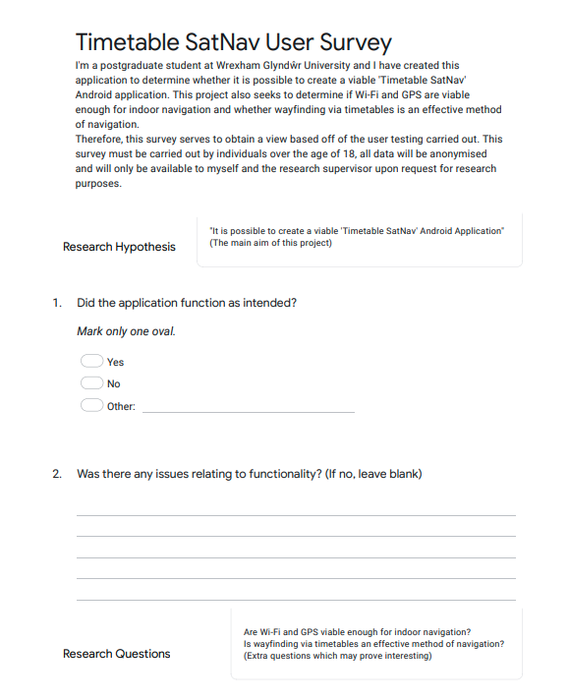

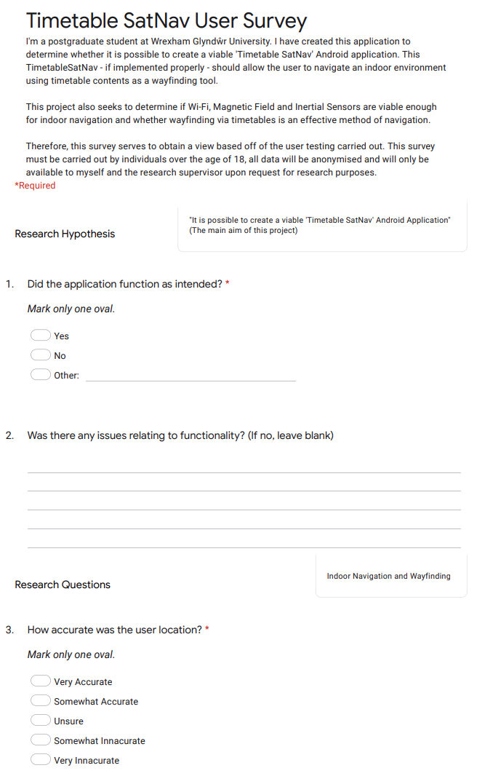

## Appendix C – Test Plan Document

**Glyndwr Timetable SatNav Test Plan**

**Prepared By:**  
Connor Laurence  
10/07/2021

1. INTRODUCTION

The product – Glyndwr Timetable SatNav – is an android application that has two major functions. The first is searching, selecting, and browsing a timetable for the university to find information and the second is an indoor map allowing user localisation, routing, and wayfinding through the university. Both components are linked directly though one element – navigating by an event selected from a timetable.

1. OBJECTIVES AND TASKS

2.1. Objectives

- Integration test of directly linked components between timetables and indoor map using a use case test

- Unit Testing of; Timetable Web Scrape, Timetable Contents Web Scrape, Search Timetables, Timetable Selection, Week Selection, Event Selection

- Decision Tables with two routes to ensure only allocated rooms can be navigate too (One route for an Online lecture and one for a room-allocated module)

- Equivalence Testing on timetable search

- Data-Flow Testing of local SQL database in its varying functions using Logcat

2.2. Tasks

Pre-testing phase:

* setup decision tables for two specific routes
* Insert Logcat messages into each aspect of data flow within application regarding local SQLite database
* Insert Logcat messages in units specified to demonstrate successful unit function

Testing phase:

* Screenshot successful and unsuccessful functioning units
* Document and screenshot results of decision table, equivalence testing and data-flow testing

Post-testing phase:

* If there are bug issues, document and rectify immediately
* Attach test plan to project document appendix and document appropriately in Chapter 8: Testing

3.0. SCOPE

In this project, five types of testing (four of which are black-box whilst the last is white-box) are included. These have been chosen to ensure that enough aspects of the product are thoroughly tested whilst not being too burdensome with regards to time.

All aspects of this testing will be undertaken by myself, and all tests should be completed within the week following end of sprint two. Any smaller tests incomplete by that stage must be discarded and documented within the testing stage to stay on target with planning.

1. Testing Strategy
   1. Alpha Testing (Unit Testing)

Unit testing will test separate units in turn such as; web scraping, timetable search, timetable selection, week selection and event selection. These will be done primarily through logcat messages demonstrating a successful test as well as UI changes which demonstrate a successful transaction.

4.2. System and Integration Testing

An integration test fully tests aspects from initially clicking a timetable through to navigating to that destination as a user may do and will be successful if the user can get to that end destination through that means. The two decision tables similarly act like integration but follow two set paths and end at the maps activity or in the event dialog depending on whether the room is allocated or not respectively.

4.3. Data Flow Testing

Data-flow testing uses an in-depth knowledge of the system to log data flow through Logcat messages at each point a flow of data may occur with the SQLite database. A successful test will show what data is moving and is backed up by being viewed in the UI i.e., Searching timetables interacts with data and the logcat results should match the search results in the UI.

4.4. User Acceptance Testing

Equivalence testing will be undertaken on the timetable search feature and will deliberately make erroneous searches like ‘modul’ instead of module or typing in numbers, searching for nonsensical strings, or trying to search for multiple different things like module and a room name. Successful results should ensure no crashes occur or functionality does not break in this unit. A blank result simply shows no results matching that string could be found and is not indicative of a failure.

4.7. Beta Testing

Following direct software testing by myself, the app will be given out to a select number of users to test and submit a user survey. The design of which comes from the design elements in Chapter 6 of the project document under ‘Survey Design’.

1. Hardware Requirements

Android Smartphone using Android 7.0+ (Nougat) or higher

Computer

Internet Connection

1. Environment Requirements

For 4.1 through 4.4, the environment is based at home with the workstation. The workstation requires Android Studio 3.5, an active internet connection and a functioning android emulator and log console, furthermore a tool like Windows snipping tool or Gyazo is necessary to screenshot elements throughout the test that ought to be documented. No special test tools are needed as all tools used within the development process can be reused to undertake this testing.

For 4.7 though, the environment changes to the university building and as such, a secure online storage tool for storing the app’s apk to later retrieve is necessary, a standalone device supporting android 7.0 or higher and a connection to Glyndwr University Wi-Fi network ‘eduroam’ is necessary at all times.

1. Test Schedule

The testing phase is initially earmarked for Tuesday 20/7/21 until Monday 2/8/21, however, this is subject to change depending on whether sprints are altered, or aspects of design or development over run.

1. Control Procedures

If problems are encountered, an incident will be documented in a table also attached to the appendix of the main project document. Not many incidents are anticipated due to its smaller scale development scope, so a table indicating incident number, description, proposed fix, and confirmation of fix should be all that is necessary to satisfy this component.

|  |  |  |  |
| --- | --- | --- | --- |
| Incident No. | Description | Proposed Fix | Was it fixed? |

1. Features to Be Tested

Timetable list, timetable search, info dialog, week spinner and load button, week contents list, contents dialog, SQLite database, Route to room POI, user location

1. Features Not to Be Tested

General wayfinding to selected POIs, AR, accessibility routes as not enough time is allotted to also cover these aspects and they generally do not directly tie in with the research goals.

1. Resources/Roles & Responsibilities

All aspects, roles and responsibilities of software testing is for me with the exception of partial roles for users in the beta testing phase.

1. Schedules

* Test Plan – in main project document’s appendix
* Test Cases – in main project document – Chapter 8
* Test Incident Reports – in main project document’s appendix
* Test Summary Reports – in main project document – Chapter 8

1. Dependencies

The major dependency in this test plan is time constraint given the short timeframe of the proposed project. Also, with limited resource and it is just me undertaking the testing. Getting enough user testers is also a constraint as limited users may signify inconclusive results.

1. Risks/Assumptions

|  |  |
| --- | --- |
| Risk | Mitigation |
| Not enough time | Alter test plan to test for less use cases, less in-depth data flow testing to suit time available |
| Not enough users for survey | More qualitative questions in survey and extract what results can be had from available data |
| Survey and user testing affected by pandemic |  |

1. Tools

Android Studio

Windows Snipping Tool

Microsoft Office – Word

Google Sheets

## Appendix D – Testing Incident Report

Table - Test Incident Report

|  |  |  |  |
| --- | --- | --- | --- |
| Incident No. | Description | Proposed Fix | Was it fixed? |
| 1 | Timetable Contents Dialog saying array out of index | Add “Please select a week and load to checking array”, change array size so message can display indicating not a timetable when list item is clicked | Yes |
| 2 | Map Dropouts –  User had said map dropouts occasionally whilst navigating. Could be that they don’t notice arrived at destination pop up. | Make destination alert more obvious. If mapping is still an issue, add more mapping paths to the heatmap on first floor B corridor | Yes |
| 3 | Floor Detection off –  User had said map was showing ground floor instead of first floor. User was slightly smaller than other testers – indicates floor separation distance is just off? Floor detection tool ~80% certain so lower floor separation distance from default 5.4m to 5m? | Reduce floor separation in IA webtool to 5m instead of 5.4m or ask supervisor if they know accurate distance or get measuring tape and check | Yes – needs more testing |
| 6 | Floor Detection Still off | Reduced floor separation to 4m and mapped around gallery where starting point for testing usually originates because of its ease.  Likely a combination of the app not knowing exactly where it is, and the incorrect separation distance was causing this issue with floor detection. | Fixed |
| 7 | Timetable contents weeks not showing | Glyndwr’s timetabling website was updated on 4th August 2021 to have building works in the majority of rooms over summer semester. Only the first three weeks of the September semester have been made up, but the app was designed up to end of academic year 20-21. This constraint has now been removed to allow any further user testing with timetables | Fixed |

## 

## Appendix E – Final Survey Design



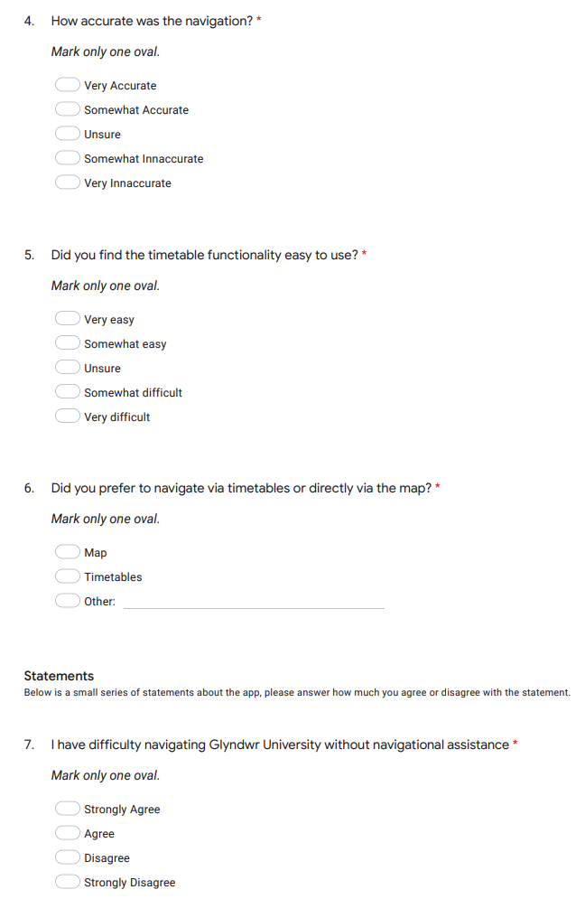

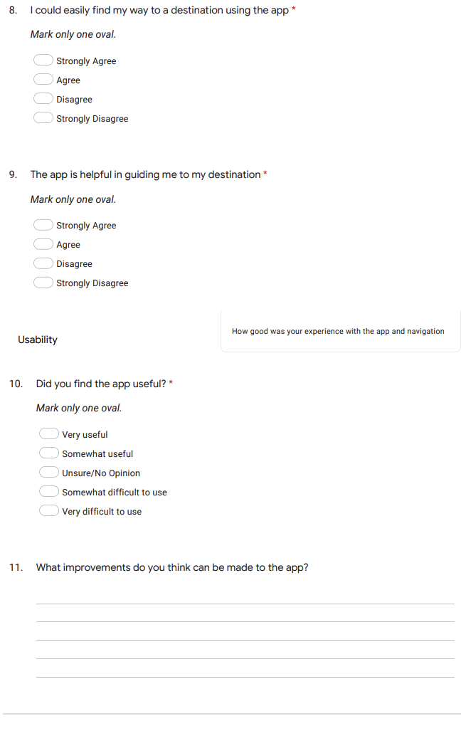

## Appendix F – Survey Results

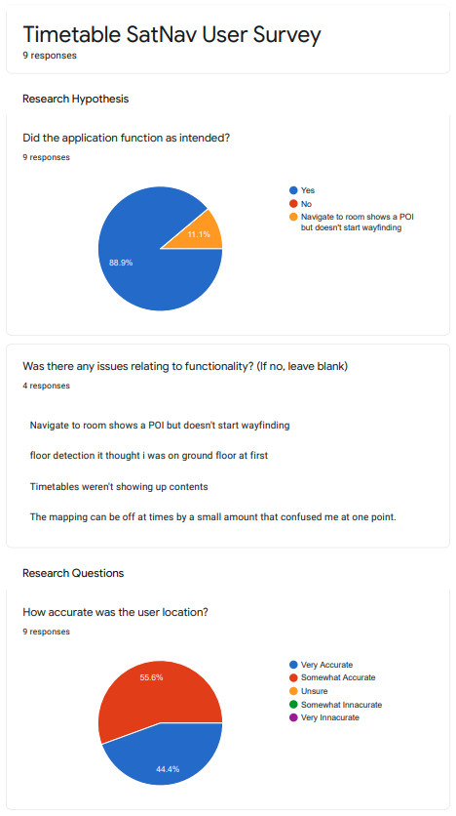

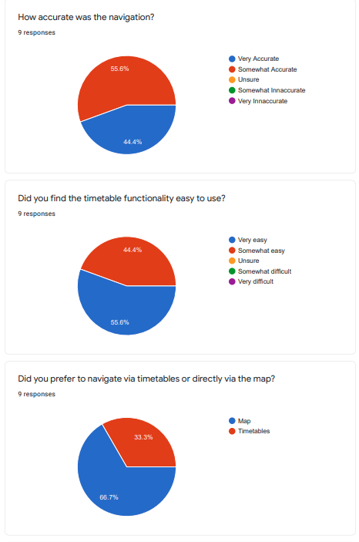



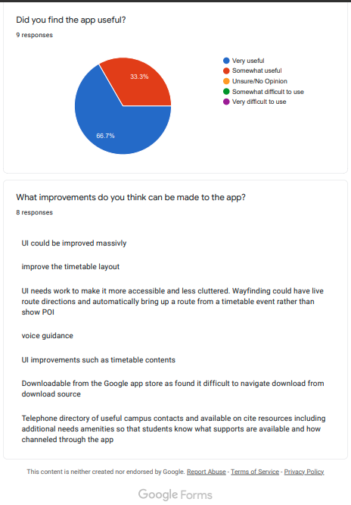

## Appendix G – Demonstration Video

Link to the demo video made for external verification of work can be found on YouTube via the link <https://youtu.be/EQhVYRDoZek>

## Appendix H – Project Files – GitHub Repository

The project files can be found on GitHub at <https://github.com/ConnorYoto/Glyndwr-Timetable-SatNav>. The API keys have been removed but you need only sign up for indoor atlas free trial and configure the keys as I have done as well as sign up for a trial of google maps. If you would like to see the examples for indoor atlas, they can be found here <https://github.com/IndoorAtlas/android-sdk-examples>